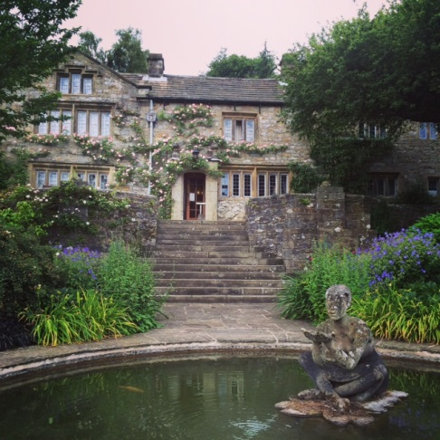
WORKING MEMORY DISCUSSION MEETING 2015
22nd-24th June 2015
Dear colleague,
This is to inform you that the Working Memory Discussion Group meeting will take place at the beautiful Parcevall Hall, in Appletreewick, near Skipton, North Yorkshire, on Monday 22nd-Wednesday 24thJune 2015. The meeting will begin at 3pm on the Monday and will end after lunch on the Wednesday.
If you are unfamiliar with the meeting, this is not a formal conference, but instead it is an opportunity to present data, work-in-progress, and discuss recent theoretical and methodological developments in a relaxed and informal setting. There is therefore no formal programme, and the meeting will consist of short presentations and more general group discussions. Everyone attending will have an opportunity to present if they wish.
Parcevall Hall, the Bradford Diocesan Retreat House, is located in North Yorkshire, near Skipton, and is about 5 miles from Bolton Abbey (postcode: BD23 6DG). Further information about the facilities at Parcevall Hall and about the surrounding area is available at http://www.parcevallhall.org.uk/
The total cost of the meeting is £165. This includes full board and accommodation in a shared room. If you would like to join us, please complete the attached booking form and return it to either of us by email by Friday 1st May 2015 at the latest. We will then request payment via the link in the group webpage, which is noted below, and provide more detailed information about the meeting. We will try our best to accommodate everyone but, as places are limited, rooms will be filled on a first-come, first-served basis. Do please pass details of the meeting on to any postgraduate students or colleagues who might be interested in taking part.
We look forward to seeing you at Parcevall Hall in the summer!
Louise Brown & Richard Allen
For general queries email: louisebrownparcevall@gmail.com OR richardallenparcevall@gmail.com
https://sites.google.com/site/workingmemorydiscussionmeeting/
BOOKING FORM
WORKING MEMORY DISCUSSION MEETING
22nd-24th June 2015

To book a place at this year’s meeting, please complete this form and email to:
EITHER louisebrownparcevall@gmail.com OR richardallenparcevall@gmail.com
* IMPORTANT: ALL FORMS MUST BE RETURNED NO LATER THAN 1st May*

I would like to book a place at the working memory discussion meeting in June. I understand that this will cost £165 (to be paid ASAP and by 1st May at the latest; we will send you a link for payment on receipt of this form). In the event of cancellation, a refund can only be made if the vacant place can be filled.
Please complete the following information:
Your details
Name:
Address:

Email:

Address:

Email:

Dietary requirements
Do you require vegetarian food (delete as appropriate): YES / NO
Please note any other important dietary requirements here:

Topic area
Please give us a brief idea of what general topic you are interested in presenting at the meeting:

