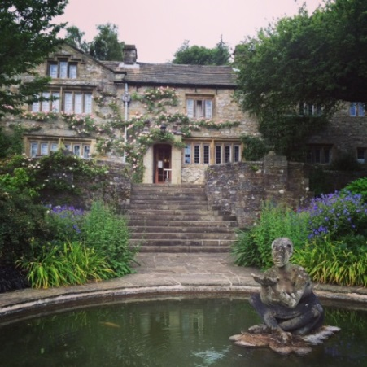
WORKING MEMORY DISCUSSION MEETING 2020
Monday 29th June - Wednesday 1st July
Dear colleague,
The Working Memory Discussion Group meeting will take place at the beautiful Parcevall Hall, in Appletreewick, near Skipton, North Yorkshire, on Monday 29th June - Wednesday 1st July. The meeting will begin at 3pm on the Monday (arrival from 2pm) and will end after lunch on the Wednesday.
If you are unfamiliar with the meeting, this is not a formal conference, but instead an opportunity to present data, work-in-progress, and discuss recent theoretical and methodological developments in a relaxed and informal setting. The meeting will consist of short presentations and more general group discussions. Everyone attending will have an opportunity to present if they wish, and the talk schedule will be announced in advance.
Parcevall Hall, the Bradford Diocesan Retreat House, is located in North Yorkshire, near Skipton (postcode: BD23 6DG), and is about 5 miles from Bolton Abbey. Further information about the facilities at Parcevall Hall and about the surrounding area is available at http://www.parcevallhall.org.uk/. Please also see attached ‘Information for Participants’, especially if you have never visited before.
The total cost of the meeting is £172. This includes full board and accommodation in a shared room. If you would like to join us, please complete the booking form below, and return it to either of us by email as soon as possible. Once you’ve received confirmation of your place, we will require payment via the following link by 1st May at the very latest:
https://store.leeds.ac.uk/conferences-and-events/psychology/school-of-psychology
Places are very limited and will be filled on a first-come, first-served basis. Please pass the meeting details on to any of your postgraduate students or colleagues who might also be interested.
We look forward to seeing you at Parcevall Hall in the summer!
Louise Nicholls & Richard Allen
For general queries email: louisebrownparcevall@gmail.com OR richardallenparcevall@gmail.com
https://sites.google.com/site/workingmemorydiscussionmeeting/

BOOKING FORM
WORKING MEMORY DISCUSSION MEETING
Monday 29th June - Wednesday 1st July 2020

To book a place at this year’s meeting, please complete this form and email to:
EITHER louisebrownparcevall@gmail.com OR richardallenparcevall@gmail.com
* IMPORTANT: PLACES ARE FILLED ON A FIRST-COME, FIRST-SERVED BASIS, BUT ALL FORMS AND PAYMENT MUST BE RETURNED NO LATER THAN 1st May.*
I would like to book a place at the Working Memory Discussion Meeting in June. I understand that this will cost £172 (to be paid ASAP after we have confirmed your place, and by 1st May at the latest). In the event of cancellation, a refund can only be made if the vacant place can be filled.
Payment Link: https://store.leeds.ac.uk/conferences-and-events/psychology/school-of-psychology
Your details
Name:
Affiliation:
Email:

Address:

Email:

Dietary requirements
If you have any dietary requirements including allergies or vegetarian/vegan food, please detail these here and we will pass these on to the Hall. Although staff are very accommodating, they would like you to be aware that in their kitchen they use nuts, dairy, wheat, gluten, soya, and eggs, and they cannot guarantee these won’t find their way into their home-cooked food.

Room sharing
Please suggest one or two individuals you could share with (to aid organisation):

Topic area
To aid scheduling, please tell us what general topic area you will present at the meeting. If not planning to present, please state this:

Personal Emergency Evacuation Plan
Do you answer ‘yes’ to one or more of the below questions: ☐ YES ☐ NO
If so, we will be in touch regarding your requirements and a Personal Emergency Evacuation Plan.
- Do you have any problems reading and identifying signs that mark emergency exits and evacuation routes to the emergency exits?
- Do you have any problems hearing fire alarm(s)?
- Would you experience any problems raising the alarm if you discovered a fire?
- Is anyone designated to assist you to get out in an emergency?
- Are you likely to experience difficulties independently travelling to the nearest emergency exit for a safe and timely evacuation?
- Do you find the stairs difficult to use?
- Are you dependent on a wheelchair for mobility?
- If you use a wheelchair would you have problems being able to transfer from your wheelchair without assistance?

