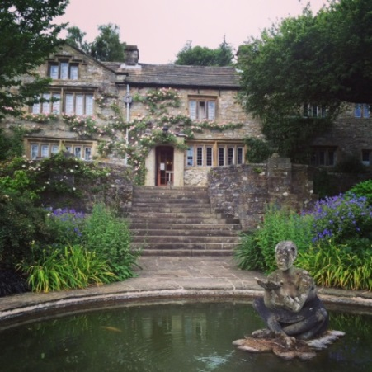
WORKING MEMORY DISCUSSION MEETING 2018
Monday 25th - Wednesday 27th June
Dear colleague,
This is to inform you that the Working Memory Discussion Group meeting will take place at the beautiful Parcevall Hall, in Appletreewick, near Skipton, North Yorkshire, on Monday 25th - Wednesday 27th June 2018. The meeting will begin at 3pm on the Monday (with arrival from 2pm) and will end after lunch on the Wednesday.
If you are unfamiliar with the meeting, this is not a formal conference, but instead it is an opportunity to present data, work-in-progress, and discuss recent theoretical and methodological developments in a relaxed and informal setting. The meeting will consist of short presentations and more general group discussions. Everyone attending will have an opportunity to present if they wish, and the talk schedule will be announced in advance.
Parcevall Hall, the Bradford Diocesan Retreat House, is located in North Yorkshire, near Skipton (postcode: BD23 6DG), and is about 5 miles from Bolton Abbey. Further information about the facilities at Parcevall Hall and about the surrounding area is available at http://www.parcevallhall.org.uk/. Please also see attached ‘Information for Participants’ (especially if you have never visited).
The total cost of the meeting is £160. This includes full board and accommodation in a shared room. If you would like to join us, please complete the booking form below, and return it to either of us by email as soon as possible. Once you’ve received confirmation of your place, we will require payment via the following link by 1st May 2018 at the very latest:
https://store.leeds.ac.uk/conferences-and-events/psychology/school-of-psychology/working-memory-discussion-meeting-2018
As places are very limited, rooms will be filled on a first-come, first-served basis. Please pass the meeting details on to any of your postgraduate students or colleagues who might be interested.
We look forward to seeing you at Parcevall Hall in the summer!
Louise Brown & Richard Allen
For general queries email: louisebrownparcevall@gmail.com OR richardallenparcevall@gmail.com
https://sites.google.com/site/workingmemorydiscussionmeeting/
BOOKING FORM
WORKING MEMORY DISCUSSION MEETING
Monday 25th - Wednesday 27th June 2018

To book a place at this year’s meeting, please complete this form and email to:
EITHER louisebrownparcevall@gmail.com OR richardallenparcevall@gmail.com
* IMPORTANT: PLACES ARE FILLED ON A FIRST-COME, FIRST-SERVED BASIS, BUT ALL FORMS AND PAYMENT MUST BE RETURNED NO LATER THAN 1st May.*
I would like to book a place at the working memory discussion meeting in June. I understand that this will cost £160 (to be paid ASAP after we have confirmed your place, and by 1st May at the latest). In the event of cancellation, a refund can only be made if the vacant place can be filled.
Payment Link:
https://store.leeds.ac.uk/conferences-and-events/psychology/school-of-psychology/working-memory-discussion-meeting-2018
Your details
Name:
Affiliation:
Address:
Email:

Address:

Email:

Dietary requirements
Do you require vegetarian food (delete as appropriate): YES / NO
Please note any other dietary requirements here:

Room sharing
If you know who you would like to share a room with, please request below:

Topic area
To aid scheduling, please tell us what topic area you will present at the meeting:

