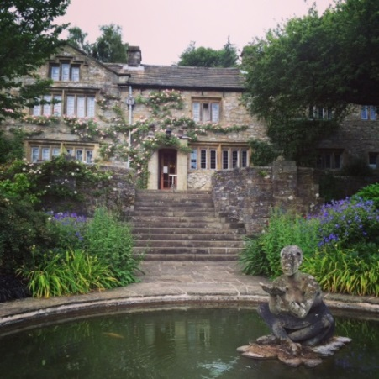
WORKING MEMORY DISCUSSION MEETING

Monday 26th June to Wednesday 28th June 2023

Dear colleague,
The Working Memory Discussion Group meeting will take place at the beautiful Parcevall Hall, in Appletreewick, near Skipton, North Yorkshire, on Monday 26th June to Wednesday 28th June. The meeting will begin at 4pm on the Monday (arrival from 3pm) and will end after lunch on the Wednesday (departure by 2pm).
If you are unfamiliar with the meeting, this is not a formal conference, but instead an opportunity to present data, work-in-progress, and discuss recent theoretical and methodological developments in a relaxed and informal setting. The meeting will consist of short presentations and more general group discussions. Everyone attending will have an opportunity to present if they wish, and the talk schedule will be announced in advance.
Parcevall Hall, the Bradford Diocesan Retreat House, is located in North Yorkshire, near Skipton (postcode: BD23 6DG), and is about 5 miles from Bolton Abbey. Further information about the facilities at Parcevall Hall and about the surrounding area is available at http://www.parcevallhall.org.uk/. Please also see attached ‘Information for Participants’, especially if you have never visited before.
The total cost of the meeting is £189. This includes full board and accommodation for two nights. If you would like to join us, please complete the booking form below, and return it to either of us by email as soon as possible. Once you’ve received confirmation of your place, we will require payment via the following link asap and by 8th May at the very latest:
https://store.leeds.ac.uk/conferences-and-events/psychology/school-of-psychology/working-memory-discussion-meeting-2023
Places are extremely limited and will be filled on a first-come, first-served basis.
Please feel free to pass the meeting details on to any of your PhD students or colleagues who might also be interested.
We look forward to seeing you at Parcevall Hall in the summer!
Louise Nicholls & Richard Allen
For general queries email: louisebrownparcevall@gmail.com OR richardallenparcevall@gmail.com
https://sites.google.com/site/workingmemorydiscussionmeeting/
BOOKING FORM
WORKING MEMORY DISCUSSION MEETING
Monday 26th June to Wednesday 28th June 2023

To book a place at this year’s meeting, please complete this form and email to:
EITHER louisebrownparcevall@gmail.com OR richardallenparcevall@gmail.com

* IMPORTANT: PLACES ARE FILLED ON A FIRST-COME, FIRST-SERVED BASIS, BUT ALL FORMS AND PAYMENT MUST BE RECEIVED NO LATER THAN 8th May.*

I would like to book a place at the Working Memory Discussion Meeting in June. I understand that this will cost £189 (to be paid ASAP after we have confirmed your place, and by 8th May at the latest). In the event of cancellation, a refund can only be made if the vacant place can be filled (but see COVID-related information below).
Payment Link: https://store.leeds.ac.uk/conferences-and-events/psychology/school-of-psychology/working-memory-discussion-meeting-2023

Your details
Name:
Affiliation:
Email:

Address:

Email:

Dietary requirements
If you have any dietary requirements including allergies or vegetarian/vegan food, please detail these here and we will pass these on to the Hall. Although staff are very accommodating, they would like you to be aware that in their kitchen they use nuts, dairy, wheat, gluten, soya, and eggs, and they cannot guarantee these won’t find their way into their home-cooked food.

Topic area
To aid scheduling, please tell us what general topic area you will present at the meeting. If not planning to present, please state this:

CONTINUED OVER…

PERSONAL EMERGENCY EVACUATION PLAN

Do you answer ‘yes’ to one or more of the below questions (please check box as appropriate):
☐ YES ☐ NO
If ‘yes’, you will need to arrange a Personal Emergency Evacuation Plan with the Hall on arrival.
- Do you have any problems reading and identifying signs that mark emergency exits and evacuation routes to the emergency exits?
- Do you have any problems hearing fire alarm(s)?
- Would you experience any problems raising the alarm if you discovered a fire?
- Is anyone designated to assist you to get out in an emergency?
- Are you likely to experience difficulties independently travelling to the nearest emergency exit for a safe and timely evacuation?
- Do you find the stairs difficult to use?
- Are you dependent on a wheelchair for mobility?
- If you use a wheelchair would you have problems being able to transfer from your wheelchair without assistance?

CONTINUED OVER…

COVID-19 INFORMATION FROM PARCEVALL HALL
Parcevall Hall staff take bi-weekly lateral flow tests and wear face masks when working in the public areas. All touch points are regularly cleaned throughout the day. Our kitchen staff will continue to follow strict food safety and hygiene procedures, enhanced to limit the opportunities for the transmission of Covid-19.
If you have symptoms of Covid-19 before arrival, please do not visit Parcevall Hall. We will not charge a cancellation fee in these circumstances. If anyone develops symptoms during their time at Parcevall Hall, they must immediately advise a member of staff, self-isolate in their room and arrange private transportation home. If they do not have access to private transport or are not well enough to travel, we will contact a health care professional and the local authority. The cost for any additional stay will be invoiced to you. All other guests will be asked to return home at their own expense and a refund for any outstanding stay will not be made. A later stay may be possible, at the discretion of Parcevall Hall.
Currently, the following requirements are in place for guests visiting Parcevall Hall:
- All guests must wear a face mask before entry into the Hall, when walking though the Hall and on the corridors, and when in the presence of staff. Wearing a mask at other times is at guests’ discretion, but we encourage you to be sensitive to the preferences and needs of other guests.
- Guests should bring their own alcohol-based hand sanitiser, for use before leaving their rooms and entering the public areas, where hand gel is also provided.
- If in advance of your arrival it is necessary for Parcevall Hall to close for reasons associated with Covid-19, we will inform you at the earliest opportunity and refund monies paid.
- Despite best efforts, we are not able to guarantee that we can eliminate the risk of Covid-19 transmission in or around Parcevall Hall. By signing this form and / or visiting Parcevall Hall, guests accept this responsibility for their own health.
- Depending on government advice at the time of your visit, we will let guests know after they arrive of any additional practices we have in place to protect themselves, fellow guests and staff. We will do our best to make your stay as pleasant as we can!
Please check the box to confirm that you have read the information above, and that you can / will comply with these requirements: ☐

