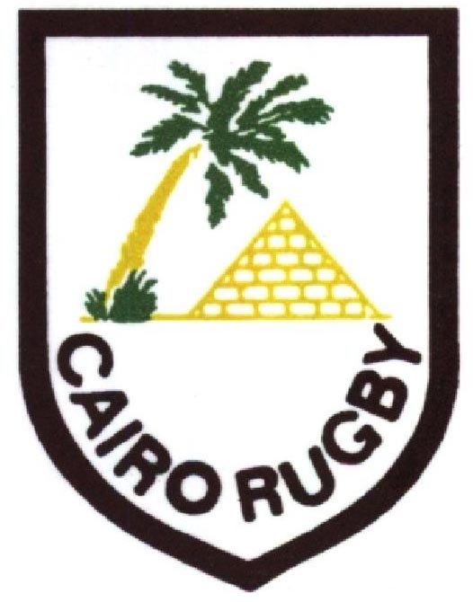

Cairo Rugby Proudly Presents

The 2012 Desert Dinner

At the Mena House Hotel, Giza Pyramids

Thursday, 10th May 2012

Entertainment by Ahmed Harfoush and the Riff Band

Outdoor drinks reception in the “Oasis Garden”
(at the foot of the pyramids) from 6pm
Dinner in the Banqueting Suite at 8pm
Carriages at 2.30am

Dress Code: Formal

Ticket Price: Cairo Rugby Members – LE 650 Non-members – LE 700

The standard table size is for 10 guests

However, groups of less than 10 are welcome and will be seated according to availability

The ticket price includes drinks and canapes on arrival, a formal sit-down dinner, entertainment and, in the spirit of previous years, all corkage has been prepaid in your ticket price, so feel free to bring champagne, wine, spirits, beer or your poison of choice. The Mena House bar service will also be available.

PLEASE COMPLETE THE ATTACHED MEAL SELECTION & CONTACT DETAILS FORM

Please tick one per person

 | NAME | RUGBY MEMBER |  | BEEF | CHICKEN | VEGETARIAN | FEE
 |  | Yes | No
1
2
3
4
5
6
7
8
9
10

Special Seating Requests (i.e. table to be near to):_______________________________________________________________________________

Contact Name:____________________________________________ E-Mail:________________________________________________________

Home Phone:_____________________________________________ Mobile #:_______________________________________________________

Cairo Rugby Use Only
Beef
Chicken
Vegetarian
Table Number

