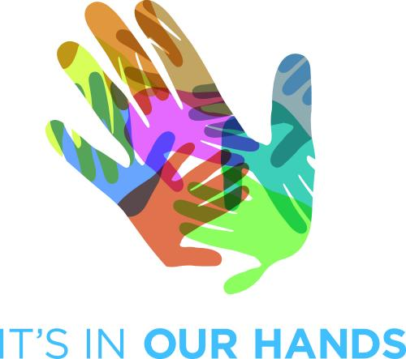
3 DAY WORKSHOP

AN AWAKENING

Wellness… a word we have all heard, are aware of, have experienced it and yet fear that it will be snatched away from us, in the blink of an eye!
We are fearful of our environment, germs, viruses, hereditary, wrong food, bad habits…we seem to live in a world out to get us.
Are our bodies so fragile? How did we survive for 3.5 billion years and evolve to the top of the chain, if everything around us can make us sick?
What makes us sick? What keeps us well?
Is health built up or is it automatic? Or is it a bit of both?
How can some people sleep late, eat wrong, and still be healthy? While some of us can fail, catch flu, by the mere thought of it!
Are we the same or are we different?
If we share the same cells and tissues, the same DNA, what makes us differ? Why is healing relative?
We fear our BODY.
NATURE AND HER WAYS TOO. THE SAME Nature that has kept us alive for over 3.5 billion years! IT’S BECOME EASIER TO trust medicines and doctors, than our own Body!
We have over drawn the resources of Earth AND MINED AWAY AT HER VERY SOURCES OF LIFE.

WHAT IS THE CONSEQUENCE?

Fatter chickens, fatter babies and obese adults.
We have more variety of foods, yet fewer choices.
Fertility clinics on every corner. As a species we are losing our ability to procreate. Much like corals.
What is the impact of our every day choices on our health and healing?
What is the role of our eating habits?
Why do we experience illness more than energy?
Where is our body- in our hands? Or entangled within the medical system?
How is all this related to our daily lifestyle?

THE 3 DAY WORKSHOP IS DESIGNED TO

*Clear Myths on Food, Health and Disease
*Understand the Structure and Function of the body
*Awaken, Clarify and Clear Concepts.
*Understand the role of the Senses in Illness and Wellness.
*Make daily choices for healthy living by understanding the body's potential for Wellness and move towards a health stimulating and environmentally sustainable lifestyle.
*Break habits and tweak awareness.
*Recognize body symptoms and begin to take responsibility for your health choices.
*Know what the Body needs for Optimum Health
*Take care of ourselves through periods of Stress and Sickness
*Take home an ACTION PLAN with practical tips

HIGHLIGHTS OF THE WORKSHOP

-Theoretical and interactive discussions Food, Health, Earth, Body and Disease.
-Audio visual sessions
-Practical Demonstrations on making Food with Kitchen Management tips.
-De-activation techniques: how to shut down an overburdened nervous system, switch off
over stimulated senses, relax the body from over stresses daily lifestyles.

ABOUT THAC (The Health Awareness Centre)

For over 25 years now, Dr Vijaya Venkat, founder of The Health Awareness Centre Mumbai, and her team have been urging people to take health in their own hands. And in the process contribute to the welfare of Planet Earth. The Health Awareness Centre was started in 1989, to bridge the gap between facts, as they stand, and realities prevailing today. Their views on nutrition, backed by four decades of research on the subject, embody a deeper philosophy that looks at health as part of the whole and uses food as a starting point to experience sound health for the individual, the community and the earth. Through their workshops and awareness programmes they seek to inspire people to embrace the simple fundamentals that govern health and well-being. The prime focus is to enable people to take care of their own health, without an external intervention and collectively move from an ‘llness Consciousness’ society to a ‘Wellness rooted’ society.

