This page contains the details of a technical writing project accepted for Season of Docs.

Project summary
Open source organization:
Wechaty
Technical writer:
Anirudh T.P.V.S
Project name:
Create easy to learn tutorials for beginners
Project length:
Standard length (3 months)

Project description

Synopsis:
Wechaty is a RPA (Robotic Process Automation) SDK for Chatbot Makers which can help you create a bot in 6 lines of Javascript, Python, Go, and Java, with cross-platform support including Linux, Windows and MacOS, and Docker. Wechaty is used in many ChatBot projects by thousands of developers. To further efficiently serve these users, documentation proves to be essential and is used by most developers, administrators, and end-users. Therefore, documentation can be established as a principal factor of the Wechatty ecosystem. The current documentation for the Wechaty tutorials doesn’t include a universal & unified set of rules and style guidelines. The motive of this proposal is to create a full and renewed set of documentation style guidelines, and tutorials that are universally applicable for wechaty documentation. The project idea involves consolidating all aspects of design and style guidelines like semantics, syntactics, grammar guidelines, punctuation, development-specific rules, design attributes and formatting specifics. It also incorporates language conventions like voice, tone, tense, all parts of speech, as well as naming conventions. The tools, languages and platforms used will be Wechaty, GitHub, Markdown, HTML/CSS, MS Word.

Project Plan:
Current State of Documentation Style Guides:
Users come to Wechaty website and are seeking how to use Wechaty to build a chatbot application for solving their problems. Unfortunately, the learning curve is not friendly to the users, as they always struggle with setting up with their development environment, and could not get started with the simplest example source code, and hard to know what they can do with our API. This problem leads the Wechaty team lost lots of new users, increased the number of questions asked in the community, and lowered the user satisfactions. Adding to that, the current version of tutorials is a structurally very messy due to improper planning. Hence, there is a need to design and develop the tutorials on the website by creating video tutorials and along with graphical presentation of each steps in order to create interest in users who would using Wechaty.

Objectives:
Tutorials are lessons that take the reader by the hand through a series of steps to complete running Wechaty code. They are what our project needs in order to show a beginner that they can achieve something with it. They are wholly learning-oriented, and specifically, they are oriented towards learning how rather than learning that. Documentation is an essential element in assisting these developers and users to efficiently fulfil these functionalities without any hassles, even in case of inconveniences. The overall objective of this project proposal is to standardize a design & style guide, make the tutorials easy to comprehend and follow, unify existing style guides and update as well as append new regulations and specifications for Wechaty tutorial documentation. This would enable ease of use, simplicity and uniformity in the documentation.

Implementation:
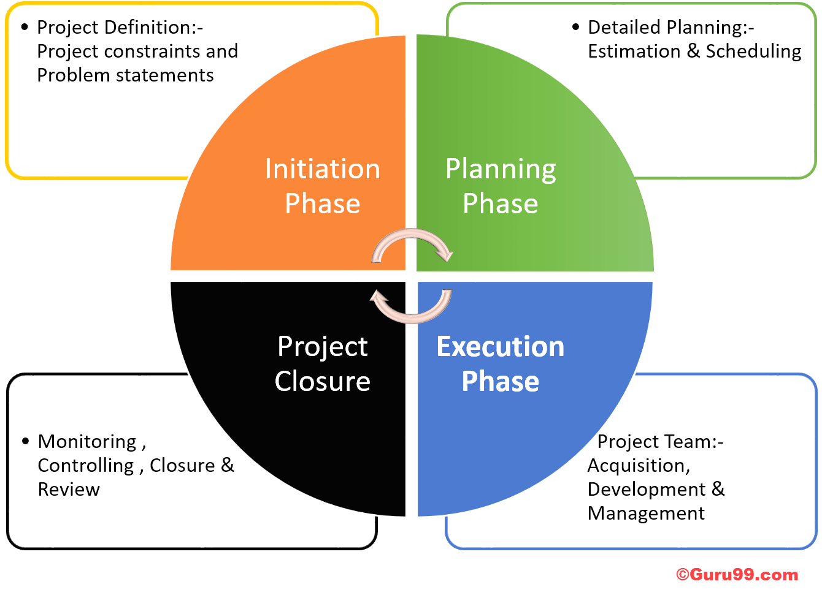

The project can be approached in 4 phases: Initiation, Planning, Implementation and Maintenance phase. Before commencement of the project, during the pre-internship period, I will work with my mentor and finalize a suitable schedule and timeline going along the lines of my ensuing timeline & deliverables. I will familiarize myself further with the Wechaty system and the work protocols for this project.
As the internship commences, I will discuss and draft the abstract of the plan with my mentor. The requirements and necessities will be determined. Firstly, I will outline the flow of the documentation and the user interaction process. Subsequently, the layout wireframes of each section, category and component will be outlined. These layouts will then be reviewed by my mentor. If required, the layouts will be redesigned and some components added/removed. I will then conduct user research for determining usability and feasibility of the interface flow. Subsequently, the tutorials will be implemented per section. Style guides from other organizations that are under any open source or Creative Commons licenses can be referenced to append our guide as well. If during this period, any usability difficulties occur, I will redesign them.
Optimizations will be carried out after the tutorials(made with unified styling) is completed and integrated. Any redundant elements or components would be rectified. UI and code testing will be carried out and unwanted bugs & errors will be fixed, if required. A final quality control for the complete tutorials will be conducted for language, grammar, spellings, punctuation, etc.
Tasks pending due to unforeseen delays would be completed in the buffer period. Additional functionalities or features that would be determined feasible along the course of the project can be implemented after final tutorial draft is done. A deployment plan would be constructed and the finished product will be submitted.

Tools & Methodologies:
The documentation will be compiled and edited on a collaborative platform, such as Google Docs. If required to publish via GitHub, markup languages like Markdown or GitHub Flavoured Markdown can be implemented as well. For design and style standards, open source style guidelines can also be referenced. Finally, the completed tutorials would be formatted and published. Adding to that, there is a dire need to use SEO tools in order to make it more visible on to the public audience.

Component Table:
This is an exhaustive list of components that can be implemented in the Style Guide. Document Guidelines - Accessibility, Document Structure, Encoding, External Sources, Facts, Fonts, Global Audience, Inclusivity, Legality, Multi-platform Accessibility, Non-ambiguous, No Excessive Claims, Page Layout, Political Correctness, Protocols, Security, Sentence Structure, Succinct Writing, Tone & Style, Unbiased.
Language & Grammar - Abbreviations & acronyms, Affirmation & Negation, Articles, Capitalization, Clause, Direct/Indirect speech, First/Second/Third person, Genders, Glossary, Nouns, Prefixes & suffixes, Prepositions, Pronouns, Referencing, Slang & jargon, Spellings, Technical terms, Tense, Verbs, Voice
Punctuation - Apostrophe & Quotation Marks, Colons & Semi Colons, Commas, Ellipses, Exclamation Marks, Hyphens & Dashes, Parentheses, Periods, Question Marks, Slashes
Formatting - Abstracts, Introduction, Prefaces, Brand Names, Product Names, Captions, Code Snippets, Code Blocks, Date & Time, Time Zones, Places, Currencies, File Names, Footnotes, Headings & Titles, Highlighting (Bold, Italics, Underline, Strikethrough, Quotation), Indentation, Index, Links & URLs, Lists, Bullet Points, Numbering, Media (Images, Videos) & Illustrations, Notes, Warnings, Tips, Numbers & Phone Numbers, Polyglots, Translation, Language Scripts, Spacing, Tables, Text, Trademarks, Copyrights, Patents, Citations, Tutorials & Procedures, UI elements, Units of Measurement
User Interface - Activities, Buttons, Code Snippets, Code Blocks, Command Line Interface, Dialogs, Menus & Dropdowns, Pop-ups & Alerts, Tabs, Terminology, UI elements
Code - CSS, HTML, JS, Markdown, Syntax, XML
Word Usage Dictionary/Glossary - A to Z
Tutorials: Video and text format with lots of graphics/pictures for easier comprehension.

