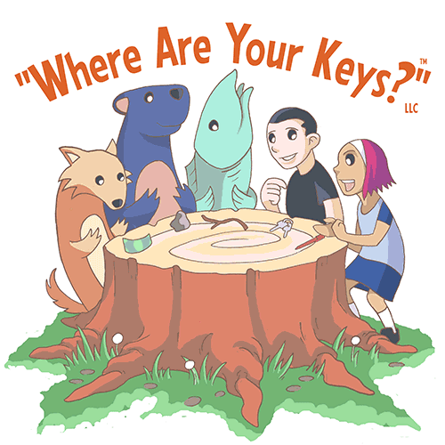
http://www.whereareyourkeys.org

Universal Speed Curriculum:

English

Phase 1
Present Tense + Singular Dialogue

What

Part 1: “What is that?”

Technique (TQ)
TQ: Make me say yes/no
TQ: Set-Up
TQ: Mumble
TQ: Limit
TQ: Copy-Cat

Vocabulary List (VL)
VL: yes/no/not
VL: my/your

Example:
Alice: What is that?
Bob: That is a pen.
Alice: Is that a pen?
Bob: Yes. That is a pen.
Alice: Is that a phone?
Bob: No. That is not a phone. That is a pen.

Example: My/Your (Alice has a phone, Bob has a pen)
Alice: That is my phone. That is your pen.
Bob: That is my pen. That is your phone.
Alice: Is that my phone?
Bob: Yes. That is your phone.
Alice: Is that your pen?
Bob: Yes. That is my pen.

Example: Not my/Not your
Alice: That is my phone. That is your pen.
Bob: That is my pen. That is your phone
Alice: Is that my pen?
Bob: No. That is not your pen. That is my pen.
Alice: Is that your phone?
Bob: No. That is not my phone. That is your phone.

Part 2: “Want/Have/Give”

Technique (TQ)

Vocabulary List (VL)
VL: I/my/you/your
VL: want/have/give

Example: Have
Alice: I have a phone. You have a pen.
Bob: I have a pen. You have a phone.
Alice: Do you have a pen?
Bob: Yes. I do have a pen.

Example: Do not have
Alice: Do you have a phone?
Bob: No. I do not have a phone. I have a pen.

Example: Want
Alice: I have a phone. Do you want my phone?
Bob: Yes. I want your phone.
Alice gives Bob the phone.

Example: Do not want
Alice: I have a phone. Do you want my phone?
Bob: No, I do not want your phone.

Example: Give
Alice: I want your pen. Will you give me your pen?
Bob: Yes, I will give you my pen.
Bob gives Alice the pen.

Example: Will not give
Alice: I want your pen. Will you give me your pen?
Bob: No, I will not give you my pen.

Part 3: “for/if/and/then/but”

Vocabulary List (VL)
VL: I/me/my/you/you/yours
VL: want/have/give
VL: for/if/and/then/but

Example: For
Alice: I want your pen. I will give you my phone for your pen.
Bob: Okay, you will give me your phone for my pen.
They then exchange items.

Example: If
Alice: I have a phone. You have a pen.
Bob: I have a pen. You have a phone.
Alice: Do you want my phone?
Bob: Yes. I want your phone.
Alice: I want your pen.
Bob: You want my pen.
Alice: If I give you my phone, will you give me your pen?
Bob: Yes. If you give me your phone, I will give you my pen.
They then exchange items.

Example: If (make me say no)
Alice: I have a phone. You have a pen.
Bob: I have a pen. You have a phone.
Alice: If I give you my phone, will you give me your pen?
Bob: No. I will not give you my pen if you give me your phone.

Example: And (now Alice has a phone and a dollar. Bob has a pen and a cup)
Alice: I have a phone and a dollar. You have a pen and a cup.
Bob: I have a pen and a cup. You have a phone and a dollar.

Example: But
Alice: I want your pen. Do you want my phone?
Bob: No, I do not want your phone, but I want your dollar.
Alice: You do not want my phone, but you want my dollar.
Bob: Yes. If you give me your dollar, I will give you my pen.

Example: Then
Alice: I want your pen. Do you want my phone?
Bob: Yes, I want your phone.
Alice: If you give me your pen, then I will give you my phone.
Bob: If you give me your phone, then I will give you my pen.
They then exchange items.

Part 4: “Which” and “to”

Do you- want to trade?
want to buy?
want to go?

Using two verbs in the same sentence:

Example:
I want you to give me your pen.
I want you to have my pen.
I want to give you my pen.
I want to have your pen.

Which
“Which do you want?”

Like to do

What do you like to cook?

What do you like to eat?

Always/Sometimes/Never -Ever

Do you want the pen?
Do you want me to give you the pen?
I will give you my pen for your phone
I want to give you my pen for your phone.

Where

Part 1:

CL: Above/Below/In Front/Behind/Next to/between
CL: On top/Under/In/Out/

That Is
I want the pen that is on top of the notebook.

Three cup game
Where is your phone?
My phone is between my notebook and my pen box.
Is your phone between your notebook and your pen box?
Yes. My phone is between my notebook and my pen box.
Is your phone between your pen and my notebook?
No. My phone is not between your notebook and my pen box. My phone is between my notebook and my pen box.

What do you like?
What do you like to do?
What do you want to do?

Auxiliary Verbs
AV only
Base form only
Will/can
would/should/could
may/might/must
do/does/did

Present participle only
am/is/are/was/were/be/been

Past participle only
have/has/had/being

will/can
have
am/are/is
at/in/on/of/with/by
as

Prepositions of Time: at, on, and in
We use at to designate specific times. The train is due at 12:15 p.m.
We use on to designate days and dates. My brother is coming on Monday. We're having a party on the Fourth of July.
We use in for nonspecific times during a day, a month, a season, or a year. She likes to jog in the morning. It's too cold in winter to run outside. He started the job in 1971. He's going to quit in August.

How/How many?

Who

When

Why

