**ODOT Region 1 Headquarters**

123 NW Flanders Blvd.

Portland, Oregon 97209 Reception desk (503) 731-8200 Guard desk (503) 731-8518

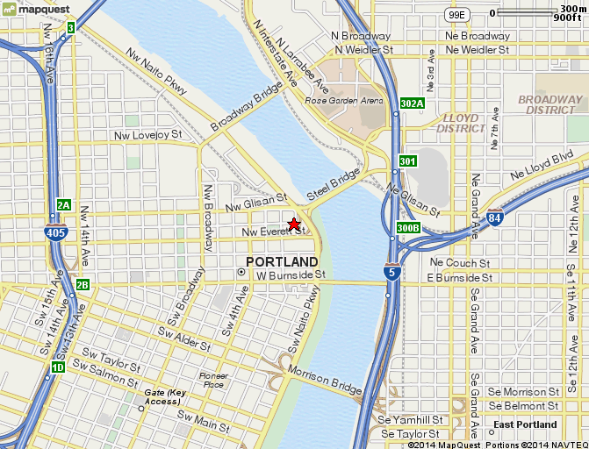

**DRIVING DIRECTIONS**

**From I-5 North and I-84:**

* City Center/Oregon City Exit
* Cross Morrison Bridge
* Right on 2nd, go North 10 blocks

**From I-5 South:**

* City Center Exit 302A to Front Avenue
* Go North 18 blocks
* Left on Davis, Right on 2nd

**From Airport:**

* Take I-205 South to I-84 West to Portland
* Go West on I-84 to Lloyd Blvd. Exit
* Take Lloyd Blvd. West to Union/Martin Luther King (MLK)
* Turn Left on MLK and proceed to Burnside, turn Right and go across bridge
* Turn Right -- Go 4 blocks North to Flanders

**Travel Time from Airport:**

* 18 minutes, 12.4 mile