I installed Virtual box and vagrant, here is the screenshot
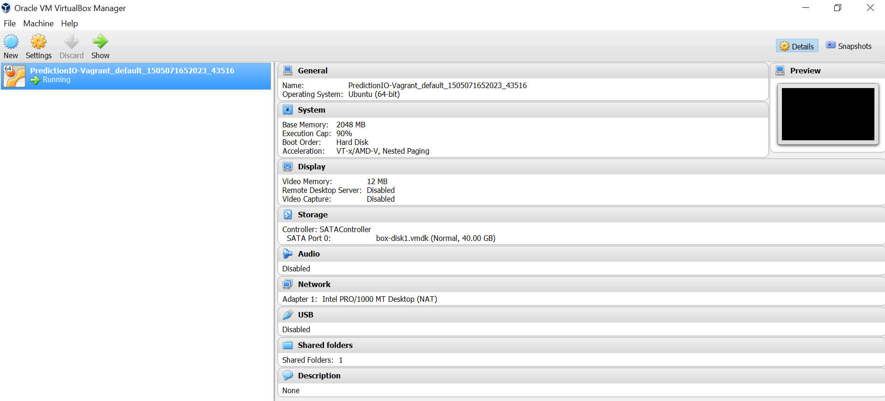

Here is the error msg I am getting
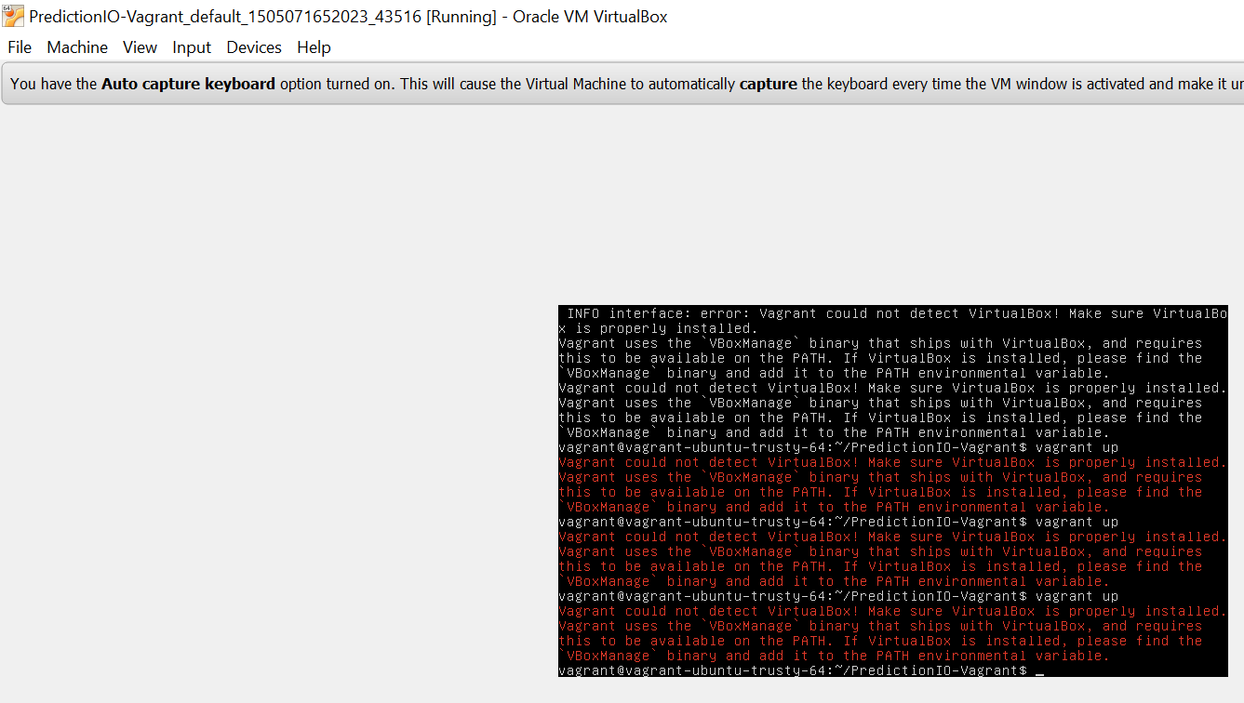
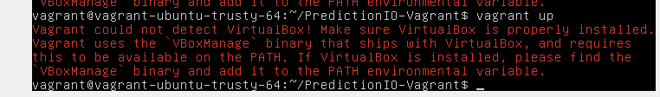

Looks like I installed the following rev:
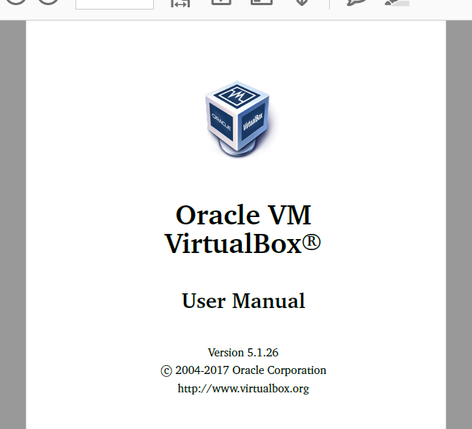

Here is the installation folder:
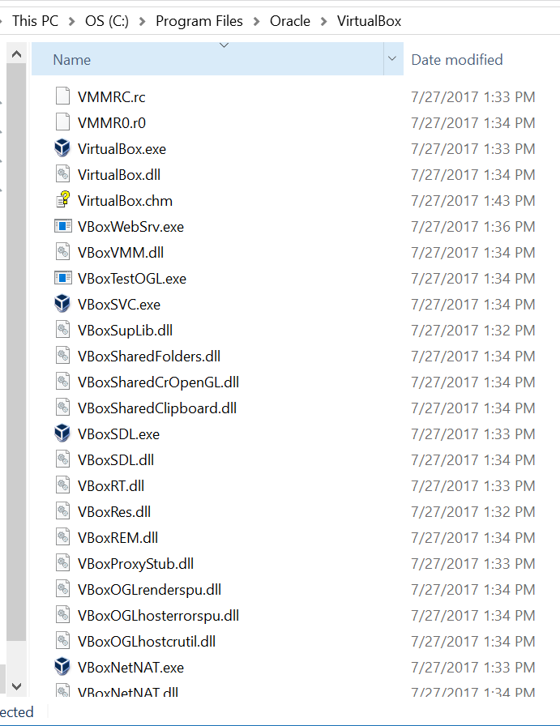

I installed on windows 10
I set environment variable

I updated Path as below:
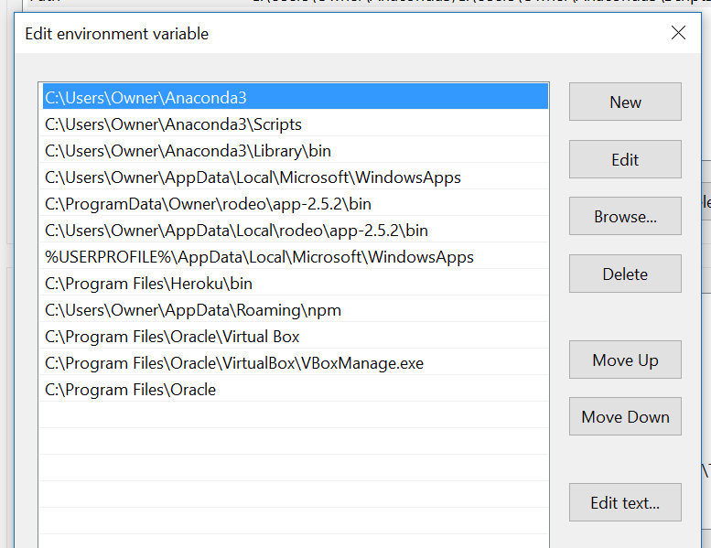

I think I installed this vagrant
