APIs in Government

APIs grant automated access to information and services, moving past one-off, human interactions.

In other words, APIs are efficiency.

Why APIs?

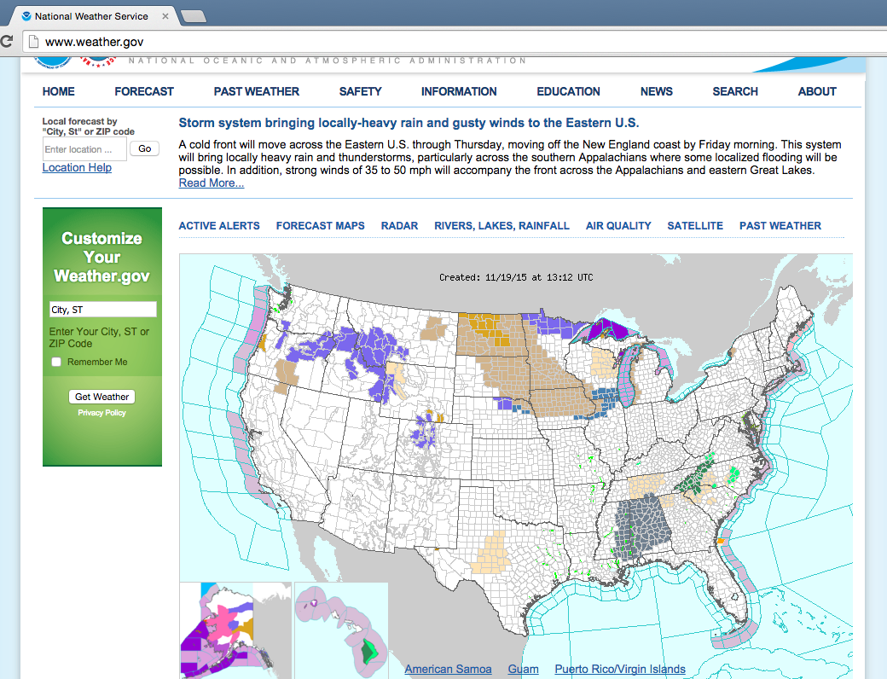 | vs. | 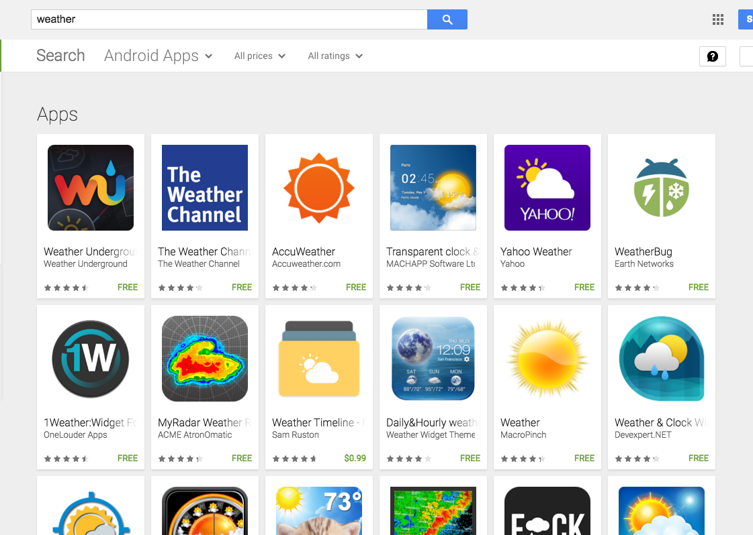

Where is this happening?

- dol.gov/developer  - state.gov/developer | - whitehouse.gov/developers  - consumerfinance.gov/developers | - api.nasa.gov  - ~40% of agencies

What is needed?

- Always build an API.
- Always build it first.
- Eat your own dogfood.

Links:

- Training, Resources, Direct Support - bit.ly/government-api
- US Government APIs Google Group - bit.ly/gov-api-group
- DC API Meetup - www.meetup.com/dc-web-api-user-group/

