3717 Jonlen Drive
Fairfax, OH 45227

Dance at the Distillery!
Learn to Dance Together to any Style of Music.
Perfect for Singles or Couples.
No experience Needed. Hosted by Juanita Gable.
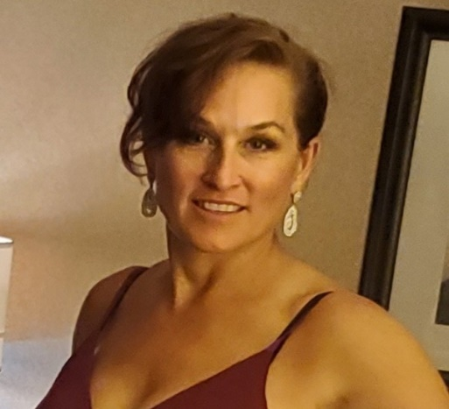
FREE every Wednesday
Beginning September 8, 2021
Beginner Lesson
6:30 - 7:30
Intermediate Lesson
7:30 - 8:00
Dance Party!
8:00 - 10:00
Playing a mix of popular hits, waltz, cha cha, swing, salsa, foxtrot, nightclub 2, rumba and more
