

Guest Speakers:

**Richard O’Neill – Independent Consultant & Trainer**

**Lisa Smith – Worcestershire Traveller Education**

**Dr Jo Richardson – De Montfort University**

**Dr Cath Jackson – University of York**

Also featuring:

The Premiere of ‘Moving Forward Together’,

a film commissioned by the Trust which highlights the lives and issues of the local Gypsy & Traveller community.

For bookings please contact: **wdu@york.gov.uk**

Cost:

**Statutory:** **£50 Voluntary: £30 Students: £20**

Hosted at:

**York St John University**

Friday 15th January 2016 9am - 4pm

A further opportunity for community members & professionals to work together to develop effective communication.

Information Packs, Lunch & Refreshments provided

**This event is provided in partnership with:**

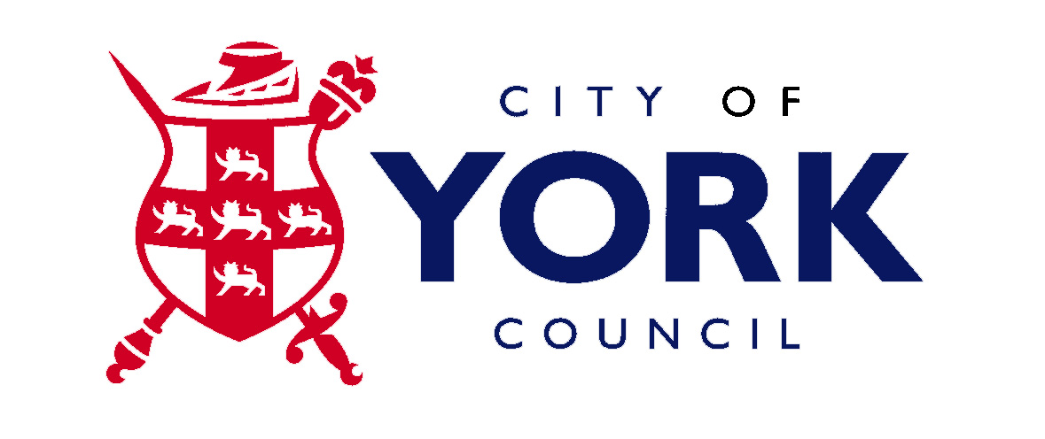



**TEMSS**

**Traveller & Ethnic Minority Support Service**

Annual

**Moving Forward Together Conference 2016**

Celebrating Gypsy, Roma & Traveller Diversity & Culture

