Junkomat

Develop the business logic of a vending machine (Junkomat) with change function. The machine can sell different items, each with its own price. The logic must be exposed via a typed interface, on which your tests should exemplify the functionality. The main function could look like this:
PurchasedDrinkAndChange (DrinkRequest selection, Coin... deposit);
The function returns either the desired drink and possibly the change in the form of coins different value or an error, if e.g. the desired drink is sold out, the amount deposited is too low or the machine can’t provide the appropriate change.
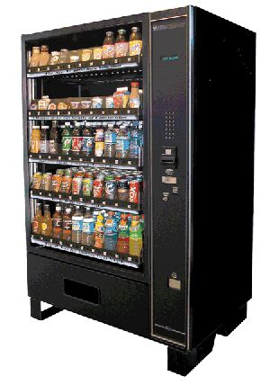
The Junkomat works with the following coins:
- 10 cents, 20 cents, 50 cents
- 1 Euro (= 100 Cent), 2 Euro (= 200 Cent)
For example: If you deposit a 2-euro coin and want to buy a drink for the price of 1.20 euros, the machine gives you back the drink along with 80 cent change in the form of a 50, a 20 and a 10 cent coin.
The stock of goods and coins in the Junkomat is limited, and the API should have functions for filling and emptying the vending machine.
Consider in your design only as much flexibility as it seems to make sense, e.g. the ability to configure different goods and prices for Junkomats placed in different locations, but e.g. not different coin values.
The exercise does not require persisting the current state of the automaton in a database. A transient solution is sufficient.
HOW you implement it is essential. The goal is to design an elegant, easy-to-understand solution that uses - as far as possible - the natural terminology provided. Use a nice coding style, apply OOP principles and make use of Java and the standard APIs, but avoid overburdening your solution. It must remain suple and elegant.
The completeness of the result is secondary. Even a partial solution is welcome, if it’s completed and secured by an automatic test.
For the exercise is a duration of at least two hours, not more than four hours.
Work equipment:
- Eclipse and JUnit, current versions
- A ready-made Java standard project
- Essential libraries from the Apache Commons
- Internet access

