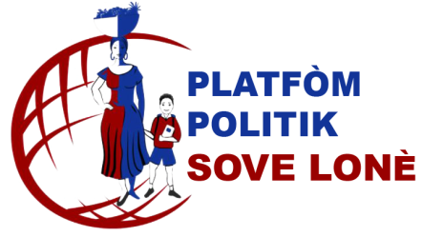
#56, rue Lambert, Pétion-ville, Haiti

sovelone@gmail.com
www.sovelone.ht
PPSL

November 30th 2022
Dear compatriot:
The Haitian community always dreams of a parade on Independence Day. We will have one on January 1st 2023 on Main Street in Flushing New York from 11: 00 am to 4:00 pm. The sponsoring organizations Global Hero Foundation and Sove Lonè invite the cultural organizations, the regional ones, the institutions and the business organizations to register from December 1st to December 8th 2022 to participate in the parade.
With discipline and pride we will raise very high the Haitian flag.
To register call Jean Hervé Charles, at 347-250-2877 or write jeanhcharles@aol.com before December 8th 2021.
Wishing everybody Merry Christmas and Happy New Year 2023
Let’s Sove Lonè with an Haiti “Djanm”

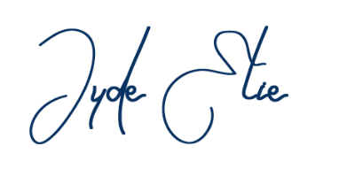
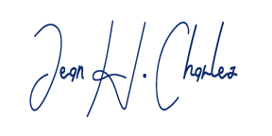

Jude Elie Jean Hervé Charles
President Sove Lonè Vice President Sove Lonè
+1 347-250-2877 / +1 904 480 9137

