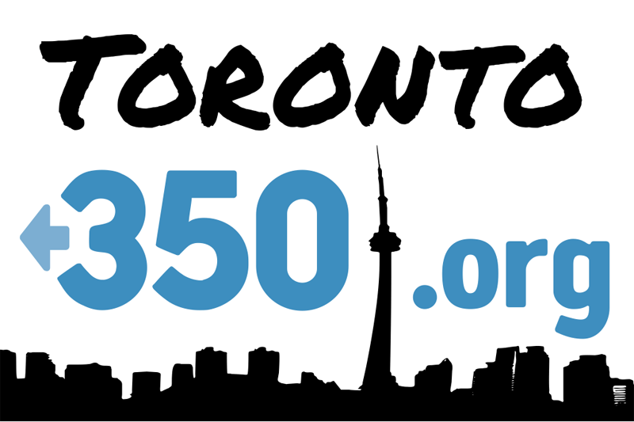
PETITION TO THE PRESIDENT OF THE UNIVERSITY OF TORONTO
CALLING ON THE UNIVERSITY TO DIVEST FROM SHELL
In order to avoid dangerous climate change, the world needs to redirect investment from fossil fuels to alternative forms of energy that are compatible with climate safety.
The University of Toronto is heavily invested in the fossil fuel industry. For example, Shell stock comprises the university's single largest holding of corporate equity, with $9.84 million invested. This represents less than 1% of the university's total stock investment.
Governments and organizations around the world have recognized warming of 2 ̊C as the threshold where climate change will become dangerous. If we want to stay below that limit, we can emit no more than 565 billion tonnes (gigatonnes) of carbon dioxide. Global fossil reserves contain 2,795 gigatonnes of carbon dioxide, more than enough to drive humanity off the 2 ̊C trajectory.
Shell is an especially problematic company due to its long record of environmental and human rights abuses, as well as its involvement in a number of high-risk ventures, including the expansion of the Alberta oil sands and arctic drilling. Shell is thus a major industrial player in the production of fossil fuels contributing to the problem of climate change. Also, the value of Shell stock depends on the assumption that all of these fuels will be burned. In a world where fossil fuel consumption must be limited, this stock is significantly over-valued.
Investment in fossil fuel corporations such as Shell drives the consumption of fossil fuel reserves, which MUST remain underground in order to avoid dangerous climate change.
THEREFORE,
We, the undersigned, call upon the university to respond to the seriousness of climate change by making a statement of principle immediately affirming their intention to divest from fossil fuel companies, to immediately stop investing new money in the industry, and to spend the next five years winding down existing holdings. We also call on the university to divest from Shell by the end of 2013.

PRINT NAME | POST CODE | EMAIL  Please write clearly | OPT OUT?  Monthly email

