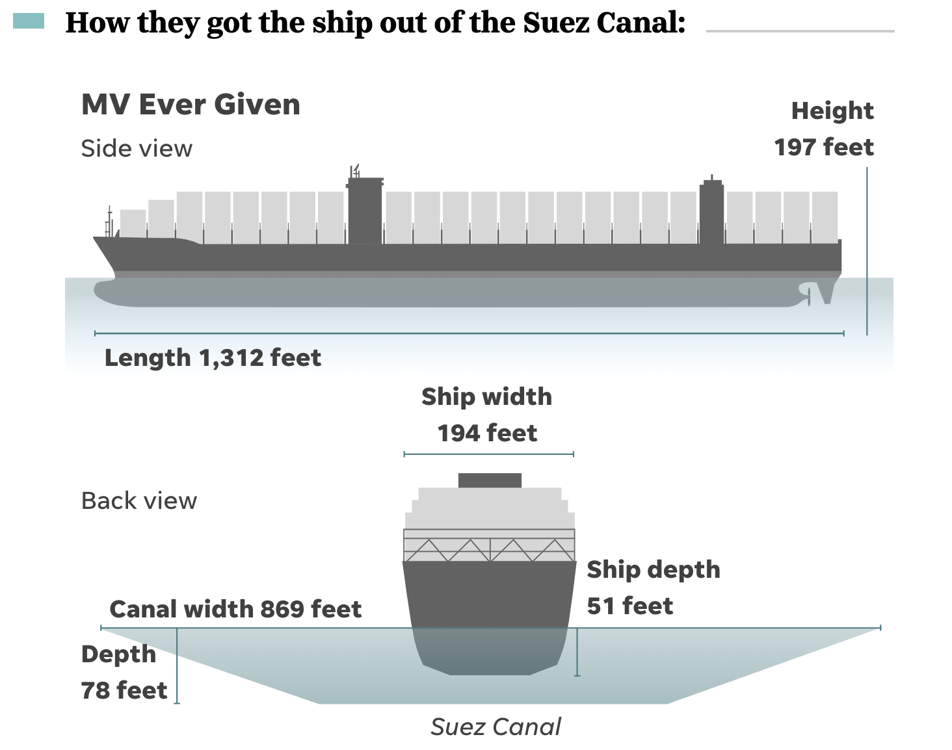

Although the "saga" of the stuck Mega Container vessel, MV Ever Given, has been resolved, at least as far as reopening the Suez Canal is concerned, I thought this would have made a nice geometry problem. Actually, what prompted me was the fact that, depending on what news source you were looking at, the width of the Suez Canal at the point in question seemed to vary by quite a bit.
I did set up a simple .tns file, super-imposed a few line segments on one of the satellite images, and used it to measure the angle the ship was forming with the canal banks. Knowing the length of the EverGiven and using the sin of the angle, made the rest quite simple.
And for the classes who haven't studied trig. functions, yet, using the Pythagorean Theorem should allow them to get some pretty good estimates for the true width at the site of the accident. Taking accurate measurements and using the scale of the geometry app. will make for a nice challenge for the students.
Talk about "just in time" applications.

https://www.usatoday.com/in-depth/graphics/2021/03/29/ever-given-refloated-and-freed-how-did-they-get-the-ship-out-of-the-suez-canal/7043678002/

