Superimposed Seams

Seams in which Two or More Plies of Fabric are Superimposed on Each Other
Click to Download the Diagram | Seam Class | Needle Count | Typical Uses and Stitch Types
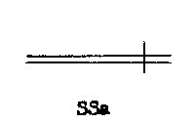 | SSa | 1 or 2 | Seaming two plies using 100cl, 300cl, 400cl, or 500cl
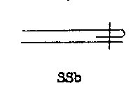 | SSb | 1 or 2 | Seaming two plies with one edge folded using 100cl, 300cl, or 400cl
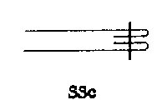 | SSc | 1 or 2 | Seaming two plies with a finished edge 100cl, 300cl, or 400cl
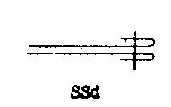 | SSd | 1 or 2 | Seaming two plies using 100cl, 300cl, or 400cl
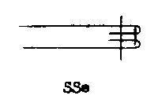 | SSe | 2 | Seaming two plies with finished edge in two steps using 100cl, 300cl, or 400cl
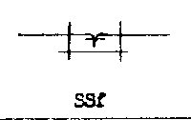 | SSf | 2 | Bottom Coverstitch Seaming on two plies using 406cl, 502cl, or 506cl
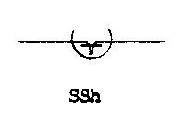 | SSh | 2 | Bottom Coverstitch Seaming on two plies 100cl, 300cl,or 400cl AND 103cl
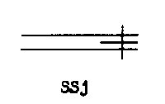 | SSj | 1 or 2 | Seaming three plies Raw edge finish where center ply may be ribbon using 100cl, 300cl, or 400cl
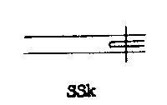 | SSk | 1 | Seaming three plies where center ply may be folded edge finish using 100cl, 300cl, or 400cl
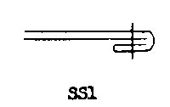 | SSl | 1 | Clean finish Seaming of two plies using 100cl, 300cl, or 400cl
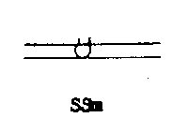 | SSm | 2 | Joining two Plies using 100cl, 300cl, or 400cl
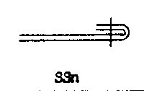 | SSn | 1 or 2 | Clean finish Seaming of two plies folded to one face using 100cl, 300cl, or 400cl
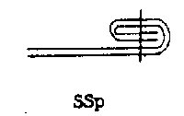 | SSp | 1 or 2 | Seaming two plies using 100cl, 300cl, or 400cl
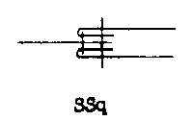 | SSq | 2 | Seaming three plies using 100cl, 300cl, or 400cl
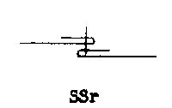 | SSr | 1 | Seaming two plies using 100cl, 300cl, or 400cl
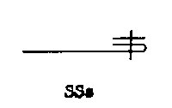 | SSs | 1 or 2 | Seaming two plies using 100cl, 300cl, or 400cl
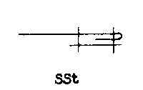 | SSt | 2 | Seaming two plies using 100cl, 300cl, or 400cl
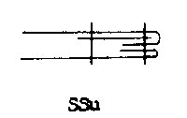 | SSu | 2 | Clean finish Edge Seam with Third ply as tape using 100cl, 300cl, or 400cl
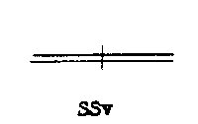 | SSv | 1 or 2 | Internal Seaming of two plies using 100cl, 300cl, or 400cl
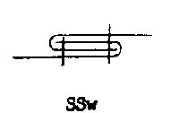 | SSw | 2 | Seaming two plies with edges folded in two passes using 100cl, 300cl, or 400cl
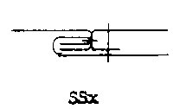 | SSx | 2 | Seaming three plies in two passes using 100cl, 300cl, or 400cl
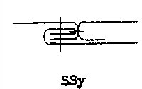 | SSy | 2 | Seaming three plies in two passes using 100cl, 300cl, or 400cl
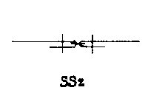 | SSz | 3 | Butt Seaming two plies in two or three passes using 100cl, 300cl, or 400cl
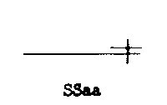 | SSaa | 1 or 2 | Seaming two plies using 100cl, 300cl, or 400cl
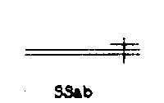 | SSab | 1 or 2 | Seaming multiple plies using 100cl, 300cl, or 400cl
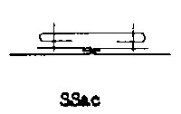 | SSac | 2 | Seaming multiple plies using 100cl, 300cl, or 400cl
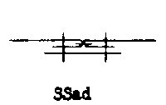 | SSad | 2 | Seaming multiple plies using 100cl, 300cl, or 400cl
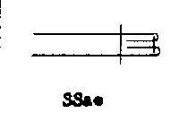 | SSae | 2 | Seaming two plies with using 100cl, 300cl, or 400cl  known as "French Seam"
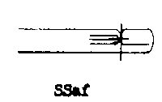 | SSaf | 2 | Seaming multiple plies using 100cl, 300cl, or 400cl
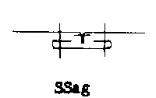 | SSag | 3 | Seaming multiple plies using 100cl, 300cl, or 400cl
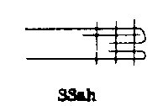 | SSah | 3 | Seaming multiple plies using 100cl, 300cl, or 400cl
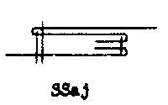 | SSaj | 3 | Seaming multiple plies using 100cl, 300cl, or 400cl
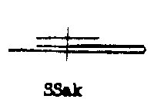 | SSak | 1 or 2 | Seaming multiple plies using 100cl, 300cl, or 400cl
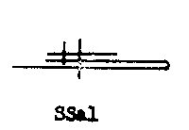 | SSal | 1 or 2 | Seaming multiple plies using 100cl, 300cl, or 400cl
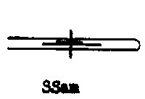 | SSam | 1 or 2 | Seaming multiple plies using 100cl, 300cl, or 400cl
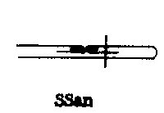 | SSan | 1 or 2 | Seaming multiple plies using 100cl, 300cl, or 400cl
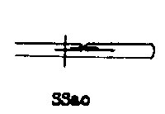 | SSao | 1 or 2 | Seaming multiple plies using 100cl, 300cl, or 400cl
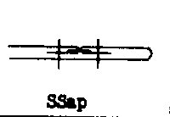 | SSap | 1 or 2 | Seaming multiple plies using 100cl, 300cl, or 400cl
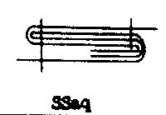 | SSaq | 1 or 2 | Seaming multiple plies using 100cl, 300cl, or 400cl
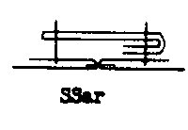 | SSar | 1 or 2 | Seaming multiple plies using 100cl, 300cl, or 400cl
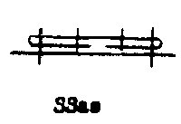 | SSas | 1 or 2 | Seaming multiple plies using 100cl, 300cl, or 400cl
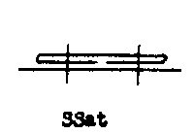 | SSat | 1 or 2 | Seaming multiple plies using 100cl, 300cl, or 400cl
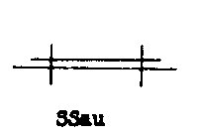 | SSau | 1 or 2 | Seaming multiple plies using 100cl, 300cl, or 400cl
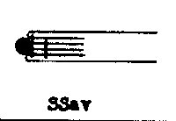 | SSav | 1 or 2 | Seaming multiple plies using 100cl, 300cl, or 400cl
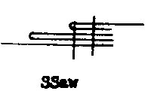 | SSaw | 1 or 2 | Seaming multiple plies using 100cl, 300cl, or 400cl
 | SSax | 1 or 2 | Seaming multiple plies using 100cl, 300cl, or 400cl
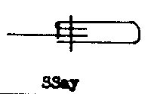 | SSay | 1 or 2 | Seaming multiple plies using 100cl, 300cl, or 400cl
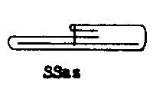 | SSaz | 1 or 2 | Seaming multiple plies using 100cl, 300cl, or 400cl
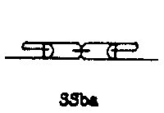 | SSba | 1 or 2 | Seaming multiple plies using 100cl, 300cl, or 400cl
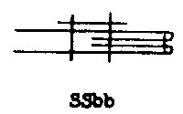 | SSbb | 1 or 2 | Seaming multiple plies using 100cl, 300cl, or 400cl
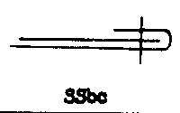 | SSbc | 1 or 2 | Seaming multiple plies using 100cl, 300cl, or 400cl
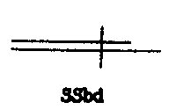 | SSbd | 1 or 2 | Seaming multiple plies using 100cl, 300cl, or 400cl
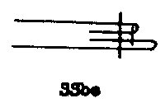 | SSbe | 1 or 2 | Seaming multiple plies using 100cl, 300cl, or 400cl
 | SSbf | 1 or 2 | Seaming multiple plies using 100cl, 300cl, or 400cl
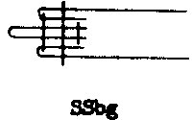 | SSbg | 1 or 2 | Seaming multiple plies using 100cl, 300cl, or 400cl
 | SSbh | 1 or 2 | Seaming multiple plies using 100cl, 300cl, or 400cl

Lapped Seams

Seams in which Two or More Plies of Fabric are Superimposed and/or Folded on Each Other
Click to Download the Diagram | Seam Class | Needle Count | Typical Uses and Stitch Types
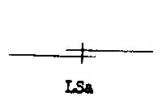 | LSa | 1 or 2 | Overlap seam of two plies at edges using 100cl, 300cl, or 400cl
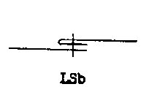 | LSb | 1 or 2 | Overlap seam of two plies with one edge folded using 100cl, 300cl, or 400cl
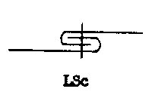 | LSc | 1, 2 or 3 | 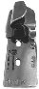  Flat Felled Seam using 100cl, 300cl, or 400cl  Attachment
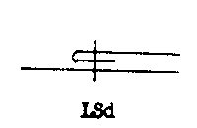 | LSd | 1 or 2 | Seaming of two plies where one ply is folded and set in the middle of the other using 100cl, 300cl, or 400cl
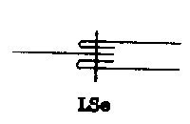 | LSe | 1 or 2 | Seaming Three plies with finished edges where two plies lay in one direction (Yoke stitch) using 100cl, 300cl, or 400cl
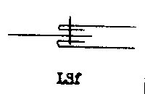 | LSf | 1 | Seaming Three plies with finished edges where two plies lay in one direction (Yoke stitch) using 100cl, 300cl, or 400cl
 | LSg | 2 | Seaming three plies with finished edges (Shirt Placket) 100cl, 300cl,or 400cl
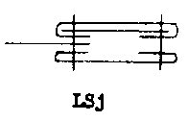 | LSj | 2 | Seaming three plies with finished edges and interfacing (Shirt Placket) 100cl, 300cl,or 400cl
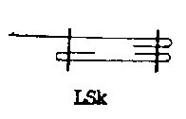 | LSk | 2 | Seaming two plies with finished edges (simple Shirt Placket) 100cl, 300cl,or 400cl
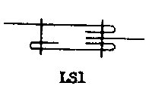 | LSl | 2 | Seaming three plies with finished edges 100cl, 300cl, or 400cl
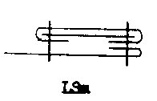 | LSm | 2 | Seaming two plies with finished edges and interfacing (simple Shirt Placket) using 100cl, 300cl, or 400cl
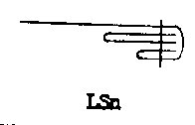 | LSn | 1 or 2 | Two plies clean finished folded and bound using 100cl, 300cl, or 400cl
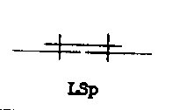 | LSp | 2 | Seaming three plies using 100cl, 300cl, or 400cl
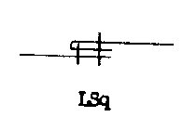 | LSq | 2 | Seaming two plies using 100cl, 300cl, or 400cl
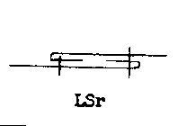 | LSr | 2 | Seaming two plies using 100cl, 300cl, or 400cl
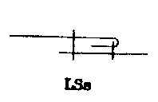 | LSs | 2 | Seaming two plies in two steps using 100cl, 300cl, or 400cl
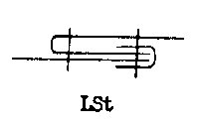 | LSt | 2 | Seaming three plies using 100cl, 300cl, or 400cl
 | ?LSu | 2 | Seaming three plies where one binds the other two behind the face 100cl, 300cl, or 400cl
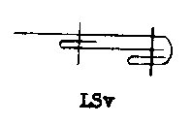 | LSv | 1 or 2 | Seaming two plies where face binds the second ply using 100cl, 300cl, or 400cl
 | LSw | 4 | Seaming four plies where one ply wraps around two facing plies, bound to another ply using 100cl, 300cl, or 400cl
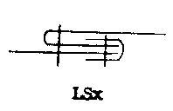 | LSx | 2 | Seaming three plies with raw edges in two passes using 100cl, 300cl, or 400cl
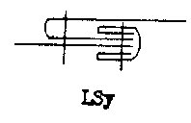 | LSy | 2 | Seaming three plies with clean finish edges in two passes using 100cl, 300cl, or 400cl
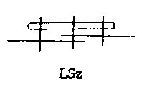 | LSz | 3 | Seaming three plies using 100cl, 300cl, or 400cl
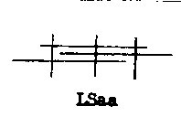 | LSaa | 3 | Seaming three plies with raw edges using 100cl, 300cl, or 400cl
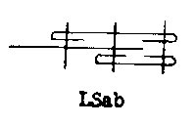 | LSab | 3 | Seaming three plies with clean finish using 100cl, 300cl, or 400cl
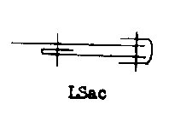 | LSac | 2 | Seaming three plies bound with raw edges using 100cl, 300cl, or 400cl
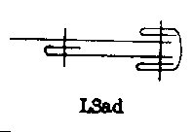 | LSad | 2 | Seaming three plies bound with raw edges using 100cl, 300cl, or 400cl
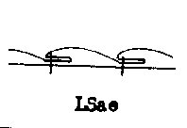 | LSae | 2 | Seaming two plies in two passes using 100cl, 300cl, or 400cl  "Stitched Pleat"
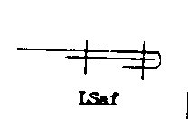 | LSaf | 2 | Seaming two plies using 100cl, 300cl, or 400cl
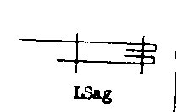 | LSag | 2 | Seaming two plies clean finish using 100cl, 300cl, or 400cl
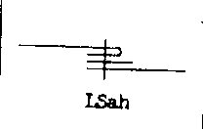 | LSah | 1 or 2 | Seaming three plies using 100cl, 300cl, or 400cl
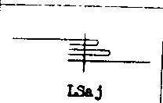 | LSaj | 1 or 2 | Seaming three plies clean finish using 100cl, 300cl, or 400cl
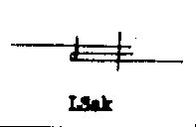 | LSak | 2 | Seaming two plies in two passes using 100cl, 300cl, or 400cl
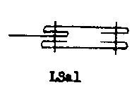 | LSal | 2 | Seaming two plies as a placket using 100cl, 300cl, or 400cl
 | LSam | 2 | Seaming three plies as a placket with interfacing using 100cl, 300cl, or 400cl
 | LSan | 2 | Seaming two plies as a placket with interfacing using 100cl, 300cl, or 400cl
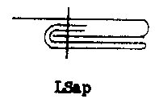 | LSap | 1 or 2 | Seaming two plies clean finish using 100cl, 300cl, or 400cl
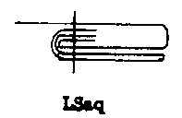 | LSaq | 1 or 2 | Seaming two plies clean finish using 100cl, 300cl, or 400cl
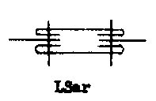 | LSar | 1 or 2 | Seaming four plies using 100cl, 300cl, or 400cl
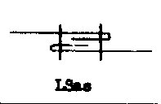 | LSas | 2 | Seaming two plies using 100cl, 300cl, or 400cl
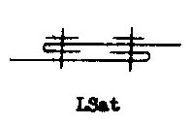 | LSat | 2 | Seaming two plies with seam tape using 100cl, 300cl, or 400cl
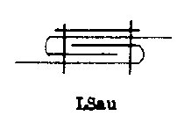 | LSau | 2 | Seaming three plies using 100cl, 300cl, or 400cl
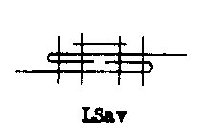 | LSav | 4 | Seaming three plies using 100cl, 300cl, or 400cl
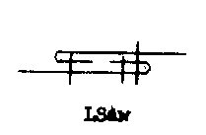 | LSaw | 3 | Seaming two plies in three passes using 100cl, 300cl, or 400cl
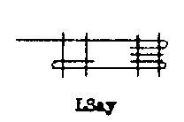 | LSay | 4 | Seaming three plies using 100cl, 300cl, or 400cl
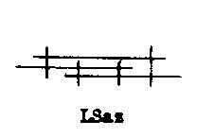 | LSaz | 4 | Seaming three plies with raw edges using 100cl, 300cl, or 400cl
 | LSbb | 4 | Seaming three plies in two passes using 100cl, 300cl, or 400cl
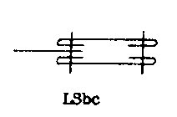 | LSbc | 2 | Seaming three plies using 100cl, 300cl, or 400cl
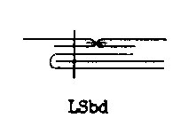 | LSbd | 2 | Seaming four plies in two passes using 100cl, 300cl, or 400cl
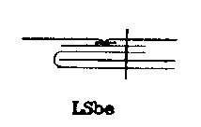 | LSbe | 2 | Seaming four plies in two passes using 100cl, 300cl, or 400cl
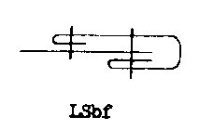 | LSbf | 2 | Seaming two plies clean finish using 100cl, 300cl, or 400cl
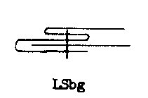 | LSbg | 1 or 2 | Seaming two plies using 100cl, 300cl, or 400cl
 | SSbh | 1 or 2 | Seaming three plies using 100cl, 300cl, or 400cl
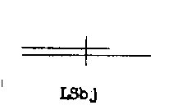 | LSbj | 1 or 2 | Seaming two plies using 100cl, 300cl, or 400cl
 | LSbk | 2 | Seaming two plies using 100cl, 300cl, or 400cl
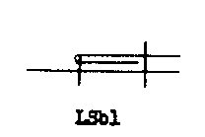 | LSbl | 2 | Seaming two plies in two passes using 100cl, 300cl, or 400cl
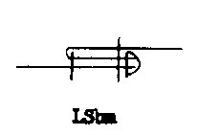 | LSbm | 3 | Seaming two plies in three passes using two of 100cl, 300cl,  or 400cl and one 500cl stitch  Sometimes known as "mock felling"
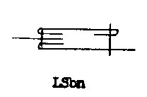 | LSbn | 2 | Seaming three plies in two passes using 100cl, 300cl, or 400cl
 | LSbo | 3 | Seaming two plies in two passes using 100cl, 300cl, or 400cl
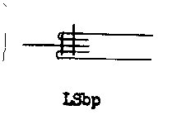 | LSbp | 2 | Seaming three plies in two passes using 100cl, 300cl, or 400cl
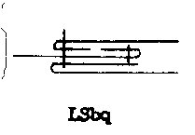 | LSbq | 2 | Seaming three plies in two passes using 100cl, 300cl, or 400cl
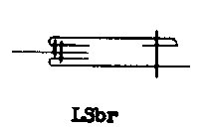 | LSbr | 3 | Seaming three plies in three passes using 100cl, 300cl, or 400cl
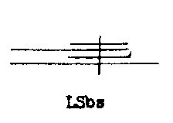 | LSbs | 1 or 2 | Seaming four plies with raw edges using 100cl, 300cl, or 400cl
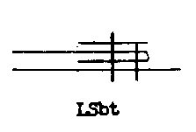 | LSbt | 2 | Seaming three plies in two passes using 100cl, 300cl, or 400cl
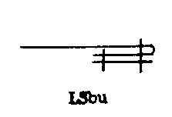 | LSbu | 2 | Seaming two plies using 100cl, 300cl, or 400cl
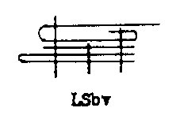 | LSbv | 3 | Seaming three plies in three passes using 100cl, 300cl, or 400cl
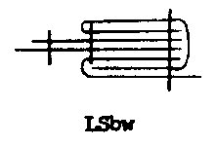 | LSbw | 3 | Seaming four plies in three passes using 100cl, 300cl, or 400cl
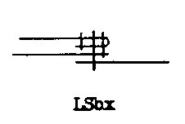 | LSbx | 3 | Seaming three plies in three passes using 100cl, 300cl, or 400cl
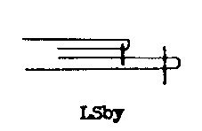 | LSby | 2 | Seaming two plies using 100cl, 300cl, or 400cl
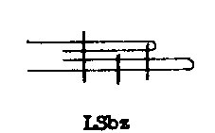 | LSbz | 3 | Seaming two plies in three passes using 100cl, 300cl, or 400cl
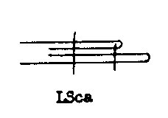 | LSca | 2 | Seaming two plies in two passes using 100cl, 300cl, or 400cl
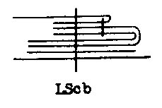 | LScb | 2 | Seaming five plies in two passes using 100cl, 300cl, or 400cl
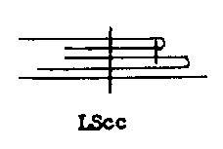 | LScc | 2 | Seaming three plies in two passes using 100cl, 300cl, or 400cl
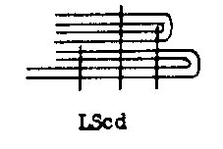 | LScd | 3 | Seaming four plies in three passes using 100cl, 300cl, or 400cl
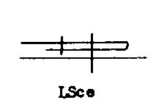 | LSce | 2 | Seaming two plies in two passes using 100cl, 300cl, or 400cl
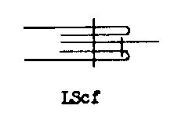 | LScf | 2 | Seaming three plies in two passes using 100cl, 300cl, or 400cl
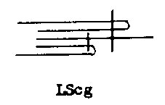 | LScg | 2 | Seaming three plies in two passes using 100cl, 300cl, or 400cl
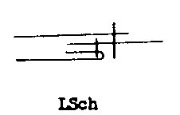 | LSch | 2 | Seaming three plies in two passes using 100cl, 300cl, or 400cl
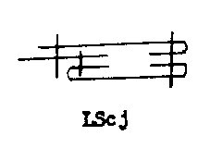 | LScj | 3 | Seaming three plies in three passes using 100cl, 300cl, or 400cl
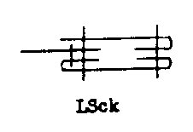 | LSck | 3 | Seaming three plies in two passes using 100cl, 300cl, or 400cl
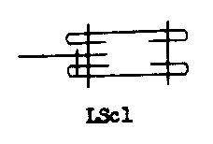 | LScl | 3 | Seaming three plies in two passes using 100cl, 300cl, or 400cl
 | LScm | 3 | Seaming three plies in two passes using 100cl, 300cl, or 400cl
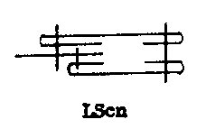 | LScn | 3 | Seaming three plies in two or three passes using 100cl, 300cl, or 400cl
 | LSco | 4 | Seaming three plies in three passes using 100cl, 300cl, or 400cl
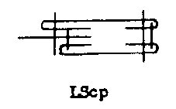 | LScp | 4 | Seaming three plies in three passes using 100cl, 300cl, or 400cl
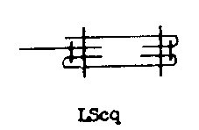 | LScq | 4 | Seaming three plies in three passes using 100cl, 300cl, or 400cl
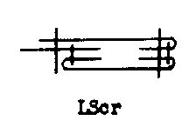 | LScr | 4 | Seaming three plies in three passes using 100cl, 300cl, or 400cl
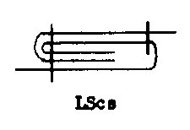 | LScs | 2 | Seaming two plies in two passes using 100cl, 300cl, or 400cl
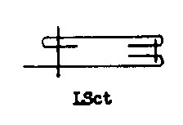 | LSct | 2 | Seaming two plies in two passes using 100cl, 300cl, or 400cl
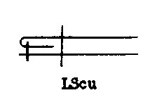 | LScu | 2 | Seaming two plies in two passes using 100cl, 300cl, or 400cl
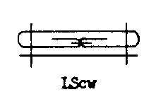 | LScw | 3 | Seaming two plies in two passes using 100cl, 300cl, or 400cl
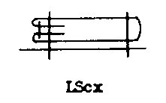 | LScx | 3 | Seaming three plies in two passes using 100cl, 300cl, or 400cl
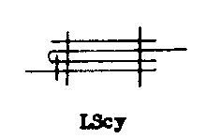 | LScy | 3 | Seaming three plies in two passes using 100cl, 300cl, or 400cl
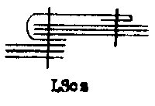 | LScz | 2 | Seaming seven plies in two passes using 100cl, 300cl, or 400cl
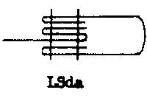 | LSda | 2 | Seaming two plies using 100cl, 300cl, or 400cl
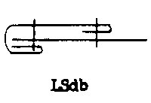 | LSdb | 2 | Seaming two plies in two passes using 100cl, 300cl, or 400cl
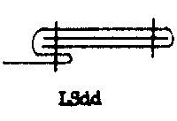 | LSdd | 2 | Seaming three plies using 100cl, 300cl, or 400cl
 | LSdo | 3 | Seaming two plies in two passes using 100cl, 300cl, or 400cl

Bound Seams

Seams in which One Ply of Fabric is sewn over the edge of Two or More Plies of Fabric
Right Click and select  Save to Download  the Diagram | Seam Class | Needle Count | Typical Uses and Stitch Types
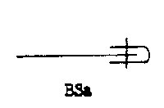 | BSa | 1 or 2 | Binding over the edge of one ply using 100cl, 300cl, or 400cl
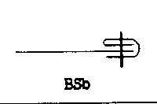 | BSb | 1 or 2 | Binding over the edge of one ply using 100cl, 300cl, or 400cl
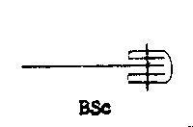 | BSc | 1 or 2 | Binding over the edge of one ply using 100cl, 300cl, or 400cl
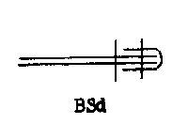 | SSd | 2 | Binding over the edge of two plies using 100cl, 300cl, or 400cl
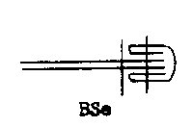 | BSe | 2 | Binding over the edge of two plies using 100cl, 300cl, or 400cl
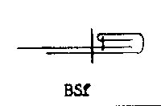 | BSf | 2 | Binding over the edge of one ply using 100cl, 300cl, or 400cl
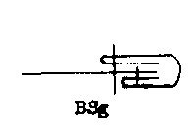 | BSg | 2 | Binding over the edge of one ply using 100cl, 300cl, or 400cl
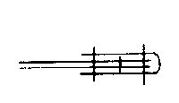 | BSh | 3 | Binding over the edge of two plies using 100cl, 300cl, or 400cl
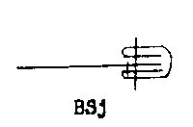 | BSj | 2 | Binding over the edge of one ply using 100cl, 300cl, or 400cl
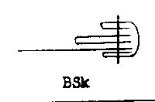 | BSk | 1 or 2 | Binding over the edge of one ply using 100cl, 300cl, or 400cl
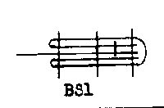 | BSl | 4 | Binding over the edge of one ply using 100cl, 300cl, or 400cl
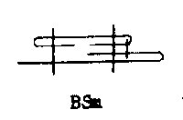 | BSm | 3 | Binding over the edge of one ply using 100cl, 300cl, or 400cl
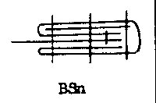 | SSn | 4 | Binding over the edge of one ply using 100cl, 300cl, or 400cl
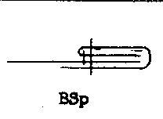 | BSp | 2 | Binding over the edge of one ply using 100cl, 300cl, or 400cl
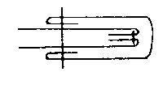 | BSq | 3 | Binding over the edge of two plies using 100cl, 300cl, or 400cl
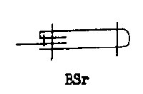 | BSr | 3 | Binding over the edge of one ply using 100cl, 300cl, or 400cl
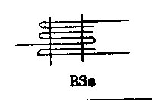 | BSs | 2 | Binding over the edge of one ply using 100cl, 300cl, or 400cl

Flat Seams

Seams in which Two or More Plies of Fabric are Sewn Together at the Edges
Right Click &  Save to Download  the Diagram | Seam Class | Needle Count | Typical Uses and Stitch Types
 | FSa | 4 | Coverstitch Seaming two plies using 606cl, or 607cl
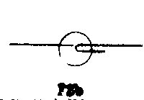 | FSb | 2 | Coverstitch Seaming two plies using 602cl, or 603cl
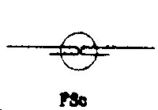 | FSc | 2 | Coverstitch Seaming two plies using 602cl, or 603cl
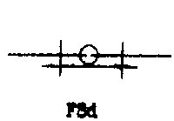 | FSd | 4 | Seaming two plies using 602cl, or 603cl, then 300cl, or 400cl
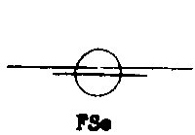 | FSe | 2 | Coverstitch Seaming two plies using 602cl, or 603cl
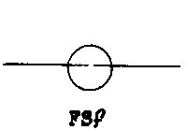 | FSf | 2 | Coverstitch Seaming two plies using 602cl, or 603cl

Edge Finish Stitching

Fabric Edge is Finished with Stitching
Right Click and  Save to Download  the Diagram | Seam Class | Needle Count | Typical Uses and Stitch Types
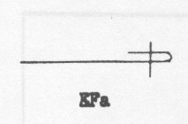 | EFa | 1 or 2 | Finishing one ply using 100cl, 300cl, or 400cl
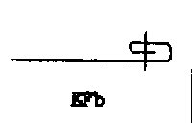 | EFb | 1 or 2 | Finishing one ply using 100cl, 300cl, or 400cl
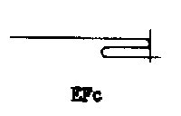 | EFc | 1 | Finishing one ply using 100cl, 300cl, or 400cl
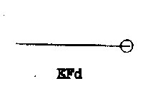 | EFd | 1 or 2 | Finishing one ply using 500cl  "Serging"
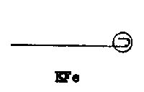 | EFe | 1 or 2 | Finishing one ply using 500cl  "Serging" Variation
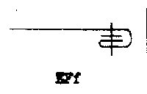 | EFf | 1 or 2 | Finishing one ply using 100cl, 300cl,400cl or 600cl
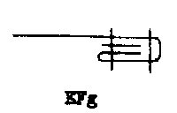 | EFg | 2 | Finishing one ply using 100cl, 300cl, or 400cl
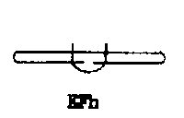 | EFh | 1 or 2 | Finishing one ply using 406cl
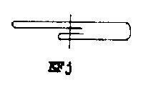 | EFj | 1 or 2 | Finishing one ply using 100cl, 300cl, or 400cl
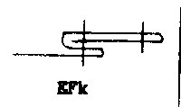 | EFk | 2 | Finishing one ply using 100cl,300cl, or 400cl
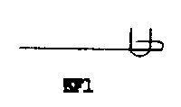 | EFl | 2 | Finishing one ply using 406cl
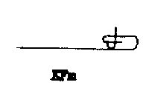 | EFm | 1 | Finishing one ply using 103cl or 306cl  Blindstitch Hem
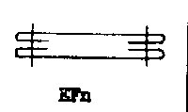 | EFn | 2 | Finishing two plies using 100cl, 300cl, or 400cl  Example; Belt Make
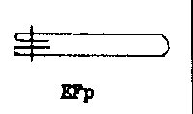 | EFp | 1 or 2 | Finishing one ply using 100cl, 300cl, or 400cl  Example; Belt Make
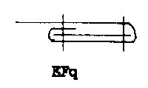 | EFq | 2 | Finishing one ply using 100cl, 300cl, or 400cl  Reinforced Hem with Interlining
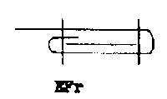 | EFr | 2 | Finishing one ply using 100cl, 300cl, or 400cl  Reinforced Hem with Interlining
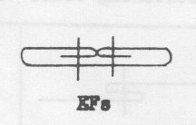 | EFs | 2 | Finishing one ply using 100cl, 300cl, or 400cl  Example; Belt Make
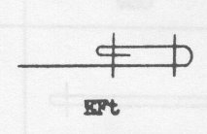 | EFt | 2 | Finishing one ply using 100cl, 300cl, or 400cl
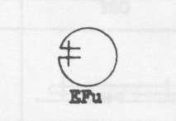 | EFu | 2 | Finishing one ply using 100cl, 300cl, or 400cl  "Spagetti Strap"
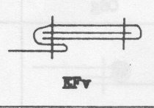 | EFv | 2 | Finishing one ply using 100cl, 300cl, or 400cl
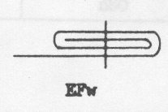 | EFw | 1 or 2 | Finishing one ply using 100cl, 300cl, or 400cl
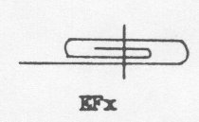 | EFx | 1 or 2 | Finishing one ply using 100cl, 300cl, or 400cl
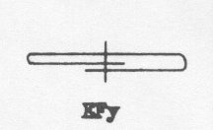 | EFy | 1 or 2 | Finishing one ply using 100cl, 300cl, or 400cl
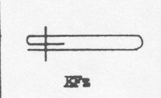 | EFz | 1 or 2 | Finishing one ply using 100cl, 300cl, or 400cl
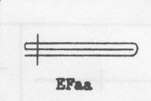 | EFaa | 1 or 2 | Finishing one ply using 100cl, 300cl, or 400cl
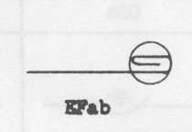 | EFab | 2 | Finishing one ply using 602cl
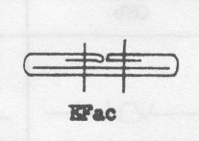 | EFac | 1 or 2 | Finishing one ply using 100cl, 300cl, or 400cl  Make Belt
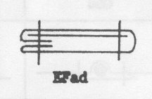 | EFad | 2 | Finishing one ply using 100cl, 300cl, or 400cl  Make Belt
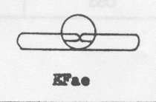 | EFae | 1 or 2 | Finishing one ply using 500cl
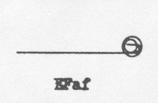 | EFaf | 3 | Finishing one ply using 500cl, then 602cl
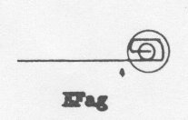 | EFag | 3 | Finishing one ply using 500cl, then 602cl
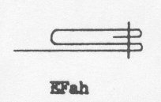 | EFah | 1 or 2 | Finishing one ply using 100cl, 300cl, or 400cl

Ornamental Stitching

Ornamental Stitching is Stitches Sewn on One Ply of Fabric
Right Click &  Save to Download  the Diagram | Seam Class | Needle Count | Typical Uses and Stitch Types
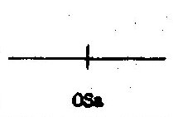 | OSa | 1 to ? | Decorative Stitching using 100cl, 300cl, 400cl or 600cl
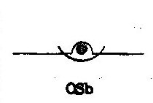 | OSb | 1 or 2 | Decorative Stitching using cording  Sometimes called "Pin-tuck" with Cording  Using 304cl or 406cl stitch
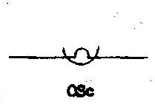 | OSc | 1 or 2 | Decorative Stitching sometimes called "Pin-tuck"  Using 304cl or 406cl stitch
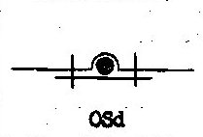 | OSd | 2 | Tuck stitching with Cording and Backer  using dual 101cl, 301cl, or 401cl stitch
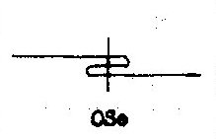 | OSe | 1 | Side Tuck Stitching using 101cl, 301cl, or 401cl stitch
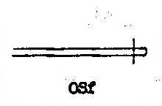 | OSf | 2 | "Stitch-Crease" stitching using 301cl stitch
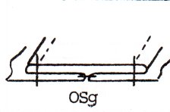 | OSg | 2 | Self-Stripe Trim using 100cl, 300cl, or 400cl stitch
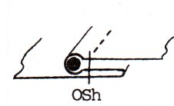 | OSh | 2 | Piping Trim using 100cl, 300cl, or 400cl stitch

