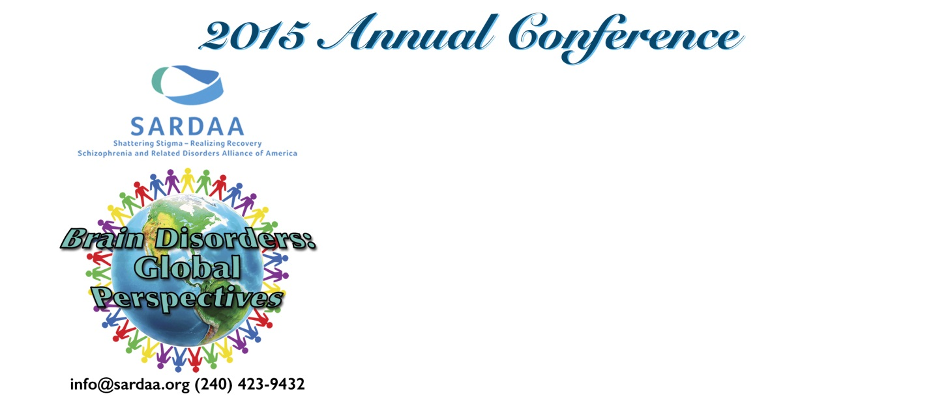
Schizophrenia, it’s a loaded word that many people don’t fully understand. Shattering that stigma and helping those challenged with schizophrenia and other psychotic brain disorders, and their families, is what SARDAA does. Schizophrenia and Related Disorders Alliance of America, or SARDAA, is hosting a conference, workshop and benefit

Saturday, October 10th
JW Marriott Houston (by Galleria)
CEU’s for Social Workers, counselors and psychologists will be provided by
MHA of Greater Houston

Emcees
Nakia Cooper, of KPRC2 and NewsWithAttitude.com
Guy Michaels, of KPVU 91.3 FM Guy Michaels Morning Show

SARDAA’s Conference & Lunch 11:30. Experts address challenges faced daily by individuals, families, professionals, the criminal justice system and policy makers, when psychiatric illness is involved.
“Hidden Pictures” by Dr. Delaney Ruston
First Episode Psychosis by Dr. Alex Kopelowicz
Steps to Helping a Loved One Seek Counseling by Dr. Mark Komrad
A Mother’s Message: Overcoming Life’s Obstacles by Shari Strong
Hope and Strength by Molly Biffle
Treatment vs Incarceration by Doris Fuller
Ask The Experts Panel: Diagnosed Individuals, Family & Psychiatrists
Workshop: Schizophrenia-related peer support groups

SARDAA’s Gala “International Jazz on My Mind” 7:00 PM Dinner, Incredible Auction and Contemporary Jazz artists Tom Braxton, Larry Braggs and Vel Lewis.
“Mental Illness on Trial” Doris Fuller

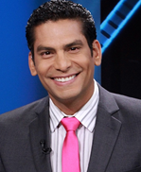
Ismael Cala, CNN en Espanol celebrity anchor, is the evening Keynote Address
“Turning Fear into Power”

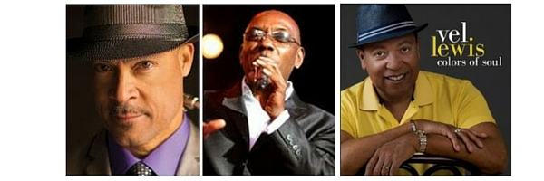
You can purchase tickets by clicking here: Purchase Tickets Proceeds go to education, support and resources for people affected by schizophrenia - related brain disorders.

