What is System Science?
A week-long Conversation was held 8-13 April in Linz, Austria, sponsored by the IFSR to discuss the nature of system science. This discussion was led by Gary Smith, co-led by Jennifer Makar, with participation by Gary Metcalf, George Mobus, Swaminathan Natarajan, and Hillary Sillitto. Below is a short report on this event. A more complete description will be provided in November in the IFSR Conversation Proceedings. For information about Conversations in general, see http://www.ifsr.org/index.php/ifsr-conversations/what-is-an-ifsr-conversation/.

Why this conversation?
Multiple perspectives, patterns in works of thought and practice from diverse sources and backgrounds indicated the potential of an emerging coherence for system science. The motivation for the conversation was to determine if these various threads could somehow be woven together into a more integrated understanding, and to make progress towards the unification of systems science as a coherent systematic enterprise. In the preparation for the conversation, we asked the question, ‘what is system science’ in two round tables, one via video conference and another at the INCOSE International Workshop. Currently, systems science is analogous to where chemistry was before the Periodic Table of the elements: many phenomena have been described, many of them understood as individual concepts and theories, but this knowledge is not yet integrated around a single foundational structure. We have developed and applied some very effective systemic methodologies (e.g. SSM, SD, VSM, architectural frameworks and others) in several fields like systems engineering (INCOSE), OR, OD, IE, and research. But without a unifying framework that everyone can refer to for understanding and communication, our ability to teach, develop coherently and practice system science is hindered. Indeed, our credibility suffers in front of our stakeholders and we lack sufficient coherence to address the global systemic issues confronting humankind and our future on this planet..

The essential journey of the conversation
On the first day of the conversation we passionately, exhaustively, thoroughly, interrogated the situation of system science from many perspectives. A set of questions arose that we wanted to try and answer:
- What is Systems Science?
- How can we make a system science that is useful (for doing stuff and learning stuff)?
- Is system science a meta science?
- What are the questions that system science has to answer?
- How do we recognise systems and why?
- What do we know about different types of systems and their “pathologies?”
- How do we choose appropriate system types to solve a problem?
- What do we know and need to know about transforming systems?
- Can we really define a systems science that is applicable to everything?
- How can we organise the body of knowledge of system science?
- What is system stuff and how can this be organised?
- How can we develop the body of knowledge of system science?
- What tools can enable our systems science practice?
- What explanations and observations about the nature of the universe emerge?
- Can system science help to resolve the semantic mismatch/confusion/ambiguity between what is real and what we think is real in our models?
- Can we use system science to get to grips with uncertainty and the fundamental limits to observational accuracy and precision?
- How can we know that our models are sufficiently complete?
On the second day, after letting our subconscious mull over the questions, we started off the day with each of the team describing visions for what system science might look like.
What emerged, using the analogy with chemistry, was a recognition that the current systems science literature in most cases does not clearly distinguish between the fundamental ingredients of all systems (think electrons, protons and neutrons), properties of all systems (think properties of atoms and elements due to the electron orbitals) and properties that can be synthesised with combinations of different “elemental types” of system – think compounds, crystals, alloys, etc. Most Systems Science literature also does not clearly distinguish between “how people perceive and interact with systems” ie. systemic practice, and the fundamental “properties of systems in the natural world” ie. systemic foundations. (Robert Rosen’s book Anticipatory Systems is a notable exception.) We thus envisaged the possibility to organise system science knowledge within the following structure.
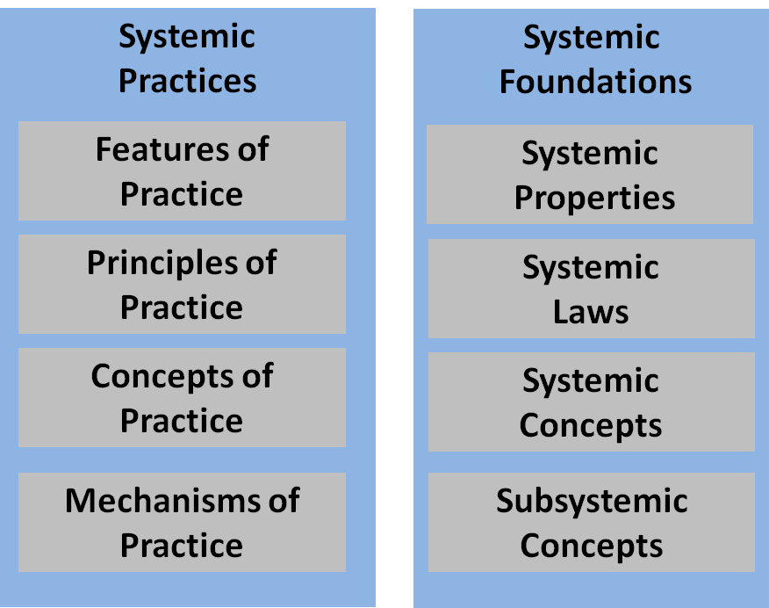

As we considered the task of allocating system concepts to the left or right side, the question which then quickly arose was “how do you know what is real and what is simply how we see the world?”, then following this, “does it really matter as long as it is useful?”. We spent quite some time thinking about these questions and many others (we had moved from structuring/organising activities and re-entered the philosophical phase of our process).

Revisiting the definition of science helped us to escape this philosophical dilemma - “Science is a systematic enterprise that builds and organizes knowledge in the form of testable explanations and predictions about the universe”. So as we attempted to systematically determine how we would logically decide where to tentatively place system concepts and knowledge we began to conceive of thought experiments to help us. We used and adapted these ‘emergent rules of placement’ through the experience of allocation. It was a mentally very challenging and exhausting task but also very thought provoking as it brought to light the variety of ways (not immediately obvious), that we viewed the world, influenced by the diversity in our scientific, professional and cultural backgrounds.

As a source of material for experimentation using the framework, we were aware that the “Active and Healthy Aging” Linz team was using system isomorphies in their big picture conceptualisation, so we borrowed their board for a while and noted down all of the isomorphies they had used. We placed these alongside other concepts and theories of systemic knowledge in the emerging framework. 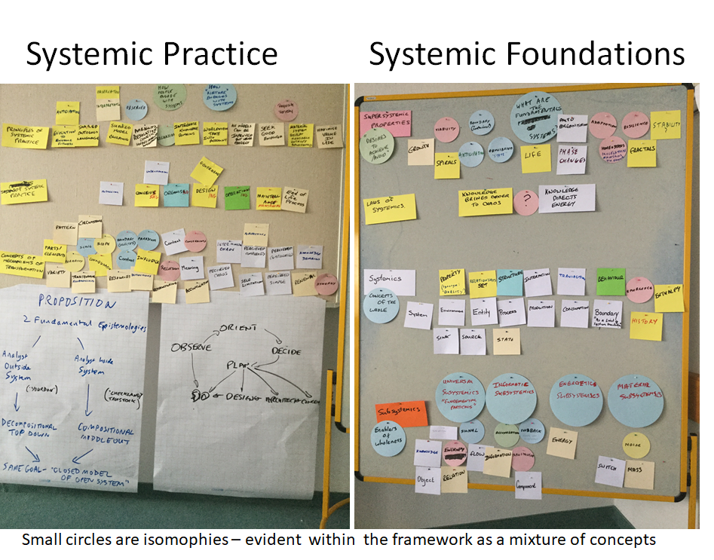
Our intent was not to be exhaustive (or with complete consensus due to time) but to see if existing systems science knowledge could usefully be organised in this sort of structure. We concluded that it could, and that such a structure offers promise in accommodating the wealth of knowledge and viewpoints found in the system science community. Also, using the notion that “Systemness” might be a fundamental organising principle of nature, we theorised that a system is a persistent region of low entropy (= organisation) in physical or conceptual space-time. Systemness, being the phenomenon that allows regions of organisation in the material world to exist in a universe that is cooling.

Development work continues with a candidate integrative framework and of a stakeholder map of systems people, research and development initiatives and organisations, these will progressively be opened up to the system science community for contribution, utilisation and testing. If we are to bring about a recognised, respected and practiced system science then we will need to bring the community together as a systematic enterprise to build and organize our systems knowledge in the form of testable explanations and predictions about the universe.

