YOUTH ARTS PROGRAMME

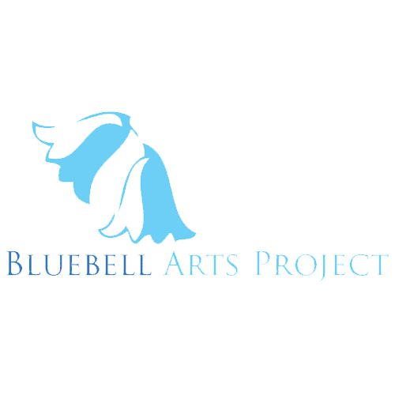
BLUEBELL ARTS @ THE GASYARD CENTRE , 128 Lecky Road, Brandywell, Derry BT48 6NP
PH: (028)71162471/71162466
Email: bluebellartsproject@hotmail.com

 | MONDAY | TUESDAY | WEDNESDAY | THURSDAY | FRIDAY | SATURDAY | STARTS
Visual Arts (Youth) |  |  |  | 7-9pm |  |  | 14.11.19
Music Production/DJ Skills (Youth) |  | 6 -8pm |  |  |  |  | 12.11.19
Film & Editing (Youth) |  |  |  | 6 -8pm |  |  | 21.11.19
Play Rehearsals | 6 -8 pm |  |  |  | 1-3pm | 12 – 2pm | ongoing
Performance & Drama (Youth) | 7 -9 pm |  |  |  |  |  | 18.11.19
Creative Writing (Youth) |  | 6-8pm |  |  |  |  | 12.11.19
ETA Workshops |  |  |  |  |  | 11am – 2pm | Contact Frank
ETA Masterclasses |  |  |  |  |  | 10am -3pm | Contact  Frank
Flip It Workshops | 10-4pm | 10 -4pm | 10 -12 noon  1 -4pm | 3 -6pm |  |  | Contact Frank
Prop/Costume/Set/  Parade Workshops |  | 5-7pm |  |  |  |  | 21.01.20
Play/Performances |  |  |  |  | 7-9pm | 7-9pm | Feb.2020
Showcases |  |  |  |  | 6-9pm | 6 -9pm | Mar.2020
Open Mics |  |  |  |  | 7-9pm | 7 -9pm | Nov.2019

Drama (Youth) ( Arts Factory Various Venues) 4 x 6 week blocks
Mon. Eves. - 18th &25th Nov – 2nd – 23rd Dec, 27th Jan- 2nd Mar, 13th Apr – 18th May,6thJul – 10th Aug.
Creative Writing (Youth) (Various venues) 4 x 6 week blocks
Tue. eves - 12th Nov – 17th Dec, 21st Jan – 25th Feb, 7thApr – 12thMay, 9thJun – 14thJul.
Music Production/DJ Skills (Youth) (Large Conference Room) 4 x 6week blocks
Tue Eves. - 12thNov – 19th Dec, 15thJan – 19thFeb, 7thApr – 12th May, 7thJul – 11th Aug.
Visual Arts (Youth) – (various venues) 4 x 6 week blocks
Thu. Eves - 14th Nov – 19th Dec, 16th Jan – 20th Feb., 9th Apr – 14th May, 11th Jun – 9th Jul.
Film and Editing (Youth) (Large Conference Room/Various Venues) 6 x 4 week blocks
Thu Eves - 21stNov – 12thDec, 9th- 30^{t} Jan, 5th-26thMar, 7th-28th May, 9th -30thJul. 3rd -24thSep.
Prop/Costume/Set -Youth (Arts Factory) 4 x 4 week blocks
Tue. Eves . – 7th – 28th Jan. 3rd -24th Mar. 5th -26th May. 7th -28th Jul.

Youth Workshops will only be open to 12 -24 yr. olds. Green Workshops indicate workshops not provided or wholly provided by Bluebell Arts & Flip it . And times when Arts Factory is available as rehearsal space or for other hire purposes.
All other listed Workshops (see below and timetable) are open to all ages
Film and Editing (Large Conference Room/Various Locations) 4 x 4 week blocks
Mon Eves – 18thNov – 9th Dec, 3rd – 24th Feb, 6th – 27thApr.
Animation (Large Conference Room) 2 x 6 week blocks
Mon. Eves - 13th Jan – 17th Feb, 16th Mar – 20th Apr.
Music Production/DJ Skills (Large Conference Room) 3 x 6week blocks
Wed. Eves. - 13th Nov – 18rd Dec, 5th Feb – 11thMar, 6th May – 10th Jun.
Creative Writing (incl. Script writing) - (Large Conf. Room) 5 x 6 week blocks
Wed. eves –13th Nov – 18th Dec, 15th Jan – 19th Feb, 4th Mar – 8thApr, 6thMay – 10thJun. 8th Jul – 12th Aug.
Drama (Arts Factory) 3 x 6 week blocks
Thu. Eves. - 5th -19th Dec – 16th -30th Jan. 5th Mar – 9th Apr, 14th May – 11th Jun.
Photography (Café/Conference Room/Various Locations) 2 x 6 week blocks
Thu. Eves - 6th Feb – 12thMar, 16th Apr – 21st May
Perfomance and Poetry – (Large Conference Room /Café) 4 x 4 week blocks
Sat. Afternoons - 11th – 25thJan & 1st Feb. 7th -28th Mar. 9th -30th May & 4th -25th Jul.
Broadcasting to Podcasting (Large Conference Room) 4 x 4week blocks
Sat. Afternoons - 11th Jan – 1st Feb, 7th – 28th Mar, 9th -30th May, 4th -25th Jul.
Prop/Costume/Set - (Arts Factory) 4 x 6 week blocks
Wed. Afternoons/Eves.- 15thJan – 19thFeb, 11th Mar – 15th Apr, 13thMay – 17thJun, 15thJul -19thAug.
There will be 3Plays /Performances per annum in February, May & August. Each will be held on Friday, Saturday or Sunday (can be for 2 or 3 nights each).
There will be 10 Open Mic events per annum one per month, to be held on Wednesdays, Fridays or Saturdays
Showcase Events - The Arts Programme will have an annual showcase event held over a weekend (tba)
Empowering The Artist Programme (ETA) will hold 4 exhibitions per annum
ETA will also provide 10 practical advice workshops for artists of all disciplines (visual, music, literature, spoken word, film/video/digital) and 4 masterclasses for Artists of all disciplines. The ETA workshops and masterclasses will be held on Saturdays.
CONTACT DETAILS FRANK - bluebellartsproject@hotmail.com 02871 162 471 x 466

