OPEN ARTS PROGRAMME
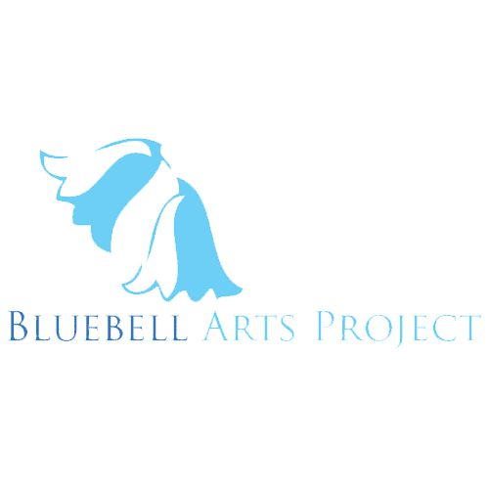BLUEBELL ARTS @ THE GASYARD CENTRE , 128 Lecky Road, Brandywell, Derry BT48 6NP
PH: (028)71162471/71162466
Email: bluebellartsproject@hotmail.com

 | MON. | TUE. | WED. | THU. | FRI. | SAT. | Starts
Keep Her Knit | 7-9pm | 7 -9pm |  | 12.30 – 2.30 |  |  | Sep – Jul.
Craft Circle |  |  |  | 10.30 – 12.30 |  |  | “ “ “
Pink Ladies Choir |  |  | 12 - 1pm |  |  |  | Ongoing
Visual Arts (General) |  |  | 5-7 p.m. |  |  |  | 02/12/19
Music Production/DJ Skills (Open) |  |  | 6-8pm |  |  |  | 13/11/19
Broadcast/Podcasting |  |  |  |  |  | 1 -3pm | 11/01/20
Film & Editing (Open) | 7-9pm |  |  |  |  |  | 18/11/19
Photography |  |  | 7 -9pm |  |  |  | 06/02/20
Animation | 5 -7pm |  |  |  |  |  | 13/01/20
Play Rehearsals (Use) |  |  | 6-8pm |  | 1-3pm | 12 – 2pm | ongoing
Drama Workshops (Open) |  |  |  | 5-7pm |  |  | 05/12/19
Creative Writing (Open)* |  |  | 7-9pm |  |  |  | 13/11/19
ETA Workshops |  |  |  |  |  | 11am – 2pm | Contact  Frank
ETA Masterclasses |  |  |  |  |  | 10am -3pm | Contact  Frank
Flip It Workshops | 10-4pm | 10 -4pm | 10 -12 n  1 -4pm | 3 -6pm |  |  | Contact  Frank
Prop/Costume/Set/  Parade Workshops |  |  | 3-6pm |  |  |  | Jan.22nd  ²⁰²⁰
Interface Arts |  |  |  | 7-9pm |  |  | Feb.2020
Plays/Performances |  |  |  |  | 7-9pm | 7-9pm | Feb.2020
Showcases |  |  |  |  | 6-9pm | 6 -9pm | Mar.2020
Open Mics |  |  |  |  | 7-9pm | 7 -9pm | Nov.2019

Workshops in Blue have a small fee for members.
Green Workshops/Times indicate workshops not provided or solely provided by Bluebell Arts & Flip it.
And times when Arts Factory is available as rehearsal space or for other hire purposes
All other Workshops are open to all ages

Keep Her Knit (Arts Factory)
Mon. Eves - Mid Sep – Mid Dec, Jan – Mar, Apr – Jul.
Tue. Eves - Mid Sep – Mid Dec, Jan – Mar, Apr – Jul.
Thu. Afternoons - Mid Sep – Mid Dec, Jan – Mar, Apr – Jul.
Craft Circle (Arts Factory)
Thu. Morns – Mid Sep – Mid Dec, Jan – Mar, Apr – Jul.
Visual Arts (Arts Factory) - 2 x 6 week blocks
Wed. Eves - 2nd Dec. – 27th Jan. 2nd Mar- 13th Apr.
Creative Writing (incl. Script writing) - (Large Conf. Room) 5 x 6 week blocks
Wed. eves – 13th Nov – 18th Dec, 15th Jan – 19th Feb, 4th Mar – 8thApr, 6thMay – 10thJun. 8th Jul – 12th Aug.
Perfomance and Poetry – (Large Conference Room /Café) 4 x 4 week blocks
Sat. Afternoons - 11th – 25thJan & 1st Feb. 7th -28th Mar. 9th -30th May & 4th -25th Jul.
Drama (Arts Factory) 3 x 6 week blocks
Thu. Eves. - 5th -19th Dec – 16th -30th Jan. 5th Mar – 9th Apr, 14th May – 11th Jun.
Music Production/DJ Skills (Large Conference Room) 3 x 6week blocks
Wed. Eves. - 13th Nov – 18rd Dec, 5th Feb – 11thMar, 6th May – 10th Jun.
Film and Editing (Large Conference Room/Various Locations) 4 x 4 week blocks
Mon Eves – 18thNov – 9th Dec, 3rd – 24th Feb, 6th – 27thApr.
Photography (Café/Conference Room/Various Locations) 2 x 6 week blocks
Thu. Eves - 6th Feb – 12thMar, 16th Apr – 21st May
Animation (Large Conference Room) 2 x 6 week blocks
Mon. Eves - 13th Jan – 17th Feb, 16th Mar – 20th Apr.
Broadcasting to Podcasting (Large Conference Room) 4 x 4week blocks
Sat. Afternoons - 11th Jan – 1st Feb, 7th – 28th Mar, 9th -30th May, 4th -25th Jul.
Prop/Costume/Set - (Arts Factory) 4 x 6 week blocks
Wed. Day/Eves.- 15thJan – 19thFeb, 11th Mar – 15th Apr, 13thMay – 17thJun, 15thJul -19thAug.
Interface Arts - (Arts Factory/Various Venues) 2 x 10 week blocks
Thu. Eves Feb – Apr, May – Jul.

Flip It! (Carers and Kids) - (Arts Factory) 4 x 6 week blocks
Tue. Afternoon (Carers) - 11th Feb – 24th Mar, 15th Apr – 20th May
Wed. Afternoon (Kids) - 10th Jun - 26th Aug.

There will be 3Plays /Performances per annum in February, May & August. Each will be held on Friday, Saturday or Sunday (can be for 2 or 3 nights each).
There will be 10 Open Mic events per annum one per month, to be held on Wednesdays, Fridays or Saturdays
Showcase Events - The Arts Programme will have an annual showcase event held over a weekend (tba)
Empowering The Artist Programme (ETA) will hold 4 exhibitions per annum
ETA will also provide 10 practical advice workshops for artists of all disciplines (visual, music, literature, spoken word, film/video/digital) and 4 masterclasses for Artists of all disciplines. The ETA workshops and masterclasses will be held on Saturdays.

CONTACT DETAILS FRANK - bluebellartsproject@hotmail.com 02871 162 471 x 466

