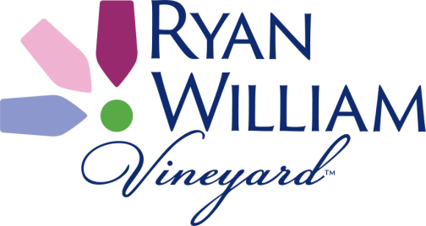

FOR IMMEDIATE RELEASE

August 19, 2021

CONTACT: Michaela Christensen, 607-535-3003

**NEW FOUNDERS TOUR SPONSOR HIGHLIGHTS THE RETURN OF THE**

**WATKINS GLEN GRAND PRIX FESTIVAL!**

Drivers in one of the Watkins Glen Grand Prix Festival’s most popular events will have a new “starting line” this year as they gather at The Tasting Barn for the **Ryan William Vineyard Founders Tour**, one of the Festival’s Stone Bridge Driver events.

The Watkins Glen Grand Prix Festival celebrates the history of U.S. road racing after World War II, which began in Watkins Glen with street racing from 1948-1952. This year’s Festival will be held on Friday, September 10, and will bring back the crowds, the cars, and the excitement that fans missed in 2020. Once again, Franklin Street in the village will be closed from 12:30pm to 8:00pm as Stone Bridge Drivers and Sportscar Vintage Racing Association race cars take laps of the original road course through and outside the village.

One of those events, the **Ryan William Vineyard Founders Tour**, has a new look this year. The nearly 100 participants will start their day at the **Ryan William Vineyard Tasting Barn** on Rt. 414, overlooking Seneca Lake. There, they will enjoy meeting and greeting the **Ryan William Vineyard** staff, who will provide box lunches and complimentary wine before the drivers set off on cross-country rallye routes throughout the Finger Lakes area. They will re-convene in Watkins Glen later in the day for their scheduled two Cayuga Health System Laps of the Old Course.

Marianne Marts, Chair of the Grand Prix Festival, thanked Ryan William Vineyard for the new sponsorship. “For recent Festivals, the Founders Tour has shared starting space with Chateau LaFayette Reneau winery, which also hosts our very popular Tour de Marque Road Rallye, featuring Alfa Romeo this year. We are thrilled that **Ryan William Vineyard** has become the sponsor of the Founders Tour, giving our drivers and participants a new rallye experience!”

The **Ryan William Vineyard Founders Tour** is one of the Festival’s thirteen Stone Bridge Driver events; owners of classic, vintage, and specialty cars participate in this event each year. **Ryan William Vineyard** is located just a short drive from Watkins Glen, on State Route 414, just past Tug Hollow Road.

*The Watkins Glen Grand Prix Festival, Presented by Chemung Canal Trust Company, is produced by Watkins Glen Promotions, a non-profit organization dedicated to producing special events in Schuyler County, N.Y.*