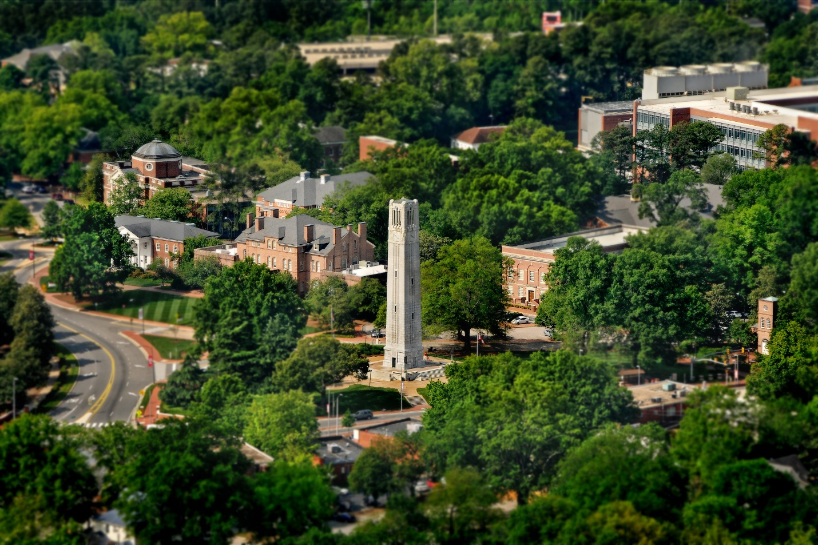
The Ph.D. Program in Lifespan Developmental Psychology at North Carolina State University invites potential applicants to an information webinar on Tuesday, Oct 18th at 12PM EST. Please click here to join the webinar: https://ncsu.zoom.us/j/97024974419

The webinar will be recorded and shared after the event. Please email Dr. Kelly Lynn Mulvey if you would like a copy of the recording (klmulvey1@ncsu.edu).

The webinar will review the program, faculty and application process.
Highlights of the lifespan developmental program and a list of faculty and their current research projects are included here as well. Additional information can be found on our website: https://psychology.chass.ncsu.edu/Lifespan/

APPLICATIONS. Due December 1.
Submit here: https://applygrad.ncsu.edu/apply/
Application information: https://psychology.chass.ncsu.edu/Lifespan/apply.php
NCSU: The 9,500-plus master’s and doctoral students at NC State don’t just work with world-leading faculty: they also do research alongside government, industry and nonprofit partners whose work shapes the world. Our proximity to the Research Triangle Park ensures our commitment to collaborative research beyond campus. Cooperative agreements with the graduate schools of the University of North Carolina at Chapel Hill, the University of North Carolina at Greensboro, and Duke University enhance our educational and research resources and allow us to take advantage of their expertise and technology in complementary areas of study. NC State leads public-private partnerships that unite academia, industry and others to solve significant social challenges. Our graduate students are embedded in those efforts. With degrees in hand, our Graduate School alumni are ready to lead.

RESEARCH: Graduate students are trained in lifespan developmental science methodologies and are expected to engage in research in partnership with their lab group and other collaborators and peers throughout their graduate career. Students design and develop research studies, gain experience collaborating on large grant-funded projects (NSF, NIH, etc.) and gain confidence in dissemination of their findings through presentations and publications. Both basic and applied research opportunities are encouraged and students benefit from the rich community partnerships, as well as local, national and international research collaborations that faculty and students at NCSU have cultivated.

TEACHING. Graduate students are encouraged to take a teaching course to help hone their teaching skills before gaining mentored experience in classrooms as a teaching assistant or primary instructor. Teaching opportunities are plentiful for students!

FUNDING AND DEGREE TIMELINE. Students entering with a masters’ degree could take as little as 3 years to complete their degree and those entering with a bachelor’s degree usually take 4 years to complete their degree. Funding packages include both research and teaching assistantships at competitive rates given the local cost of living.
FACULTY RESEARCH INTERESTS AND CONTACT INFORMATION
Jason Allaire
Everyday cognitive functioning of older adults; antecedents of individual differences in basic cognitive
functioning; cognitive interventions; short-term intraindividual variability; health disparities (https://faculty.chass.ncsu.edu/jcallair)
Note: accepting students for the 2023 academic year.

Lynne Baker-Ward
Understanding the processes through which children come to interpret, remember, and share their salient personal experiences, with applications to children’s testimony; autobiographical memory and well-being. On-going research examines linkages among children’s knowledge of COVID-19 safely practices, anxiety, and family socialization practices (https://mindlab.wordpress.ncsu.edu/)

Daniel Grühn
Emotional and cognitive development in adulthood and old age, such as empathy, well-being, emotional complexity; and historical, cultural, and biological influences on emotional development across the lifespan (https://acelab.wordpress.ncsu.edu/)
Note: accepting students for the 2023 academic year.

Amy Halberstadt
Emotional experience and expression as embedded within family, school, and cultural contexts, and as related to social justice and inequalities; affective social competence (http://www4.ncsu.edu/~halbers/index.html)

Dana Kotter-Grühn
Socioemotional development in adulthood and old age; age stereotypes and ageism, perceptions of aging; well-being and self-regulation
Kelly Lynn Mulvey
Social-cognitive development; intergroup attitudes; stereotyping and prejudice; theory of mind; social exclusion; resource allocation; social justice; gender; race and ethnicity; peer group dynamics; STEM engagement for underrepresented groups (https://sites.google.com/ncsu.edu/mulveysocialdevelopmentlab).
Note: accepting students for the 2023 academic year.

Shevaun Neupert
Daily stressors and their associations with affect, physical health, and memory across the lifespan; socioeconomic disparities in health; statistical techniques for examining change and intraindividual variability (go.ncsu.edu/wellbeinglab)
Note: accepting students for the 2023 academic year.

We encourage our students to engage in collaborations with research labs in other programs that also have developmental interests. Affiliated faculty with developmental interests include:
Jeni Burnette -- Mindsets and their role in self-regulation and goal achievement using a wide variety of research designs, ranging from interventions to basic experimental methods to longitudinal surveys (http://jeniburnette.com/)
Jing Feng—Human attention and cognition, with applications of cognitive principles to human factors; individual differences and age-related changes in attention and spatial skills, as well as the effects of cognitive training; aging and driving, driver distraction and the design of information displays (http://www4.ncsu.edu/~jfeng2/)
Mary Haskett—Bidirectional relations between parenting and children’s social-emotional functioning, with a particular interest in how these relations operate within families experiencing child maltreatment (https://faculty.chass.ncsu.edu/mehasket)
Chris Mayhorn—Memory, decision making, human-computer interaction, home medical device design (https://faculty.chass.ncsu.edu/cbmayhor)
Anne McLaughlin—Human learning and the application of training, particularly age-related changes in cognition; maintenance of cognitive abilities and the application of feedback during training (https://psychology.chass.ncsu.edu/faculty_staff/acmclaug)
Kate Norwalk -- Social dynamics of elementary and middle school students, the impact of students’ classroom social dynamics on their social, behavioral, and academic functioning, and ways in which teachers can leverage these naturally occurring dynamics to improve classroom functioning and student outcomes. (https://faculty.chass.ncsu.edu/knorwal)
Vanessa Volpe – racial/ethnic health disparities; racism; strengths-based and critical approaches, psychophysiology and intensive longitudinal data; Black and Latinx adolescents, emerging, and young adults (https://faculty.chass.ncsu.edu/vvvolpe)

