z
NLK Digitized Materials
Service Guide

1. Overview
❍ To permanently preserve, open and share its collections, the National Library of Korea (NLK) digitizes its collections and provides them online to domestic and foreign partner libraries.
❍ For increased use of the NLK’s digitized materials, copyright fee incurred when viewing/printing full-text materials in partner libraries is covered by the NLK(until next revision of regulation).

2. Current status of digitized materials
(AS of Jan, 2020.)
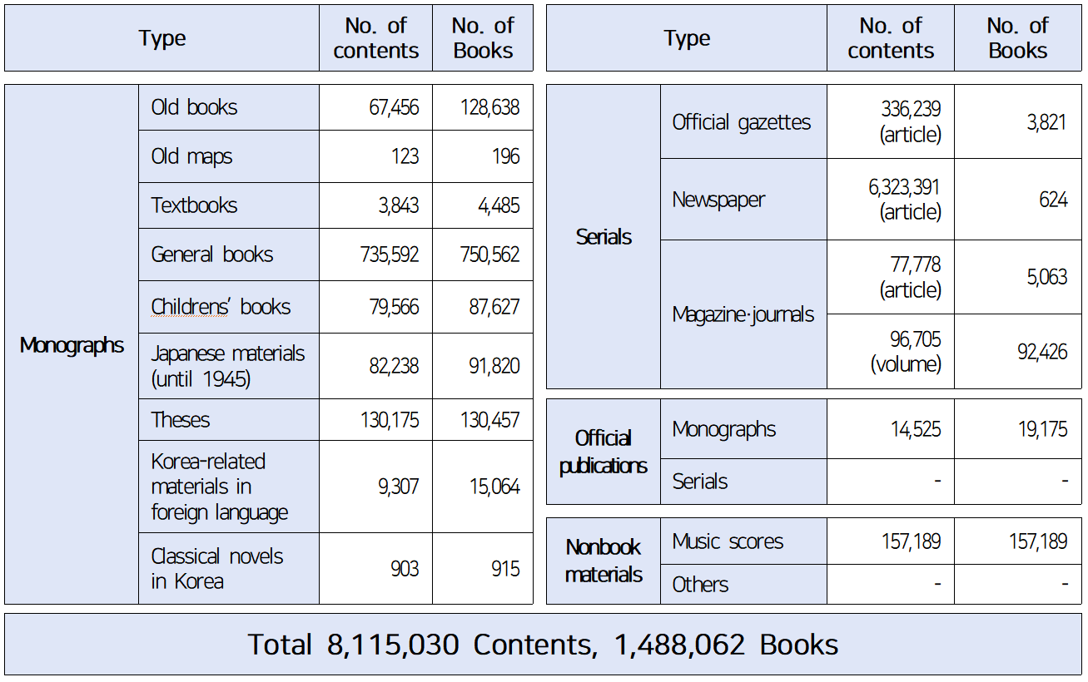
3. Accessibility
❍ Free use
- Applicable to copyright expired materials and those permitted for use
❍ Partnership agreement process for using copyright materials
- Applicable to digital materials copyrighted
- Accessible using PCs designated by partner libraries of the NLK
* Copyright fee incurred when viewing/printing full-text materials in partner libraries is covered by the NLK(until next revision of regulation).
- Partnership Agreement process
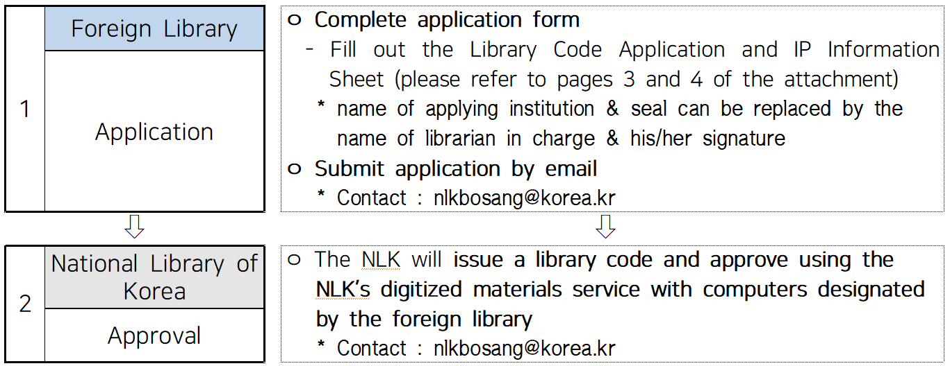

4. How to use
❍ Install viewer program
- NLK English website(www.nl.go.kr/NE) > Search > Downloadable Viewer Program
❍ Use the NLK’s Digitized Materials Service through the NLK’s homepage
* If you are using Internet Explorer, version 11 is required for viewing the NLK’s digitized materials.
- To browse digitized materials
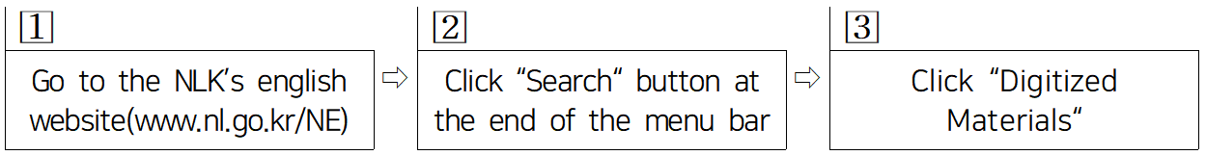
- To retrieve specific contents
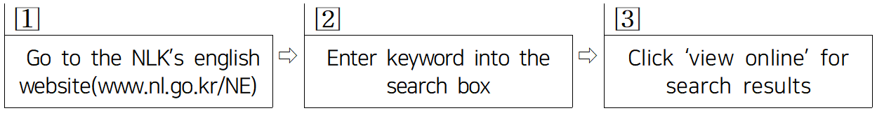

[Appendix 1]
Library Code Application

❍ Library name :
❍ Contact :
❍ Affiliation :
❍ Website :
❍ Zip code :
❍ Address :
❍ Phone :
❍ Fax :
❍ Webmaster (E-mail) :
❍ Date of application :
❍ Applying institution :

Applying institution : (seal)

National Library of Korea

Bibliographic Control Division fax: +82-2-590-6335 e-mail: kolisnet@mail.nl.go.kr
[Appendix 2]
IP INFORMATION

For Using the NLK’s Digitized Materials Service

1. Library Information
ㅇ Library Name :
ㅇ Library Code : **No need to fill out this area**
ㅇ Webmaster (E-mail) :

2. IP Information
No. | Public IP Address | Private IP Address
※ Public IPs can overlap. Private IPs must begin with either 10, 172 or 192.
※ We suggest limiting the scope of designated PCs to the ones within your library for management purposes.
For example: 193.190.253.129-159 (Good) / 134.58.*.* (not good-too broad)

ㅇ Submission Date :

National Library of Korea

Digital Library Planning Division e-mail: nlkbosang@korea.kr

