2022 Silver Spokes Cycling Club Kit
How to order your new Jakroo Kit online
Jakroo Canada changed their website in 2021 to allow each person to place and pay for their own order in our Club Storefront. Here are the instructions on how to get there, set up your own account and order your new kit!
This will get you to the Silver Spokes Storefront.
https://designlab.jakroo.com/store-front?storeId=Bk5J1ztzY

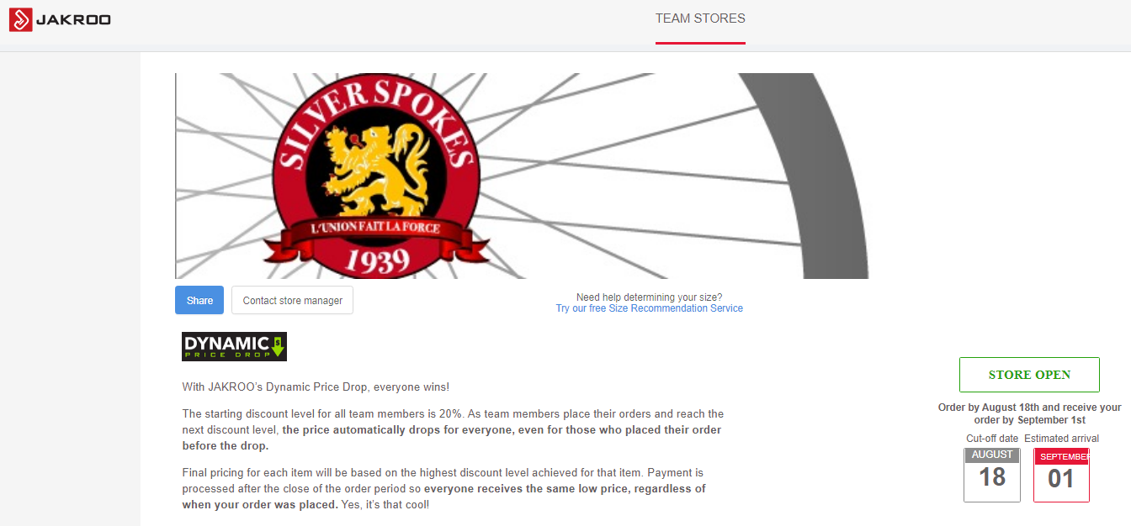
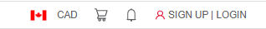
In the Top right corner, you can Sign Up (create an account) or Login to an existing account.

Once logged in you will see your name: for example

Scroll down to view the 7 club items available. Click on each one for more information. You may Add to Cart here.

To place an order, you will need to enter the following information. Then click “Add to Cart”.

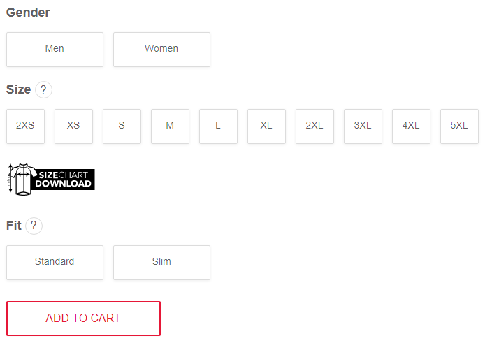

Once Added you can see how many items are in your cart here:
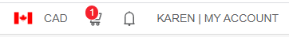

With JAKROO’s Dynamic Price Drop, everyone wins!
The starting discount level for all team members is 20%. As team members place their orders and reach the next discount level, the price automatically drops for everyone, even for those who placed their order before the drop.
Final pricing for each item will be based on the highest discount level achieved for that item. Payment is processed after the close of the order period so everyone receives the same low price, regardless of when your order was placed. Yes, it’s that cool!

Our Silver Spokes Storefront is currently open FROM MAY 30 to JUNE 10, 2022.
Please review the sizing chart carefully for each item.

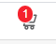
When you’re ready to order, click on your shopping cart:

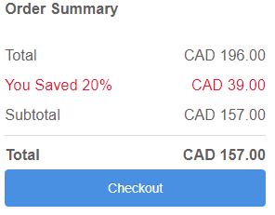
Go to Checkout:

Agree with the Terms and Conditions:

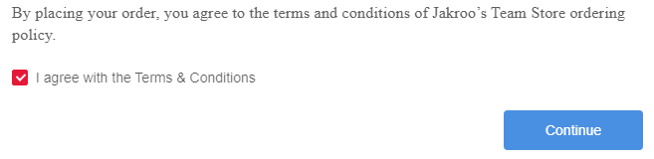

You will now be prompted to Log in or Create an Account:

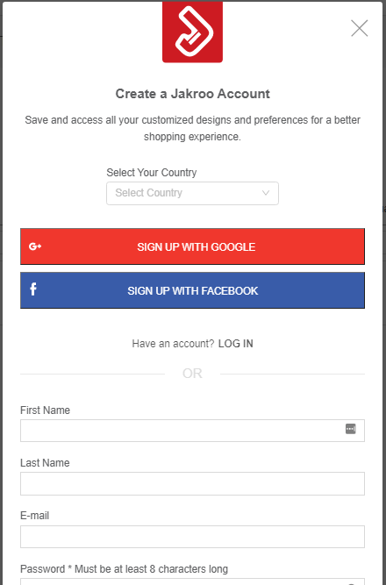

You will go through Shipping, Payment and Review.

Once you complete the order, you will receive a Pre Order Confirmation, an order number, Order date and an Estimated Delivery Date.

There is also a Link to view the updated status of your order.

