Men’s/Women’s Tour-4 Jersey

Available in Relaxed fit, Standard fit and Slim fit.
Sizes from 2XS up to 5XL
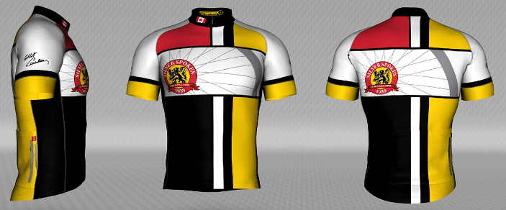
With a European twist to the classic jersey, the TOUR custom cycling jersey features longer sleeves and a folded band cuff. It is built with upgraded soft and comfortable performance fabrics and offered in all three fit styles (Slim, Standard and Relaxed) for a personally tailored fit. If you love to ride, you'll love the TOUR Jersey.

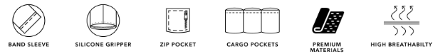

We have added a new Jersey to the line up. Check out the new Nova Pro-4 below!
Men’s/Women’s Nova Pro-4 Jersey

Available in Standard fit and Slim fit. Sizes 2XL -5XL
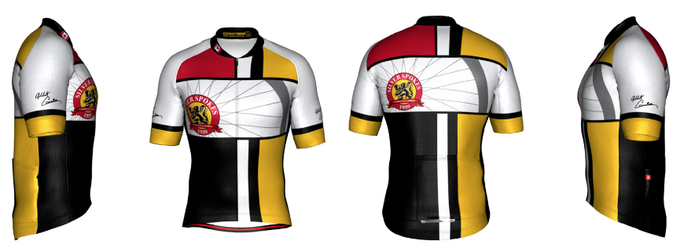

The all-new NOVA PRO is an upgrade to our NOVA high-performance jersey, featuring an updated collar, pocket layout and advanced stitching. The NOVA PRO is the new choice for professional and elite teams, with a streamlined fit and lightweight Italian fabrics that wick away sweat, keeping you cool and aerodynamic.

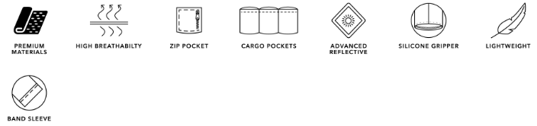

Men’s/Women’s Fresco-2 Sleeveless Jersey

Available in Relaxed and Standard fits. Sizes XS to 5XL

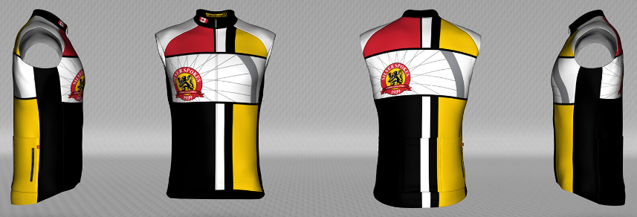

The sleeveless version of our popular Fondo Jersey, the FRESCO is an ideal option for those hotter days or avoiding the tan lines. Ideal for the occasional adventurer who wants to show off their design or add as a matching item to complete their look.

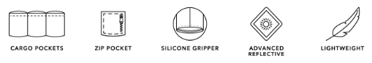

Men’s/Women’s Barrier Wind Jacket

Available in Relaxed and Slim fit, sizes 2XS to 4XL
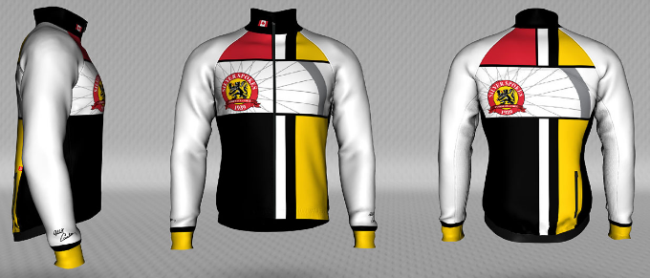

The BARRIER custom wind jacket is perfect for cool mornings and windy days. It is the perfect platform to show off your design while keeping you protected from the elements. The BARRIER comes available in two Fit Styles to better tailor your fit.

Infinity Thermal 2 Arm Warmers
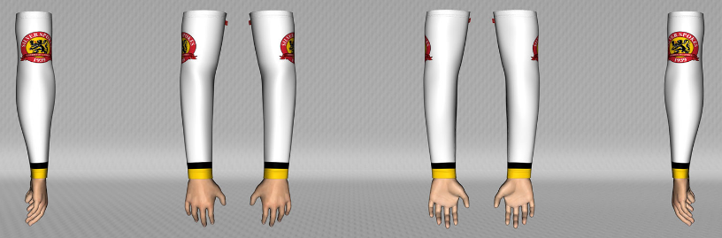
Extend your design with INFINITY custom thermal arm warmers for coverage in cooler conditions. Our thermal Italian fabric is brushed for softness and insulation, and is perfect for all users who want to keep their arms warm on rides.
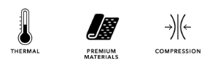
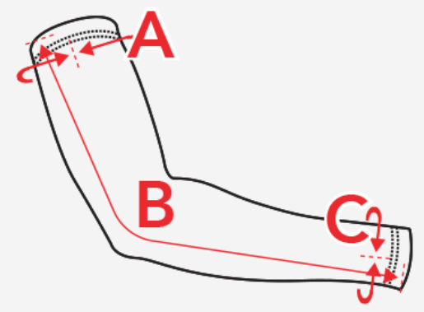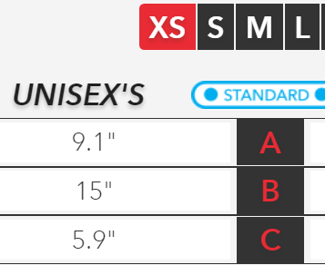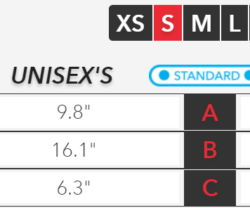
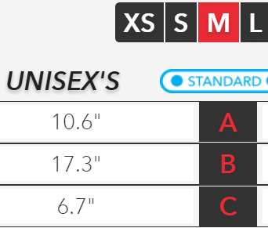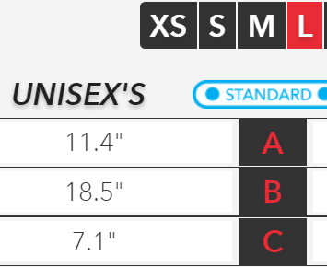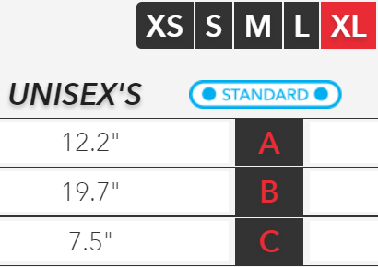

Men’s / Women’s Velo Pro Bib-3 Shorts
Available Sizes: 2XS-5XL

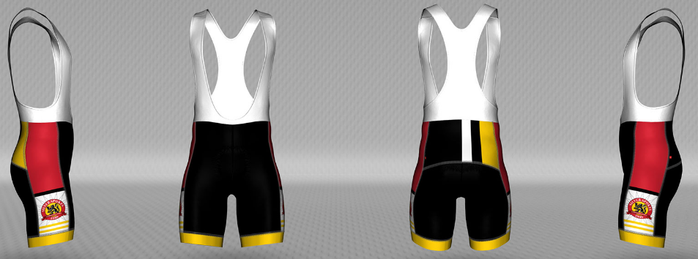
The perfect combination of comfort and performance, the VELO PRO custom bib shorts feel great with upgraded Italian fabrics and pro level chamois.
Premium Italian performance stretch fabrics composed of 80% polyester & 20% Lycra
Italian Bormio D20 chamois with a 5+ hour ride rating
5 cm Swiss made - Finished Edge Power band grippers
Mesh bib straps
Flat lock stitching

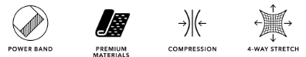

Women’s/Men’s Velo Pro-3 shorts
Available Sizes: 2XS-5XL

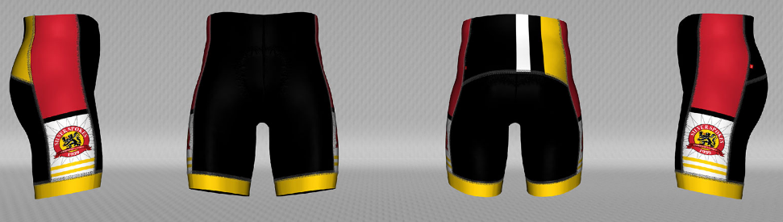

The perfect combination of comfort and performance, the VELO PRO custom cycling shorts feel great with upgraded Italian fabrics and pro level chamois. Choose the VELO for classic lines, or select the PELOTON PRO for a more modern, curved design. Complete your kit with these long lasting and great looking shorts.

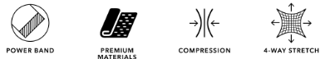

Premium Italian performance stretch fabrics composed of 80% polyester & 20% Lycra
Italian Bormio D20 chamois with a 5+ hour ride rating
5 cm Swiss made - Finished Edge Power band grippers
Flat lock stitching

