http://antibedroomtax.org.uk/2013-05-29-04-42-41/anti-bedroom-tax

Eviction Stopped By Manchester Campaign
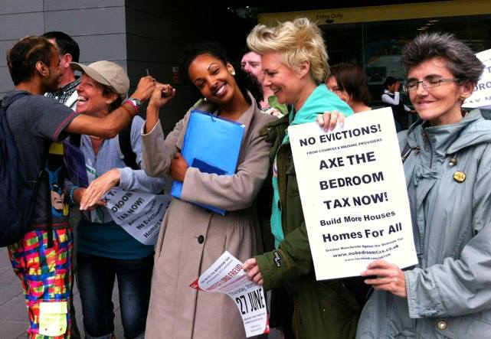
Manchester Anti-Bedroom Tax Campaigners Score Victory Against Eviction
Ella Lorelle is a single parent, living on the Old Moat Estate in WIthington. Southway Housing claim she is over £500 in rent arrears. The Bedroom Tax reduction in her Housing Benefit has added to her arrears.
...Despite offers to meet with them, Southway insisted that she appeared in court so that they can pursue a repossession order.
Campaigners joined Ella for a protest at the court today and the case has been adjourned.
More details later.
http://antibedroomtax.org.uk/2013-05-29-04-42-41/latest-news/35-sat-15-june-in-memory-of-stephanie-bottrill

Bedroom Tax Demonstration, In Memory Of Stephanie Bottrill – Sat 15th June
from Birmingham against the Cuts
Birmingham Benefits Justice Campaign are holding a demonstration on Sat 15th June from 12noon in Chamberlain Square. This will remember Stephanie Bottrill from Solihull who committed suicide, blaming the government and the bedroom tax in the notes she left. This is being held with permission of the family.
We are asking all groups to send delegations with banners to this demonstration.
The demonstration will be outdoors. Please contact us at BirminghamAgainstTheCuts@Gmail.com with any accessibility needs or questions.

Sat 15 June: In Memory Of Stephanie Bottrill
There will be a leafleting session on Saturday 1st June to build for the demonstration, meeting at Waterstones High St/Bullring from 12noon.
Can’t Pay – Won’t Leave – No Evictions
The bedroom tax is a vicious attack on some of the poorest and most vulnerable people in society. Stephanie Bottrill killed herself as a result of the stress the bedroom tax put on her.
Social tenants who receive housing benefit have their benefit cut by 14% for one “unoccupied” bedroom and 25% for two or more.
Birmingham City Council only has 368 available one and two bed properties for 14,000 tenants forced to move or pay more.
The council must refuse to evict tenants who fall into arrears as a result of the bedroom tax.
Get Involved
The Birmingham Benefit Justice Campaign is uniting all those opposed to the devastating benefit cuts. By linking up we can challenge the government’s divide and rule tactics and unite the millions of people hit by these cuts across the country. Mass resistance beat the Poll Tax and Thatcher, we can do the same to the bedroom tax and Cameron.
Email: Birminghambenefitjustics@gmail.com
Phone: 07969 415398
Twitter: @bedroomtaxbrum
Facebook: Birmingham Benefit Justice Campaign

Stop privatisation; improve existing and build a new generation of first class council housing
Call on Landlords to act against Bedroom Tax

Councils and housing associations face growing pressure to campaign against the Bedroom Tax, and ensure tenants are not evicted due to housing benefit cuts.
After a meeting of 36 Councils last week, tenant reps across Britain are calling on Councils and housing associations to join the opposition.
Tenants are signing a letter to organisers of the Chartered Institute of Housing (CIH) conference, calling on landlords to oppose the Bedroom Tax and invite a tenant to speak at the event in Manchester 25-27 June.
The letter says:
While Housing Association and Council Landlords from across the country meet in Manchester for the Chartered Institute of Housing conference, the crisis of housing policy and provision is deepening.
Increasing numbers are not paying the Bedroom Tax - because we have not got the money.
To pay the Bedroom Tax would mean living below the poverty line. Malnutrition will be the outcome. Yet threats of eviction to make us pay the Bedroom Tax still persist.
We are asking the housing providers to join with tenants, in defence social housing, and in opposition to the Bedroom Tax.
We ask to address the conference for a few minutes to explain the views of the growing number of tenants who are actively opposed to the Bedroom Tax.
The CIH conference is ten days after a West Midlands march in memory of Stephanie Bottrill, the 53 year old grandmother from Solihull who killed herself in despair due to the Bedroom Tax.
The Birmingham march, on Saturday 15th 12 noon from Chamberlain Square, will see banners from around Britain - details here
DCH is part of the Anti Bedroom Tax and Benefit Justice Federation, and campaigns for investment in existing and new Council housing. Removing the unjustified 'historic' housing debt burden on Councils would let them build a new generation of first class, secure and really-affordable council housing.
What you can do
Sign the letter to CIH conference organisers - email info@defendcouncilhousing.org.uk
Join the Birmingham march Sat 15th 12 noon Chamberlain Square B3 3DH - details here
Join DCH and Anti Bedroom Tax Federation at the Peoples Assembly 22 June in London to campaign against benefit cuts and for Council housing.

