package com.test;

import com.thoughtworks.selenium.*;
import org.testng.annotations.*;
import static org.testng.Assert.*;
import java.util.regex.Pattern;

public class TestngExample1 extends SeleneseTestNgHelper {
@Test public void testNgExample1() throws Exception {
selenium.open("/");
selenium.type("id=q", "selenium");
selenium.click("id=submit");
selenium.waitForPageToLoad("30000");
}
}

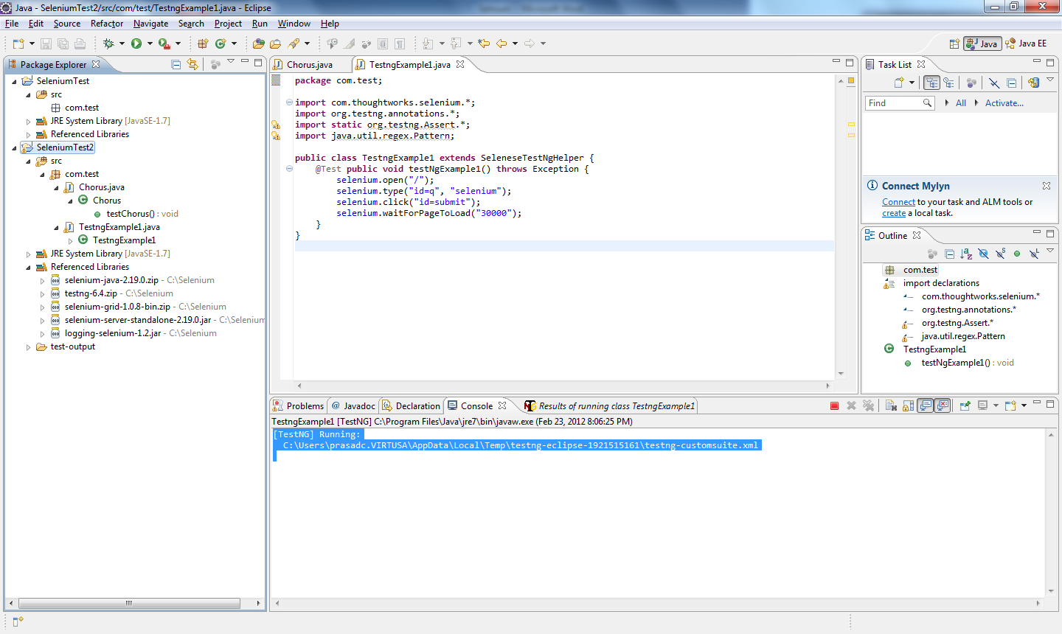

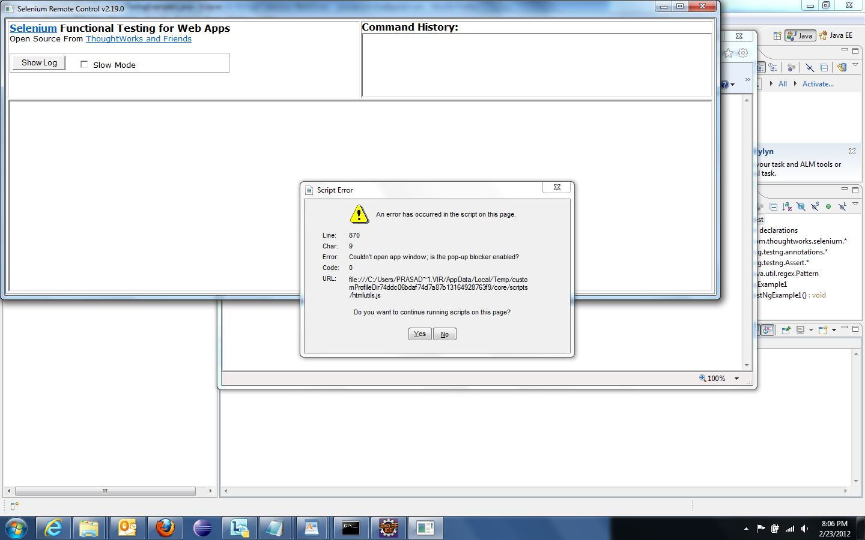

Message in Eclipse Console - [TestNG] Running:
C:\Users\pra****\AppData\Local\Temp\testng-eclipse-1921515161\testng-customsuite.xml
And a Blank Browser with the Username - C:\Users\**** \AppData\Local\Temp\customProfileDir74ddc06bdaf74d7a87b13164928763f9\core\Blank.html

