1. Click on Computer properties:

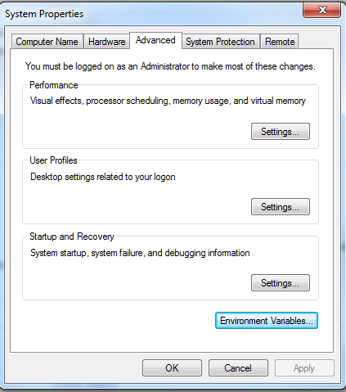

1. Then click on Environment variables:

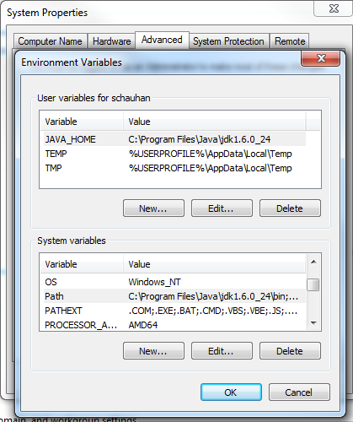

1. Click on New and give Path of Firefox:

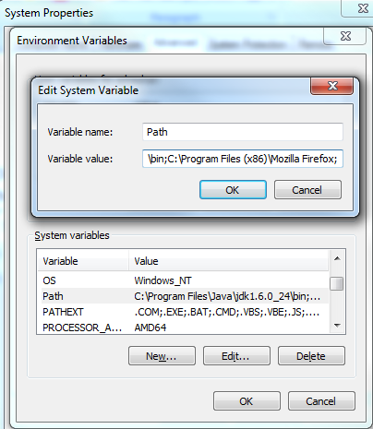

1. Click on ok