Hi kundan,
As per discussion offline i need some help from your side related to Framework Design which are quite helpful for me.
Reference Link: http://www.vmware.com/in.html
Scenario need to be tested:

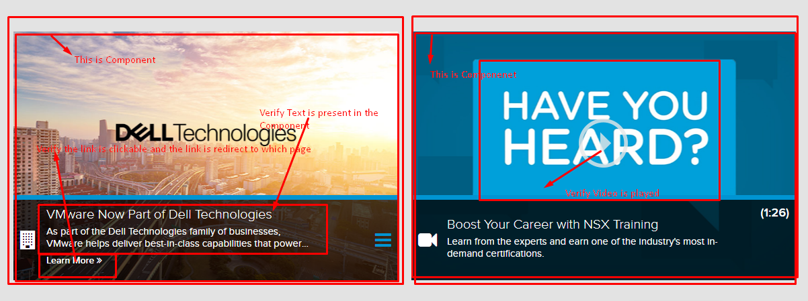
2)

3)

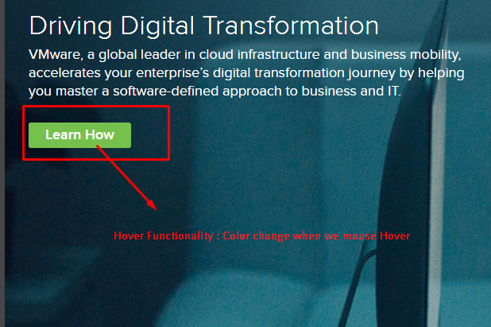

4)
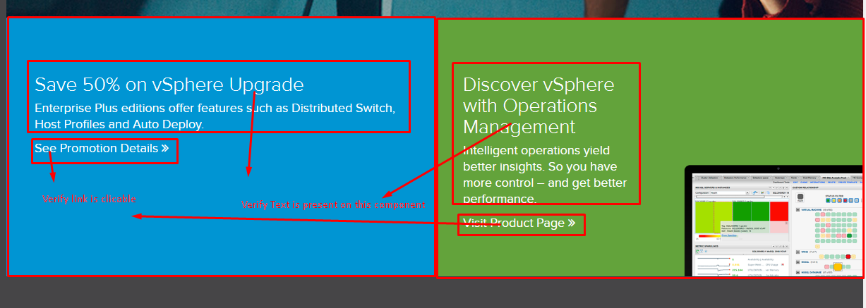

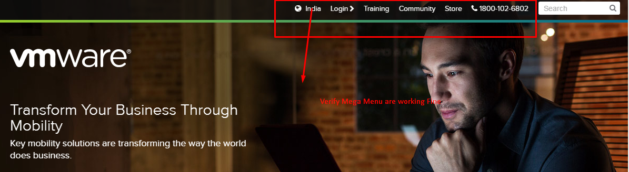
5) 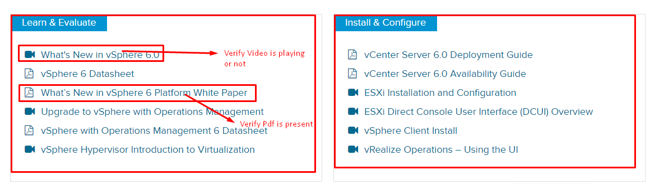
Don’t need to be tested:
