Hi Anil,
I have written the code,trying to run on Internet Explorer driver.showing an error as : “Unexpected error launching Internet Explorer. Protected Mode settings are not the same for all zones. Enable Protected Mode must be set to the same value (enabled or disabled) for all zones. (WARNING: The server did not provide any stacktrace information)
Command duration or timeout: 248 milliseconds”.
Please find the attached screenshot:
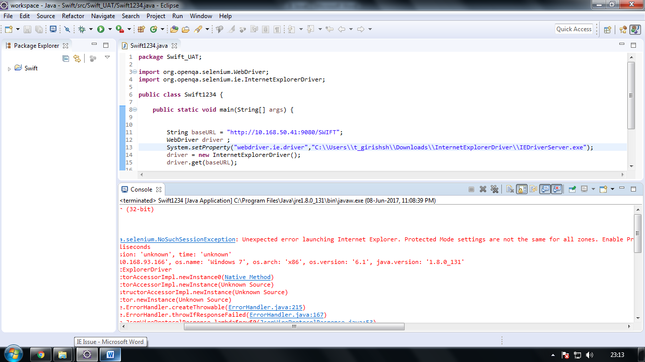
Currently I am using Internet Explorer 11 version.I went to Internet Options >> Security option I changed it to Disabled mode of Internet,Local Internet,Trusted Sites,Restricted Zones
Please find the attached below screenshots:

Internet Zone:
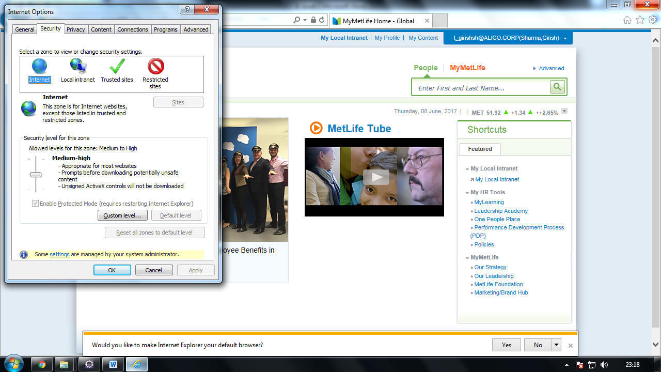

Local Internet Zone:
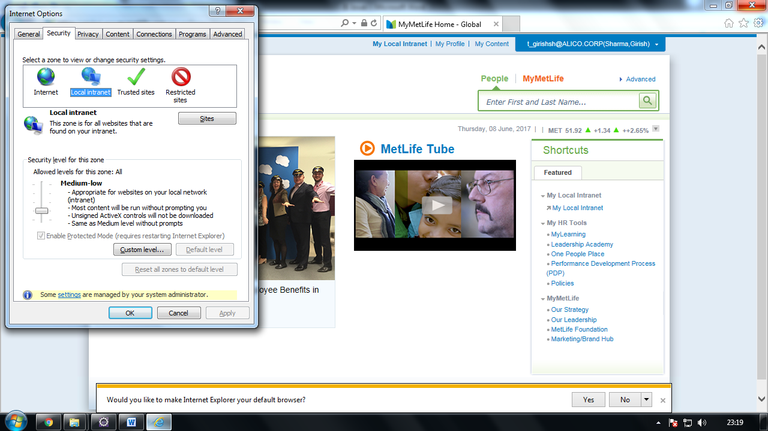

Trusted Sites Zone:
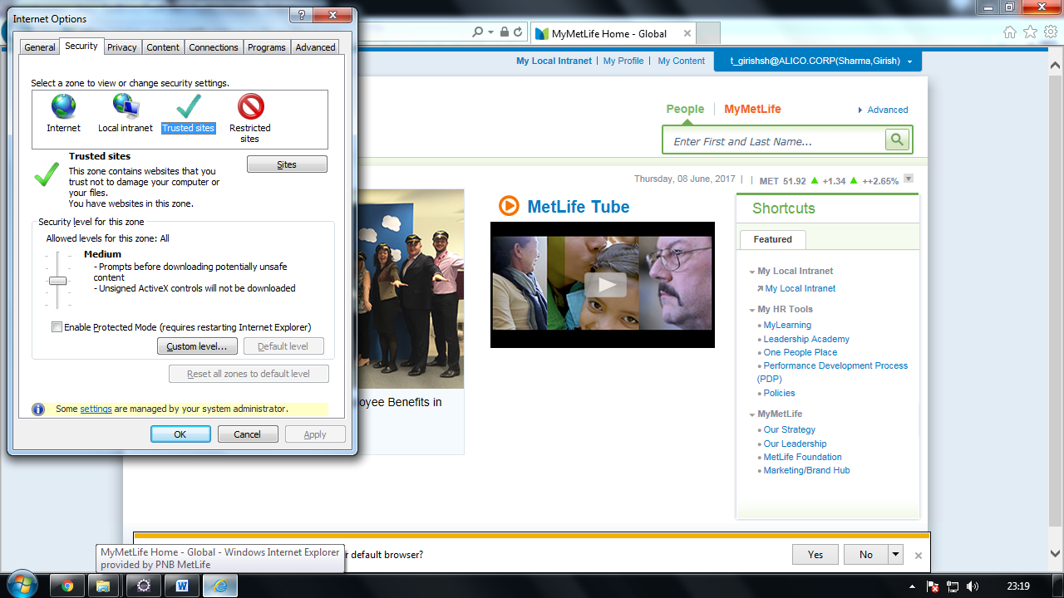

Restricted Sites Zone:
