Heathkit Gotek Floppy Emulator Notes
6 June 2018

Table of Contents
Acknowledgements 1
Hardware 1
Software 1
Gotek 2
Create Disk Image 4

Acknowledgements
Jeff at HxC for developing the firmware and software to modify the Gotek floppy emulator for Heathkit computer systems
Steven Hirsh, Mark Garlanger, Norberto Collado, and ?? for providing the detailed technical knowledge of the Heathkit disk systems.

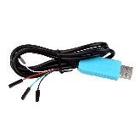
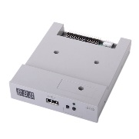
Hardware
- Gotek Floppy emulator ($27.99 from Amazon)
- USB to TTL Serial Cable ($6.99 from Amazon)
- USB flash drive (32GB works, probably could use smaller)

Software

Download the software from the following webpage
- USB STM32 HxC Floppy Emulator firmware for Gotek update: HXCFEUSB_HFE_beta_firmware.zip
- Last firmware release notes : USB_HFE_hxc_floppy_emulator_firmware_release_notes.txt
- Online Bootloader programmer: STM32_SerialBridge.zip
- You can purchase the firmware on this page : http://hxc2001.com/store/

Gotek

Your drive may need to modified in order to program it. It needs a set of jumper pins added to connect the serial cable.
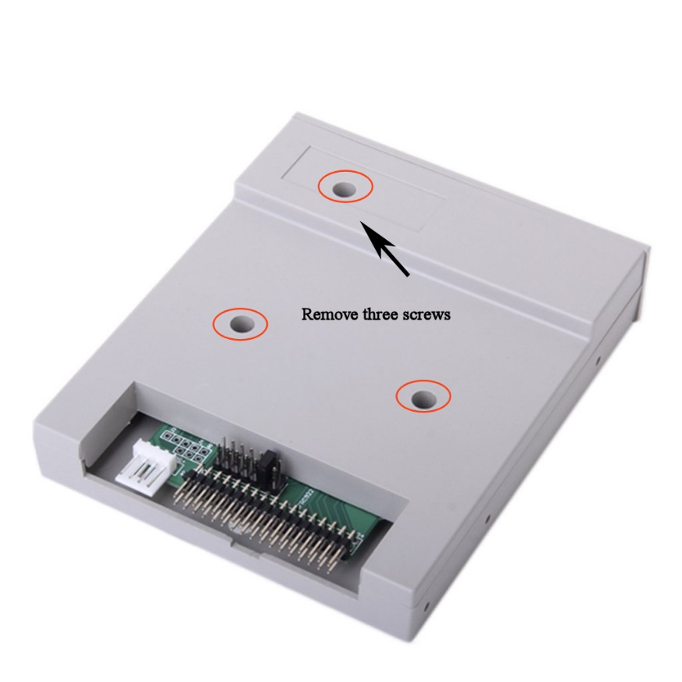
Solder a set of dual jumper pins in the area indicated.
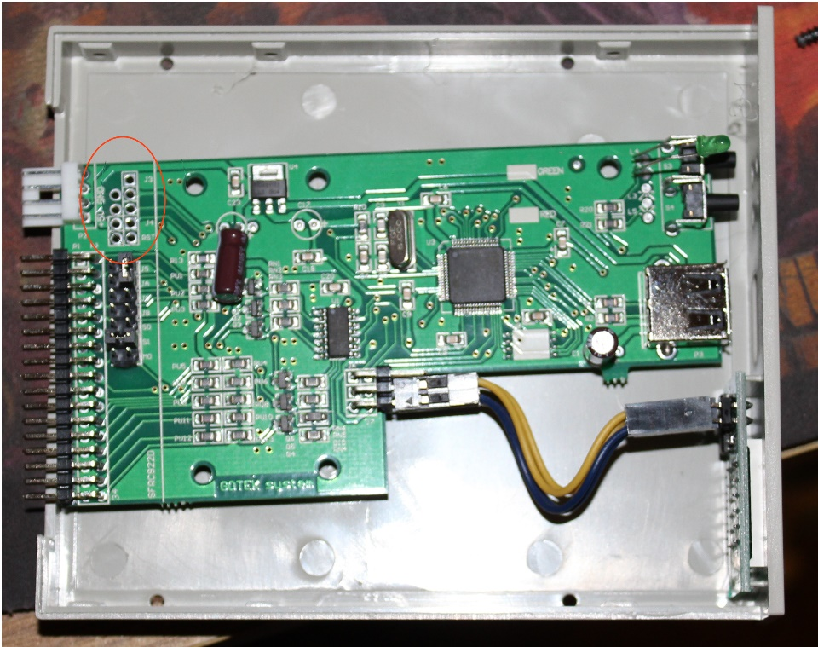

Reassemble the unit and connect the serial cable as indicated in the First time bootloader Flashing/Programming process at the following link. Note the jumper at J3. You may need to use a wire to briefly ground the Reset pin if the software doesn’t like up initially.
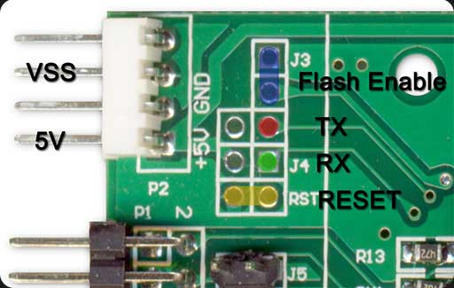
Serial cable pinout
Red cable: +5V
Black cable: GND
Green cable: TXD
White cable: RXD

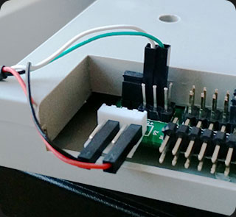
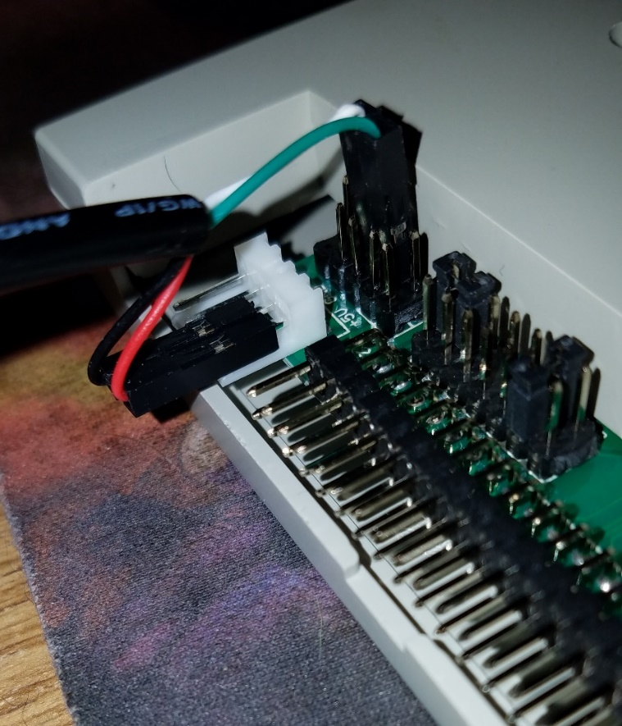

Follow the directions to flash the unit with the new bootloader

Create Disk Image

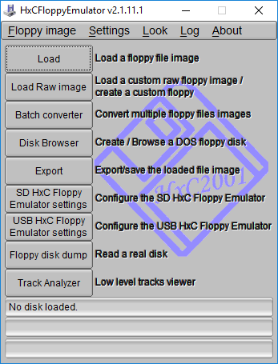
Open the HXC Floppy Emulator software

Click Load and navigate to the directory with .H8D file you wish to load.
Click Export and select "HFE version 3" as the export file type.
Copy the exported file to the USB flash drive. You will also need the latest Beta firmware from the HXC site the first time you load the Gotek.

