Scholarships Form
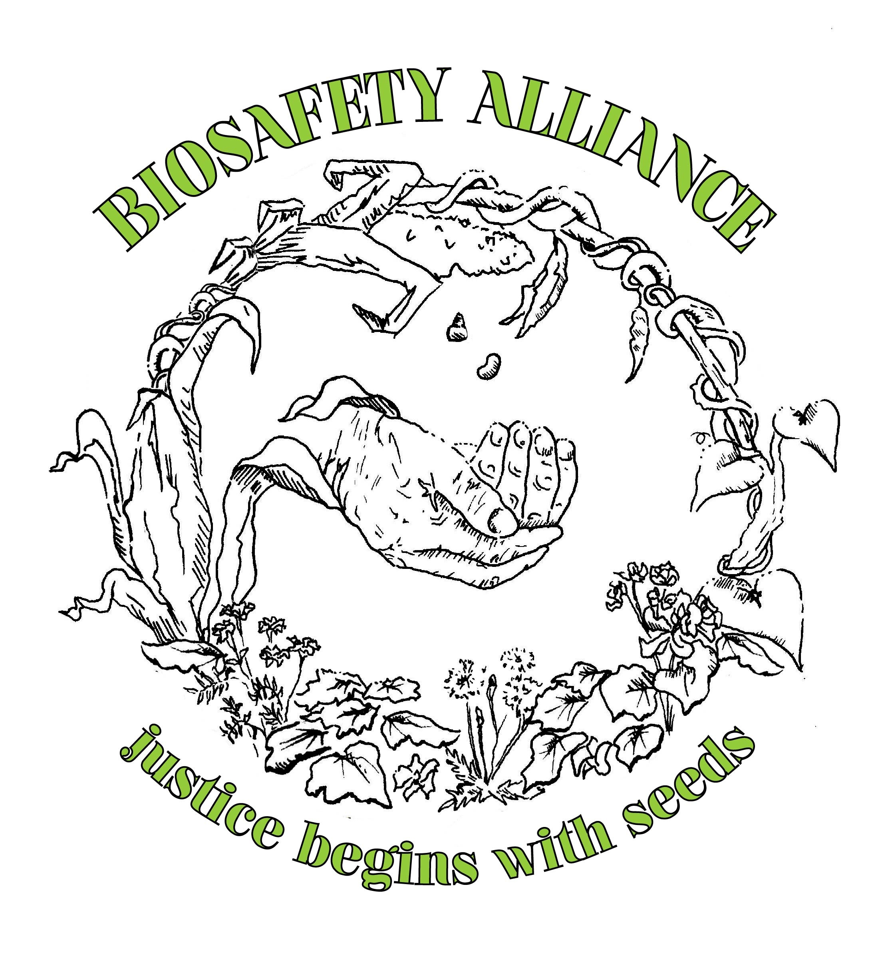
Justice Begins with Seeds 2013
International Conference
August 2nd & 3rd, Seattle, Washington
Seattle First Presbyterian Church, 1013 8th Avenue, Seattle WA 98104
Plymouth Church, United Church of Christ 1217 Sixth Avenue, Seattle WA 98101
GMO Awareness Week July 29th–August 4th 2013

Submit your application for scholarships to attend the JBS 2013 International Conference to: justicebeginswithseeds@gmail.com

Application
Please identify if you want a scholarship or want to volunteer, or both.
1) What is your interest in attending the conference and describe how this conference will benefit you.
2) Do you expect to become an active member of the Biosafety Alliance–such as bringing the movement to your community, or actively engaging in some of the non-GMO campaigns?
3) How are you involved in the food, farming and/or social justice movement?
4) Do you and close family members identify as low income, and are you unable to pay the lower end of the sliding scale rate?
5) Do you need assistance in getting to the conference?
If yes, Where will you be coming from?
6) Do you need solidarity housing?
7) Do you need food coupons?

Please provide the following contact information:
Name
phone:
email:
address:
Our Mission
The Biosafety Alliance is a cross sector, multilevel and inter-ethnic alliance of individuals and organizations working together to engage in broader outreach around genetically modified (GMO) food issues and to bring together strategic coalitions of diverse stakeholders to advocate for a GMO free food supply as a means of pushing for a shift from an industrial food model, to a model of local resilience. GMOs are a symbol that represents the industrial food system and a key point that needs to be addressed in order to address and shift the industrial food model.

Our Vision
Is to get the multi-faceted number of issues with GMOs, from health, to social justice, to environmental issues, to corporate consolidation, to enter the framework of various groups who have not traditionally focused on the issue of GMOs as a central theme and point that needs to be addressed to push for a systemic shift in the current corporate food regime.

