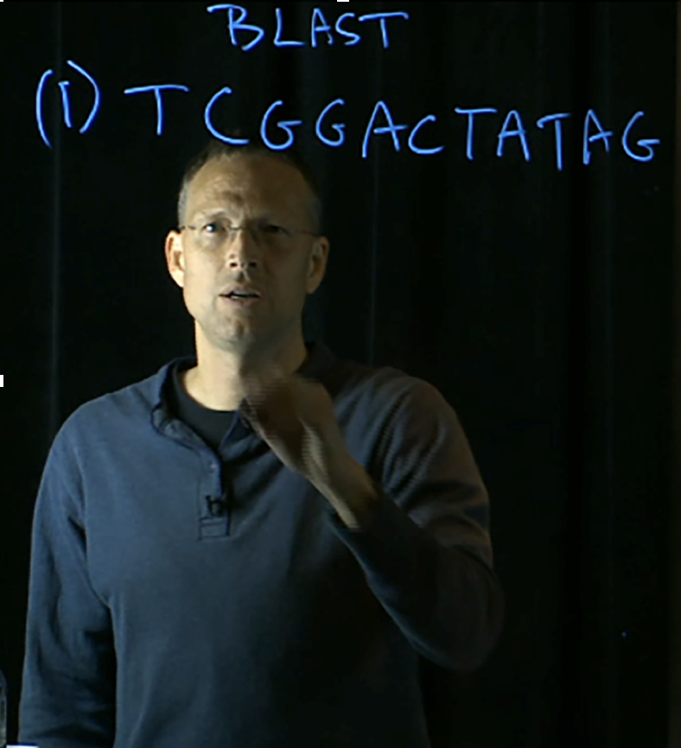Macintosh HD:Users:carolinacanocm6:Desktop:Screen Shot 2018-08-29 at 11.30.47.png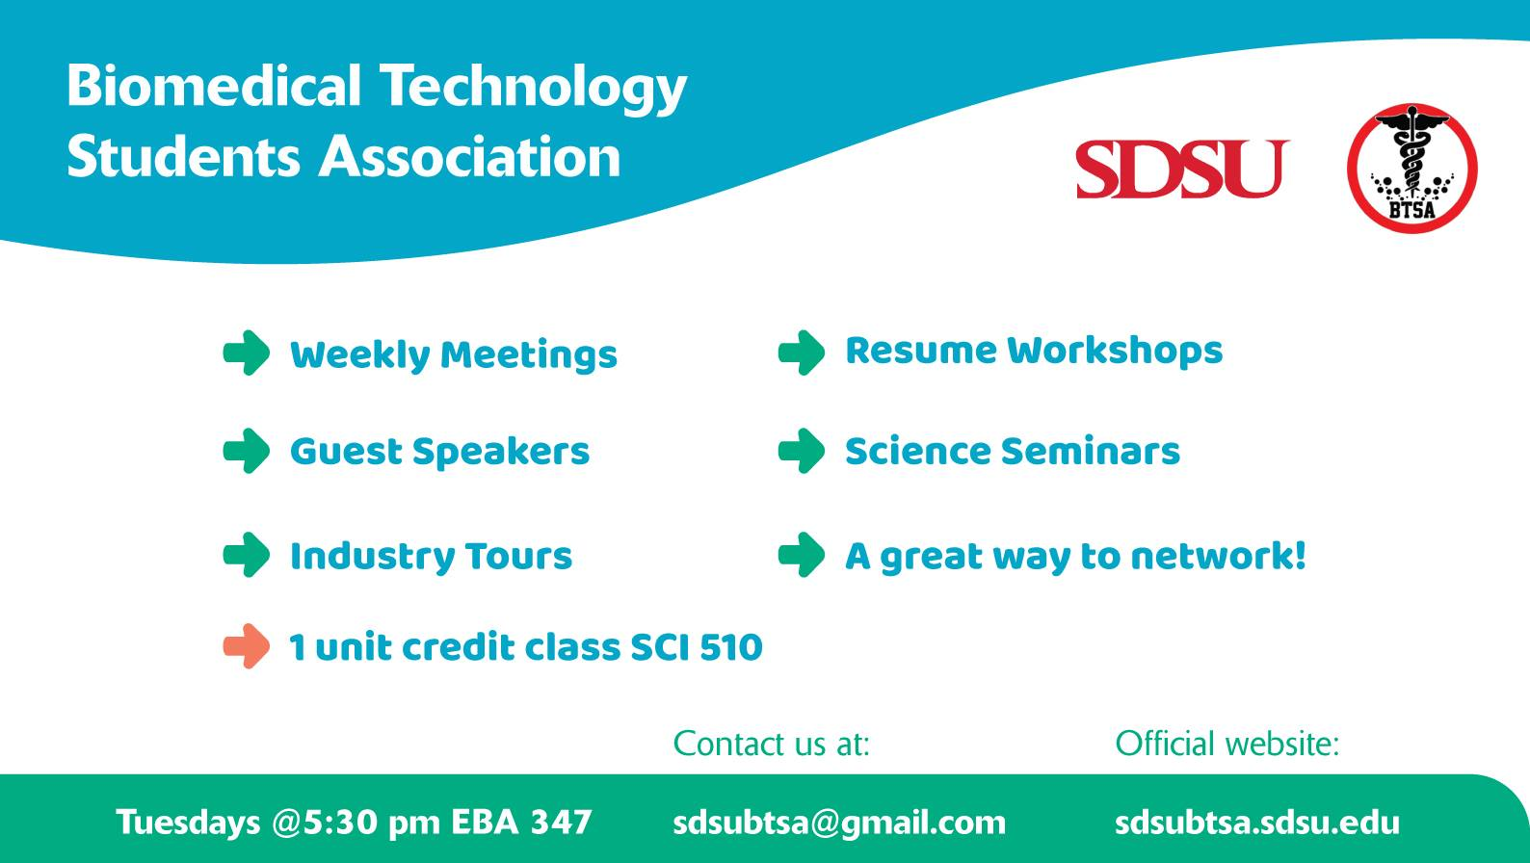

**To meet and learn more about Dr. Kelley, join us**

**Tuesday, October 2nd @5:30pm in EBA 347**

Dr. Kelley is a Biology professor. His lab focuses on combining Bioinformatics methods and culture-independent molecular tools to study environmental microbiology. Dr. Kelley also developed a bioinformatics interactive website to aid with learning bioinformatics: http://www.kelleybioinfo.org

BTSA Presents:

Dr. Scott Kelley