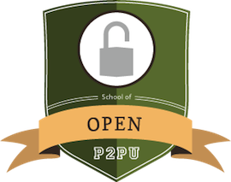
Join the School of Open

SOO website: http://schoolofopen.org
Follow #schoolofopen hashtag on social media

What?
Free education opportunities on the meaning, application, and impact of “openness” as it applies to education, science, research. We offer online courses, face-to-face workshops, and innovative training programs on topics such as Creative Commons licenses, open educational resources, and sharing creative works. Individuals and organizations may learn about these and other tools to better achieve their goals or to overcome the everyday barriers one encounters due to legal or technical restrictions.

Why?
Universal access to and participation in research, education, and culture is made possible by openness, but not enough people know what it means or how to take advantage of it. We hear about Open Source Software, Open Educational Resources, and Open Access… But what are these movements, who are their communities, and how do they work? Most importantly—how can they help me?

Learning about “open.”
Whatever the field, we seek to help people do what they already do better with the aid of open resources and tools. Here are just a few of our projects:

Courses: Copyright 4 Educators / Designing Collaborative Workshops / Writing Wikipedia Articles

Workshops: Open Science Course Sprint / Building an Open Ed Timeline / SOO in German

Training programs: SOO Kenya After School Program / Copyright for Librarians in Latin America

Who is involved?
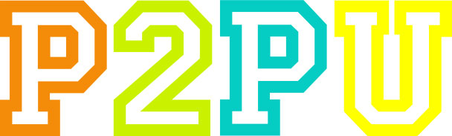
All projects are created and run by volunteers from various organizations and regions in the world. The School of Open community is coordinated by Creative Commons (CC) and the Peer 2 Peer University (P2PU).
+
Creative Commons is a globally focused nonprofit dedicated to making it easier for people to share and build upon the work of others, consistent with the rules of copyright. P2PU is a peer learning platform and community for developing and running free online courses. All School of Open courses and resources are licensed to the public under a Creative Commons Attribution-ShareAlike or more open license.
Get Involved.
There are many ways you can get started. Here are a few:

- Sign up for major announcements: school-of-open-announce@googlegroups.com
- Join the Google Group and introduce your idea or project: school-of-open@googlegroups.com
- Take or improve an existing course: http://schoolofopen.org
Questions? Ask us in the Google Group: school-of-open@googlegroups.com. It’s Open!

