Greetings from

We are a Maine-based 501c3 nonprofit offering grants*, crowdfunding tools and online garden planning software to a wide variety of food garden projects serving people in need in their communities. All of our opportunities and services are accessible via a single online grant application located here donate.seedmoney.org/start The deadline for submission is 11:59 PM Eastern Time Tuesday, November 12, 2019. This document is designed to help you apply. If you’re viewing this document online, we recommend that you download it to your computer by clicking the arrow icon located at the top right of your screen.

*We’re offering 255 grants on a sliding scale ranging from $50-$700. The size of the grant each project is capable of winning depends on the amount it is able to raise over the course of the 30-Day challenge period running from November 15 to December 15. Among the grants offered are 50 “Geographic Interest Grants (GIG)” of $100-$200 each which do not have any crowdfunding requirement. GIG grants will be primarily available to garden projects located in Maine, in developing countries and underrepresented regions in the US. Groups get to keep whatever funds they raise via their crowdfunding page whether or not they reach their funding target.

How to Apply for a SeedMoney Grant and Crowdfunding
This Word document is NOT the grant application itself and CANNOT be filled out and submitted for consideration for a grant. Only applications that have been submitted via our online application form by 11:59pm Eastern Time on 12 November 2019 will be reviewed. This form does, however, list all the questions asked in our application and can help you prepare your request for support. If you are not familiar with filling out online applications, we strongly recommend writing and saving your narrative texts in the spaces provided below and pasting them into our online form. If you have any questions, please see our FAQ section on our website first. If you can’t find your answer there, please submit it via our contact form or email.

1. Go to https://donate.seedmoney.org/ and click on the “Start” link in the main menu

2. This will open a new page for registering or logging in. If you used our platform last year, you can log with your login info from last year here or if you’re new to the site create a new account here.
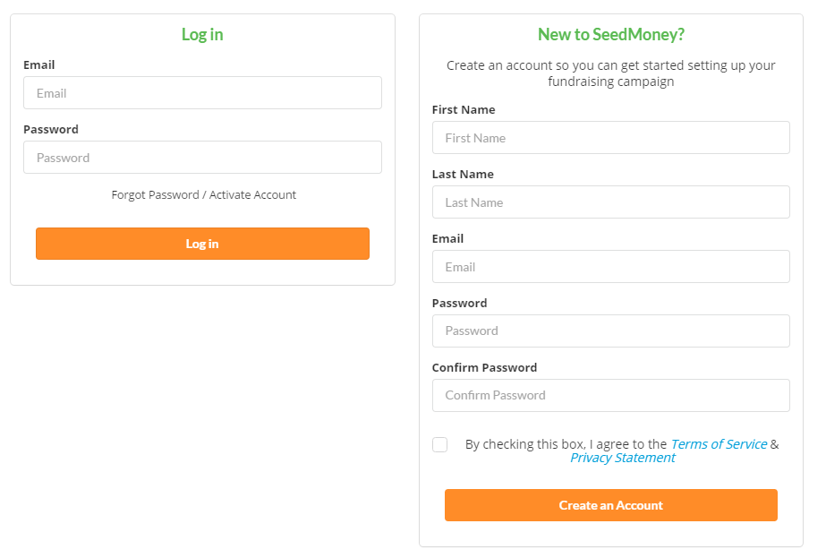

3. If you’re creating a new account, your account will be automatically and instantaneously confirmed. Use your email and password to log in here.

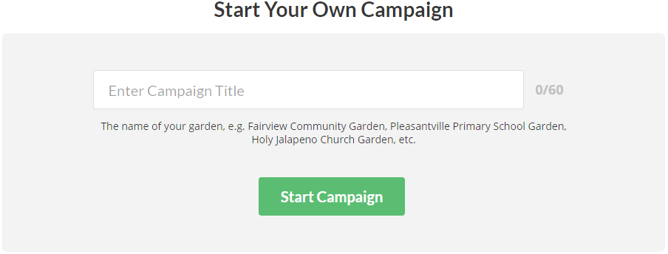
4. Once you’re logged in, you should be taken to the campaign start page, but if you’re not, you can get there by clicking the “Start” link referred to in step 1 above or by going here: donate.seedmoney.org/start. Name your campaign and click on the green “Start Campaign” button.

5. This will open up the application which consists of 4 sections that must be filled out and a button on the far right for previewing how your campaign page will appear to potential donors. At the top of the application, you’ll see a navigation menu that looks like this:
You can jump back and forth between sections by clicking on the 5 tabs at the top of the page, but for the smoothest and surest user experience, we recommend that you fill out each question and page in order from left to right.

6. The first two sections apply to all projects:
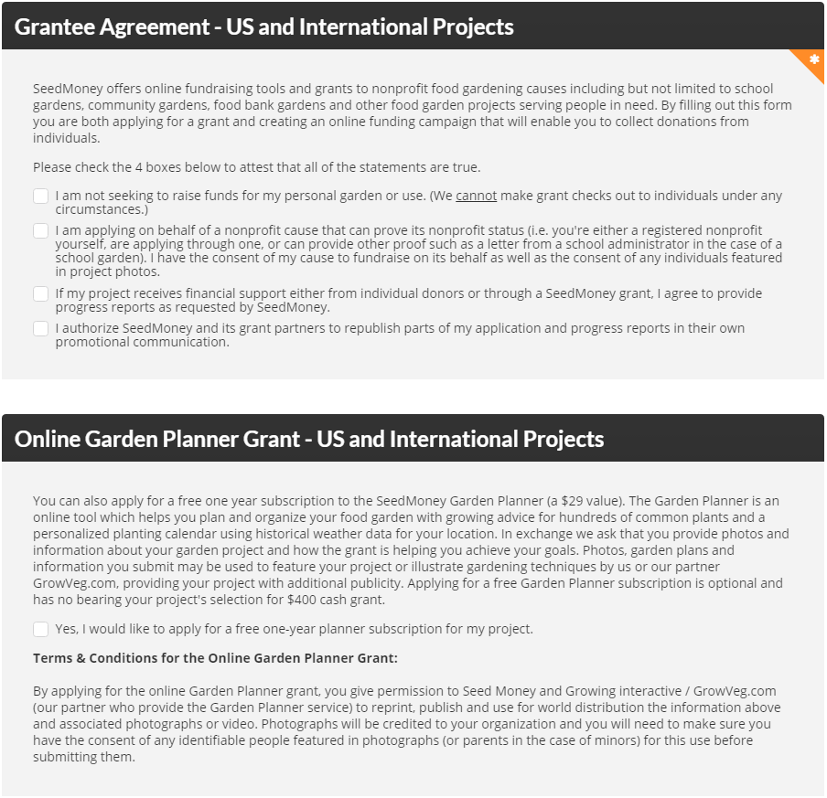

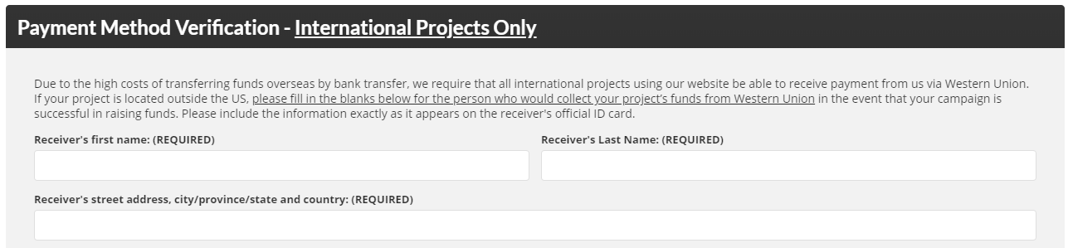
7. The next section applies only to garden projects located outside the United States. US-based projects can skip it.
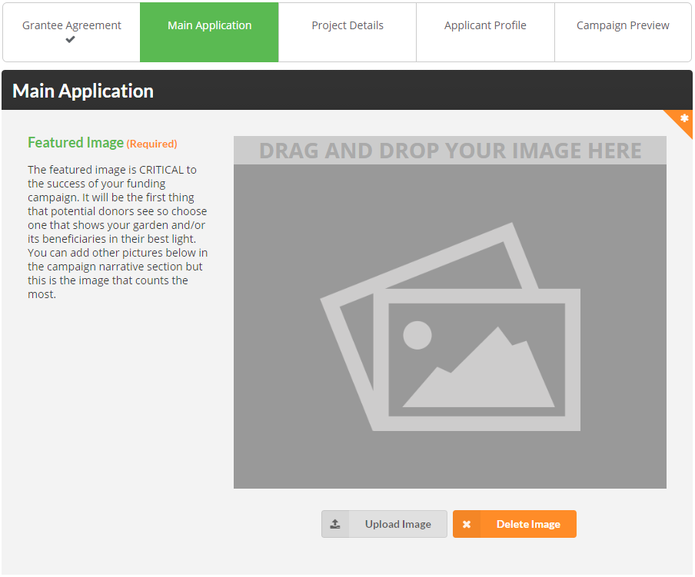
8. When you’ve completed all the applicable fields on this page, click on the blue “Next Step” button at the bottom of the page which will automatically save your answers and advance you to the next section. A checkmark will appear on the previous section to show that it is complete.

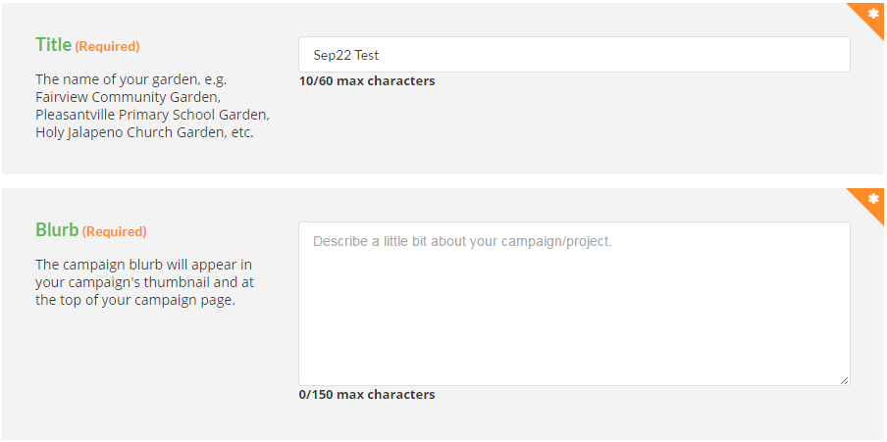
9. Continue with the next parts of that section:
Our Garden Project

Here’s a work section in case you want to write and save your blurb offline and paste it in later:

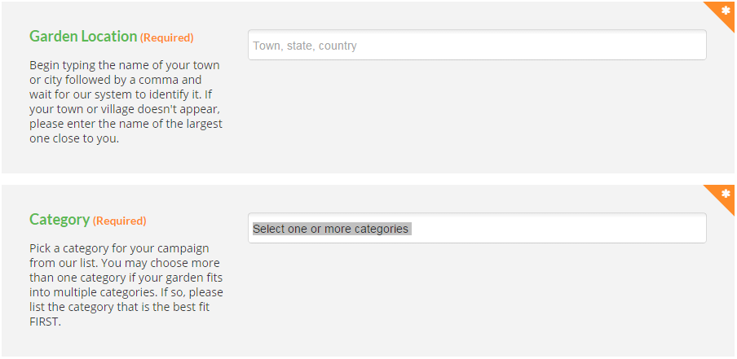
10. This is a biggie! The narrative section along with the featured image are the most important parts of your application. Take the time to get them right.
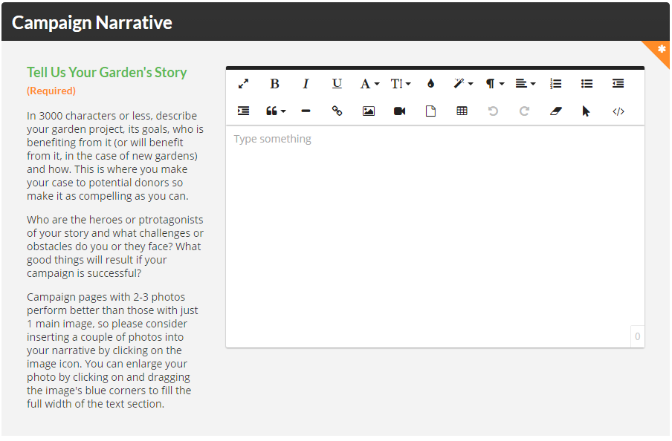
Here’s a work section in case you want to write and save your narrative offline and paste it into the online application later which we strongly recommend!

11. These next sections are important, but don’t require much work. For the funding goal section, our system automatically fills the field in with the $600 amount, but you can edit it higher or lower. We suggest choosing a goal that is realistic, yet ambitious.
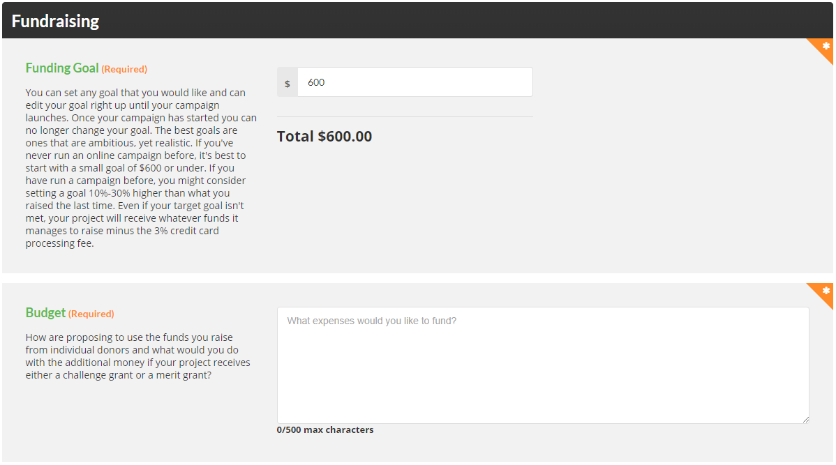
Here’s a work section in case you want to write and save your budget text offline:

12. Continue with the last part of this section and click “Next Step” to move to the next section:
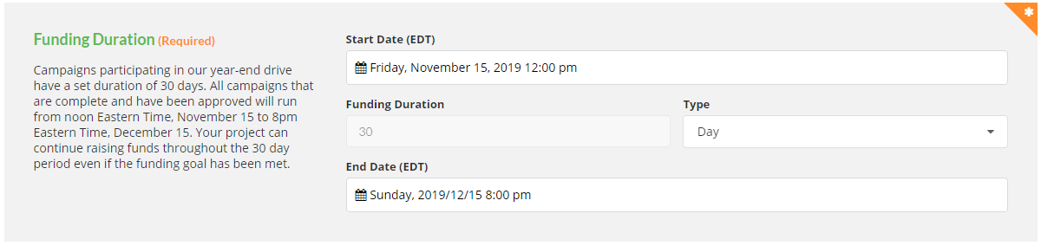

13. The next section is a breeze, just checkboxes and a couple of numbers:

14. Two more checks and you’re ready to go to the next and final step

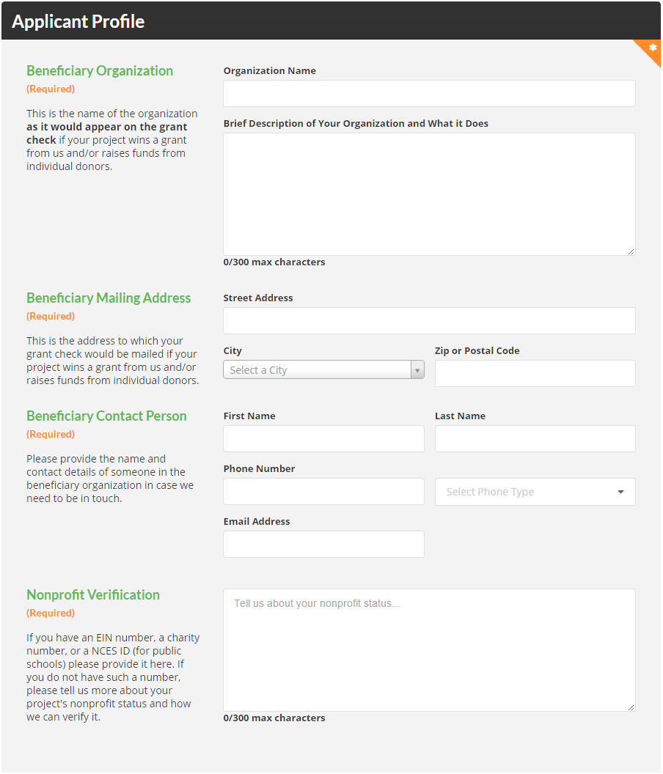
15. The last step is critical and is where we gather info that allows us to verify your project’s nonprofit status and, more importantly for you, to make a payment. The Organization Name is the name of the group that will be receiving funds for your project. This must be a nonprofit organization (a 501c3, a school, a church, a municipality, etc.); we cannot make checks out to individuals or for-profit businesses.

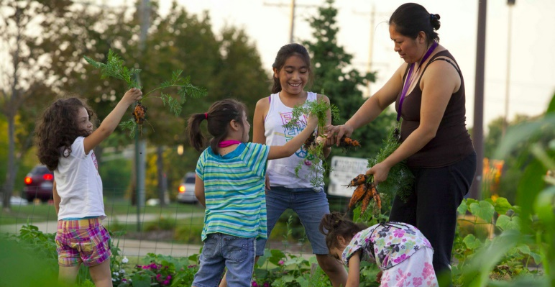
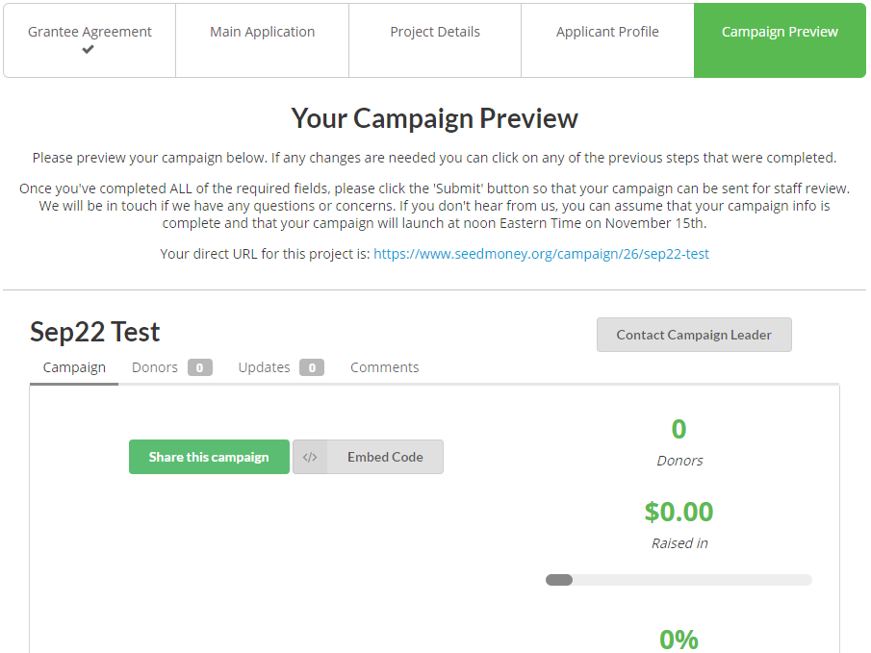
16. If you’ve completed all the required fields for each section, you can now preview your campaign page before reediting or submitting. You’ll see a page that looks like this:
Your direct URL for this project is: https://donate.seedmoney.org/campaign/26/our-garden-project
Our Garden Project

18. At the bottom of the preview page to the far right you’ll see an orange “Submit” button.

All projects must be submitted by 11:59pm Eastern, Tuesday, November 12, 2019 to be considered for a grant. You’ll receive a confirmation email from us letting you know that the application has been received.

19. Troubleshooting
If you run into trouble or just have a question, we’re here to help but ask that you seek self-help first by following the instructions above carefully first and consulting our online FAQ section. If that doesn’t work, we have a chat feature set up on our site for answering questions in real time and can also answer questions emailed to roger@seedmoney.org. If none of the above work for you, you can also call us at (207)956-0606 (we’re in Eastern Time).

