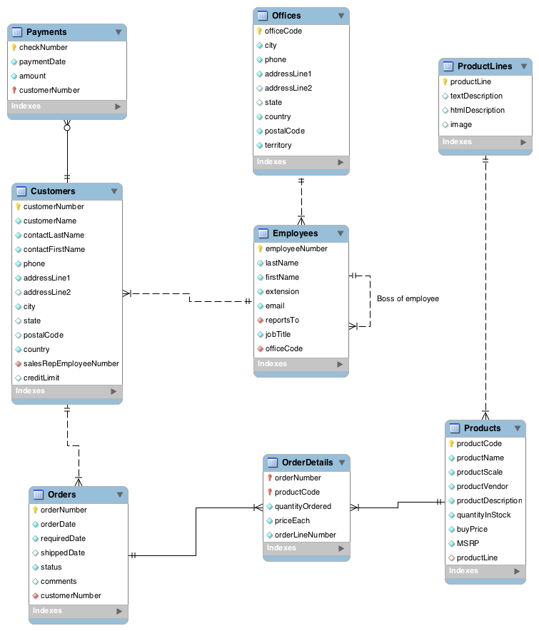

- List the names of products that start with 1945 through 1949. Sort by product scale.
- List the first and last name of employees and their extension for employees assigned to Tokyo.
- How many customers are there in each country? Sort so that the country with the most customers appears first.
- Report the order number and total value of each order received. Sort the report in descending order by total value. Format the results in whole dollars. Hint: When you format a column it becomes a string and will be sorted as such. You will need to sort on the numeric value rather than the formatted string.
- Which customers are south of the Tropic of Capricorn, which has a latitude of 23° 26′ 15.143 south (or 23.43754º S)?
- Who is the boss of the representative for Qu? Use concatenation to report the first name and last name as a single column.
- Report the total units sold for each product to Swedish customers. Sort by product name.
- Create a report listing the total payments received from each customer showing the customer’s name, customer’s total payments, and the percentage of that customer’s total payments compared to the total payments from all customers. Order by the amount paid with the highest value first.
- What is the value of the largest order received? Hint: it might be helpful to create view.
- Write a single query to report total payments by country and customers within a country.

