Save State: An Assassin Takes Any Job (Fire Emblem: Path of Radiance)

Ah, the strategy RPG. Is there any genre that’s more in need of love? I highly doubt it. Whereas the current video game industry eats up any First Person Shooter, Western RPG or just straight-up Action game, the SRPG remains a niche genre. In fact, turn based strategy in itself may already be niche, god forbid it has [i]leveling[/i] in it. “So it’s basically chess, but the pawns have faces on them?” you’ll hear people ask. To which we off course eloquently reply: “NUH-UH”! But for those of us who do appreciate a good strategy game every once in a while, there is always [i]Fire Emblem[/i].
[i]Fire Emblem[/i], a series that itself was not being released in the West until people playing [i]Super Smash Bros. Melee[/i] started wondering “who the hell are Marth and Roy?”. With Lyndis’ story on the GBA, however, Nintendo finally answered the calls of the Western gamers who couldn’t wait to jump into a series that has been so popular in Japan. But even with the GBA game, and its sequel, [i]Fire Emblem[/i] didn’t really take off until the Nintendo Gamecube got treated to a little game called [i]Fire Emblem: Path of Radiance[/i]. Ike and the Greil Mercenaries were responsible for creating many new fans of the series, and Ike himself remains a recognizable face. As we all know, he even replaced Roy in the latest [i]Smash Bros[/i]. And that’s when you know you’ve made it as a Nintendo character.
But one of the most important characters in [i]Path of Radiance[/i] has always been shrouded in mystery; little is known about him except that he loves gold. And he’s the subject of today’s Save State.
[size=16][b]As always, spoilers abound.[/b][/size]
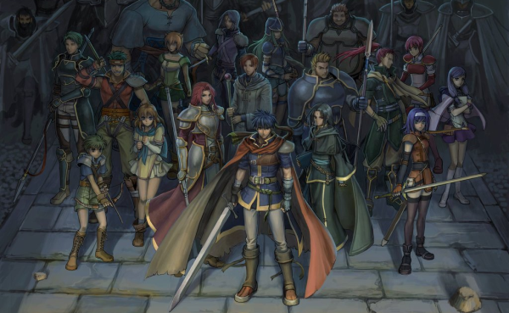
[size=16][b]The Setup[/b][/size]
The basic story of Fire Emblem: Path of Radiance is as follows. Greil, leader of the Greil Mercenaries and father to both Ike and Mist, enjoys a quiet life in the country of Crimea, where him and his loveable band of rogues make their money tossing bandits out of places where they don’t belong. Ike and Mist’s mother, Elena, died when they were both still very young. Although the mercs don’t get paid much, it’s always enough and they do good work, ensuring the safety of all.
Off course, this life of peace can’t last forever. Crimea’s neighbor Daein, under the rule of the mad king Ashnard, invades the country with brutal efficiency. As a result, the Greil Mercenaries are put on the side of Crimea’s own army, trying to defend themselves against an army that outclasses theirs in every possible way. Rather suspiciously, from the moment of the attacks Greil decides to put Ike in charge of the Greil Mercenaries, something he’s never really done before…almost like he’s preparing Ike for something.
That something soon becomes apparent. In a duel sought out by the greatest general in Daein’s army, the mysterious Black Knight, Greil is mortally wounded. Ike has to watch it happen right in front of him. And not too long after, Greil dies in Ike’s arms. The Black Knight himself is not satisfied; he was expecting more of a challenge, casually remarking: “…no…resistance?”
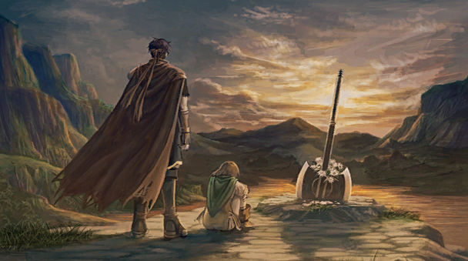
[i]- Ike and Mist mourn their father at his grave, marked by his weapon of choice: his trusty axe.[/i]
With Greil dead, Ike is the only one left to lead the Mercenaries. And that’s where our real story begins.
Not too long after Greil’s demise, a rather suspicious fellow approaches Ike. His name is Volke. He only wants one thing: to speak with Greil. He refuses to even just tell Ike what his business is with his father: Volke will speak to Greil, and Greil alone. That is, of course, until he is told that Greil has recently died. So instead, he’ll settle for Ike. Volke reveals that he is in ‘intelligence’, and is willing to share an important report for the nominal fee of 50,000 gold. While the report was meant for Greil alone, Ike is a valid substitute. But it goes without saying that the Mercenaries have nowhere near that amount of cash laying around. So I guess we’ll just send Volke on his merry way, right? How important could that report really be?
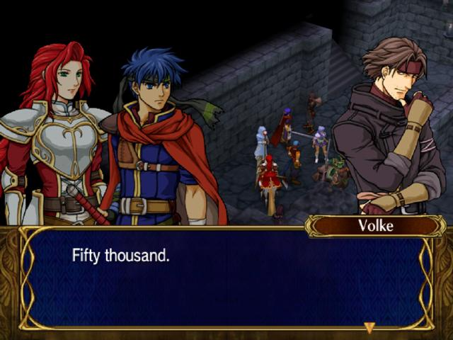
[i]- You are SO ripping us off right now.[/i]
Well, not exactly.
I mean, Volke looks like a resourceful kind of guy, and it just so happens that the Mercenaries’ next mission involves rescuing a bunch of prisoners. He [i]looks[/i] useful, at least. And who knows, perhaps a shady guy like him would know a thing or two about picking locks? As a matter of fact, he does! For a small fee of 50 gold per lock (the money-grubbing bastard!) he’ll be perfectly willing to help out the team for a little bit. And with that, Ike has a new recruit on the team: Volke, the Thief.
As expected, he instantly makes himself useful during the mission that follows. There are lots of locked cells and treasure chests around, and although he charges for each one, the gains far outweigh the costs. From even more new recruits (including fan-favorite [url=http://grandbell.net/feartwork/FE9-9/nephenee.png]Nephenee[/url]) to a whole slew of new items, Volke has more than proven his worth.
And we’re in luck too! Despite claiming that he’d only help us out for the one battle, it seems that Volke has taken a liking to the Greil mercenaries. He decides to join Ike and his team for the rest of the way. They have “sparked [his] curiosity”…and I guess he hasn’t got anything better to do? While Ike still has some suspicions, ultimately everyone decides to let Volke tag along. He’s not the most trustworthy guy, but hey. The Greil Mercenaries can use any help they can get their hands on, and he has already proven himself useful once before. Besides, as Soren observes: “He is a dubious character at best, but at least we know his motives. Everything begins and ends with gold. He'll be easy to control.” Finally, having Volke travel with them makes it all the easier to give him his money once they’ve saved up enough. It could take a while, but he doesn’t really seem to mind. For now, Ike knows his team strengthened with a shiny new knife-wielding lock-picking Thief. Permanently, this time.
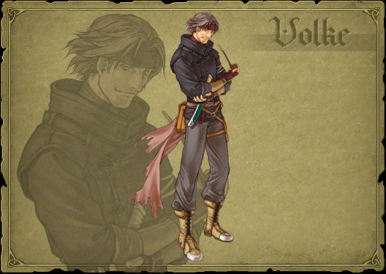
But how does this rather suspicious guy know Greil in the first place? And why did he suddenly become so cooperative when he learned that Ike was Greil’s son? Not to mention, it seems a tad difficult to believe that a Thief like him would join the Mercenaries just because he’s ‘curious’.
And on top of everything, he’s still got that report to give…
[size=16][b]The Moment[/b][/size]
A long time after Volke has joined the troupe, Ike is in for a stroke of luck. After an excruciating battle against Daein’s forces, what does he find but a whole fort full of gold! Naturally, because it’s all Daein gold, nobody has any objections to just taking the lot as spoils of war. Ike entrusts the gold to the team’s financial advisor….but there’s the little matter of that 50,000 gold he has a very good use for. After all this time, Volke has been paid. In full.
And now for that report.
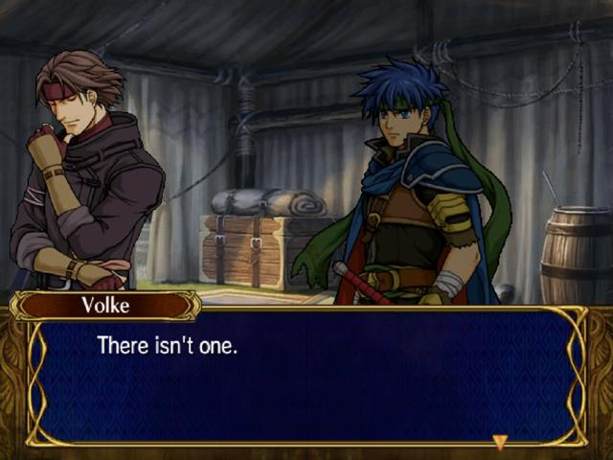
[i]- WELL FUCK![/i]
So that’s it? It was all for nothing? Well, no. It turns out that Volke never had a report that he wanted to give to Greil. But he [i]does[/i] have some other information. He just didn’t want to share it with Ike until he deemed him ready to hear…what may be a shocking truth. And the 50,000 gold? Well, he likes gold a lot. What can you say?
Volke, it turns out, once had an important contract with Greil himself. He was to shadow Greil wherever he went, and if necessary…to kill him. Volke explains it all:
Ike’s mother once possessed an historic artifact, Lehran’s Medallion, also known as the Fire Emblem. Upon her death, it went to Mist. However, dark powers rest within the medallion: anyone not pure of heart who touched it would instantly go berserk. And this is the fate that had befallen Greil. Greil was once a high-ranking general in the armies of Daein, but all of that changed when he touched the Fire Emblem. Gone berserk, Greil slayed every soldier who crossed his path with little difficulty and even less remorse. He killed enemies, complete strangers, and even friends.
In the end, he even killed that which he loved most: his wife.
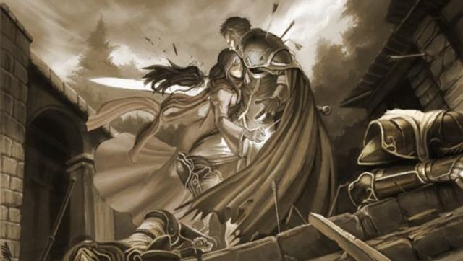
And only when he saw his wife impaled by his own sword did he regain his senses. Haunted by the vision of Elena dead by his own hand, he swore never to pick up a sword again. He was serious too: he slashed the tendons of his right arm to make sure it could never happen again. And as a final measure, a failsafe, he hired Volke to kill him if he ever went berserk again.
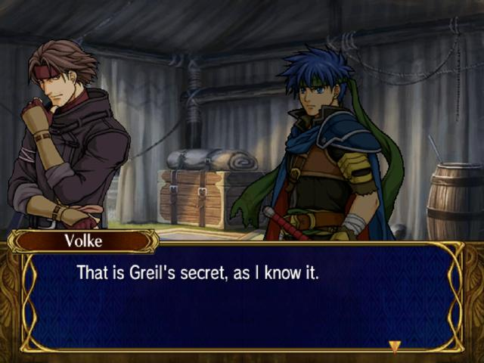
And when he has finally explained all that needed explaining, Volke offers Ike a new contract: to become part of the Mercenaries once more…and to kill Ike, should the need ever arise.
Now knowing the dangers of Lehran’s Medallion, as well as the true fate of his parents, Ike agrees.
And with that, Volke shows his true colors. A thief no longer, he becomes what he has always been:
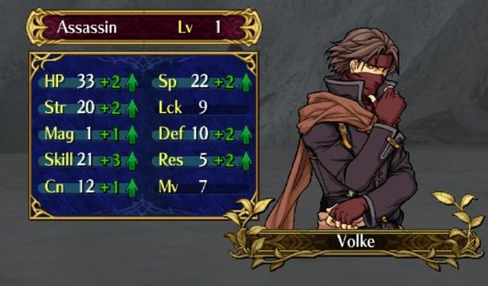
Volke, the Assassin.
Unfortunately, there’s no good video available, given that this moment is strictly text-based. This [url=http://lparchive.org/Fire-Emblem-Path-of-Radiance/Update%2041/]Let’s Play page[/url] however, does a good job of capturing it.
[size=16][b]The Impact[/b][/size]
[work in progress]
Ike realizes why the Black Knight had such an easy time slaying his father, and why he’s now after Ike himself. In fact, the only reason that Greil ever used an axe in the first place was because he made absolutely sure that he could never wield a sword again.
Volke himself realizes that the chances of him ever being able to pull of the ‘job’ were slim indeed. Greil was hailed as the best swordsman to walk the earth, and Volke knew there was no way even a stealthy assassin could ever take down Greil. Only when it becomes clear that Greil crippled himself, is Volke confident enough to take the job…if just barely.
Most importantly, he has become aware of what the mad king Ashnard is [i]really[/i] after.

