Detection of the pulsar B0329+54 with a 1.9-m dish.

A pulsar is the rapidly spinning and pulsating remnant of an exploded star.

PSR B0329+54 is a pulsar approximately 3,460 light-years away in the constellation of Camelopardalis. It completes one rotation every 0.71452 seconds and is approximately 5 million years old

Everything indicates that I may have been able to detect the pulsar B0329+54 with JRT [Job's Radio Telescope]. This dish has a diameter of 1.9 meters, which would make it the first time this pulsar has been detected with a dish of this size as far as I can tell. This result was obtained thanks to the good help and software of Michiel Klaassen.

This is the figure in which the pulsar is visible (the 'audible' audio version is being worked on).

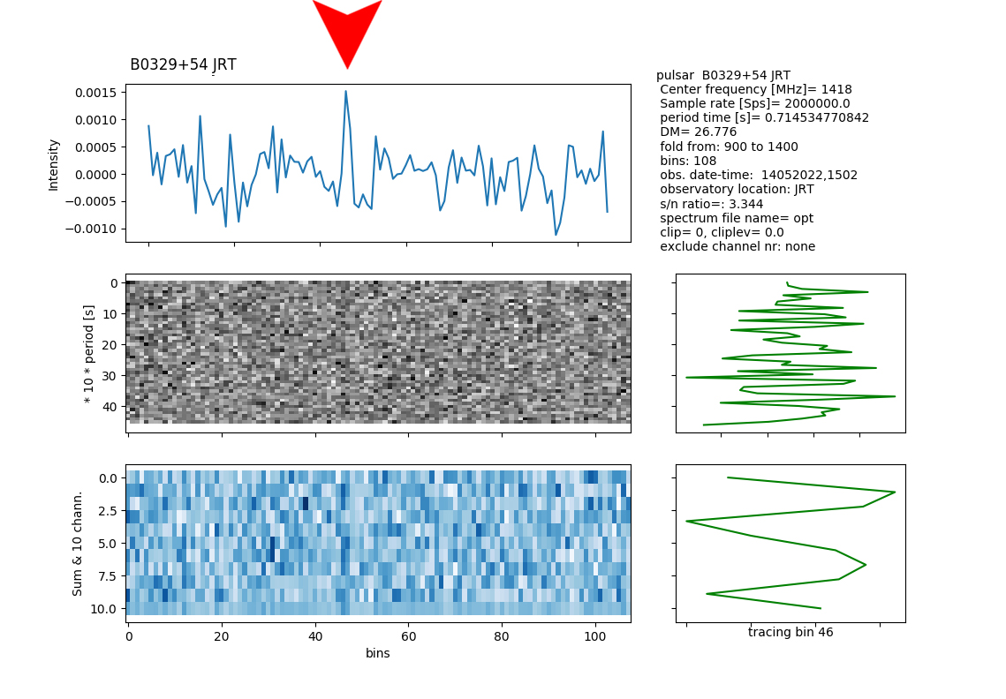

For hardware, two sensitive low noise lna’s (Low Noise Amplifiers) (ZX60-3ULN33+) and a dedicated interdigital bandpass filter were used.

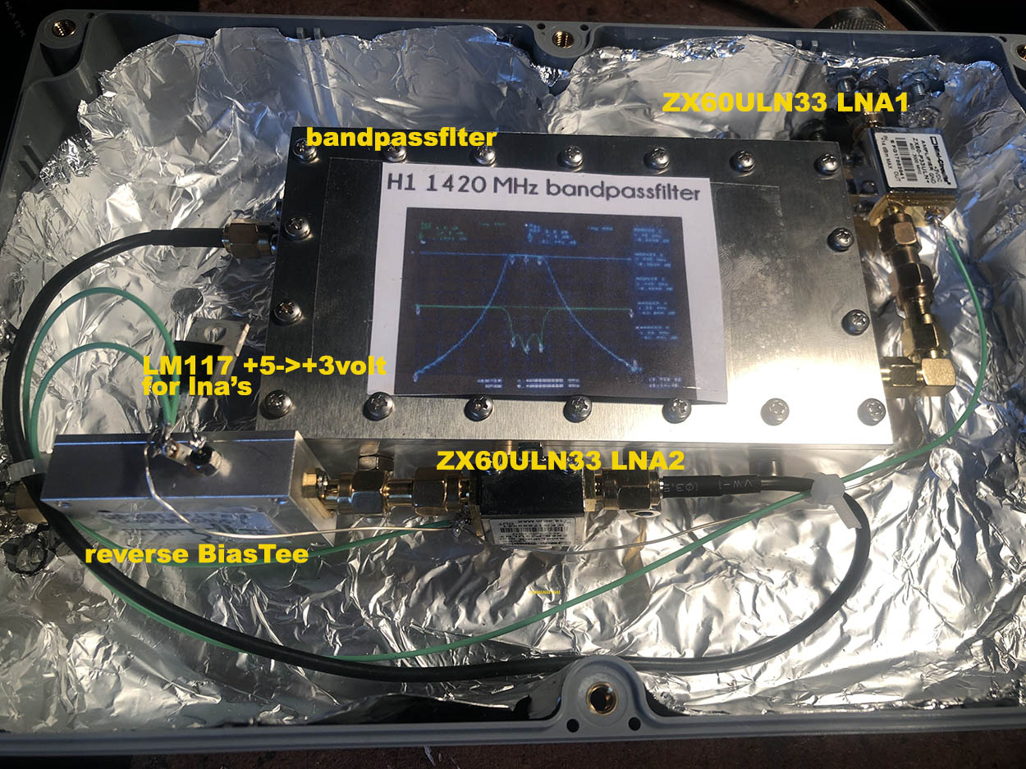

I also purchased a new (second hand) computer with the Windows XP operating system. This due to the fact that Windows 10 does too many tasks behind the scenes and that is just not the intention when I'm downloading data from a weak signal.
So there are 2 computers running, fully remote controlled (50 km). One is in charge of tracking (Radio-Eyes & PSTRotator) and the Windows XP computer is in charge of downloading the data (rtl_sdr.exe).

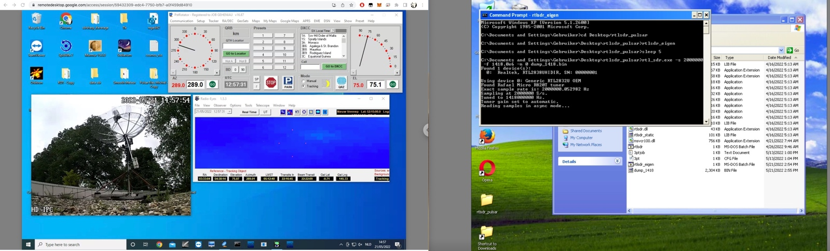

I also used a (newly) purchased Nooelec Smart SDR to avoid frequency and samplerate drift.

The software was written by Michiel Klaassen and is dedicated to capture pulsars.
You can find it on his website http://parac.eu under project MK17.
In this particular case the pulsar was recorded at 1418 MHz with a samplerate of 2 MHz.
Date May 14, 2022.

Of course I will test the result by making more recordings.
To be continued for sure. For the time being pretty proud of this unique result!

By the way, Michiel himself gives an excellent explanation of the difference in detecting a continuous signal (e.g. HI - neutral hydrogen) or a pulse (pulsar B0329+54).

I quote:

“
Measurement of H1.
This is a, in time constant, signal. To get a stronger signal there are several possibilities.
One is stacking or integrating. This is a number of samples in a register put. An FFT function is performed on these samples. The result is a spectrum. This is in a sum register each time added. Cfrad adds for example 100000 spectra in 5 minutes. After 5 minutes the final result is divided by 100000 and written to the disk as a file.
As a reference or 'dark' a region with little H1 is looked at. The first two files are often used as a ref (2X5 minutes). If there is a lot of RFI, curve fitting can also be used.
The ref is now used to correct the other measurements for the non flat pass band, so; correct measurement= measurement*1/ref=my method.
The result is an amplitude plot as a function of frequency.

Measuring pulsars.
This is a time varying but repeating signal.
Again, the signal is so small that summation is required. However, this cannot be done immediately. Due to the greater delay of the low frequency signal compared to the high frequency part (DM), the peaks come in one after the other, as it were. Direct addition makes no sense.
A way to solve this is to take a number of samples in a register and then take the FFT. Then divide that frequency band into 10 or 20 parts. Each frequency band bin is now shifted more or less (de-dispersion) and written to file.
In the plot script, all 10 or 20 spectrum band bins are shown.
All spectrum band bins are now added up and give the pulsar profile. Adding all corrected periods gives the same result.
By writing the spectra bins per period to file, a summation decision can be made per period; e.g. an RFI rich channel can be excluded from summation. Also you can see individual pulses=my method.
The result is an amplitude plot as a function of time.
“
End quote

Job Geheniau
May 2022
Website (new and under construction!) https://jgeheniau.wixsite.com/radio-astronomy

