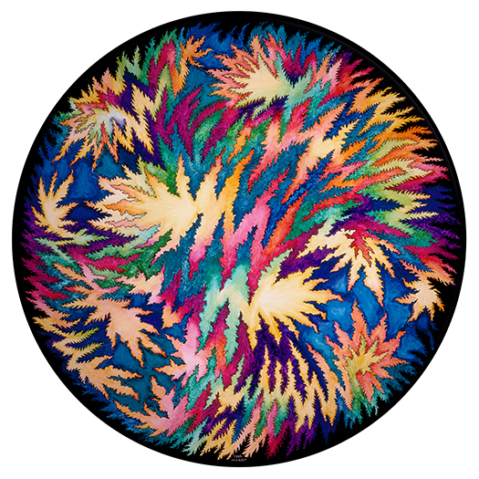

“ESSENTIAL MYSTERIES IN ART AND SCIENCE”
Trudy Myrrh Reagan’s pop-up exhibit at
Rinconada Library, 1213 Newell Rd., Palo Alto
17 days only!
January 11-28
Open Wed.- Sat. 10-6, Thurs. night 6-8 pm

Reception Saturday, January 22, 1-4 PM
Outdoors at the entrance nearest the art center.
An opportunity to buy her “Essential Mysteries” book!

Myrrh is showing the illustrations from her Essential Mysteries in Art and Science book. They are vivid circular images, fine art reproductions of her large abstract paintings created over 20 years. With them, she interprets a dozen different realms of science. The science behind the paintings comes to life in a dozen well-researched essays about them.
“I loved your artistic portrayal of complex systems of science made intelligible to the lay person. Even things that appear quite static are, in effect, teeming with life bumping into each other and being transformed. Through your colorful and insightful book, one sees the interconnectivity of all of life. Root systems actually communicate through the tips of their roots!” —Bette Spencer, buyer

View her delightful YouTube, https://www.youtube.com/watch?v=mugQ_FQqU1Y
For more information, contact Trudy Myrrh, trudy@myrrh-art.com, and re weather for the event, 650-856-9593.

