1) From KALE’S book Page no 87&88:
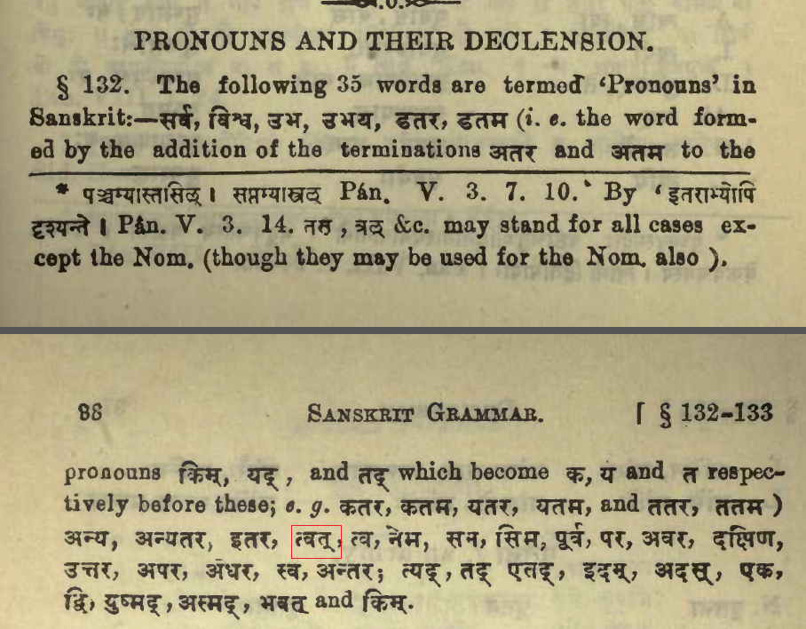

2) SabdaManjari Pages 72 & 73
