SADTU, NAPTOSA & SAOU JOINT MEDIA STATEMENT

11 September 2015
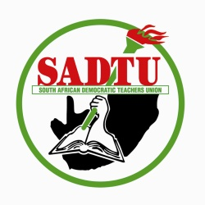
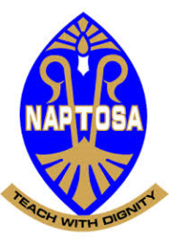

SAOU

TEACHER UNIONS UNITE ON THE 2015 ANNUAL NATIONAL ASSESSMENTS (ANA)

South Africa’s major education unions SADTU, NAPTOSA and SAOU welcome the joint decision to postpone the 2015 ANA until 2016. The decision was taken following lengthy deliberations between the Department of Basic Education (DBE) and unions in the Education Sector on 8 and 10 September 2015 in Cape Town and Durban respectively following a call from SADTU to its members not to administer ANA until the DBE comes to the table and deal with the matter of education in a responsible manner.

The postponement will allow for the remodeling of the ANA by a joint task team that will comprise of Union Principals and Senior DBE officials. It was also agreed that the remodeling will take place before the end of 2015.

Furthermore, the Unions welcome the commitment by the Director-General (DG) of the DBE to improve relations between the Department and Unions as well as making more resources available for teacher development. The DG also committed to address the outstanding issues in the Education Labour Relations Council (ELRC) as a matter of urgency.

Educators are reminded that the Unions supported the initial intention of the ANA as a systemic evaluation tool, but are opposed to the manner in which the ANA evolved into a high-stakes annual assessment system. The Unions called for the annual assessments to be substituted to be done in three year cycles in order to create space for engagement with stakeholders, remedial action and fit for purpose interventions. The Unions are also not in favour of the extension of the ANA to include other grades in addition to the initial focus grades namely, Grades 3, 6 and 9.

We are pleased that the DBE finally adhered to Unions’ requests regarding the challenges presented by the ANA and is committed to working on remodeling the assessment system for future implementation.

The date of February 2016 as indicated in the DBE statement is misleading because the new national assessment system will be a product of the Task Team work. We want to highlight that the DBE will not succeed in its attempt to avoid the conclusion of collective bargaining outstanding issues such as 0,5% parity, EMS and others. There will be no ANA in 2016 but a remodeled national assessment tool. There will be no ANA in 2015.

The gazette regime has fallen and consultations and collective bargaining will be strengthened moving forward. Freedom of association is a fundamental human right and no one can undermine it including the Department of Basic Education.

END OF STATEMENT

For further information contact:

Mugwena Maluleke - SADTU General Secretary: 082 783 2968

Basil Manuel – President ,NAPTOSA 079 508 6228

Ted Townsend - SAOU Media Officer 076 401 0342

