**Manisha Chowk – Vasna Road – Bhayli – Ampad – Sindhrot & back**

**TP – 26 km Before Mini river bridge**

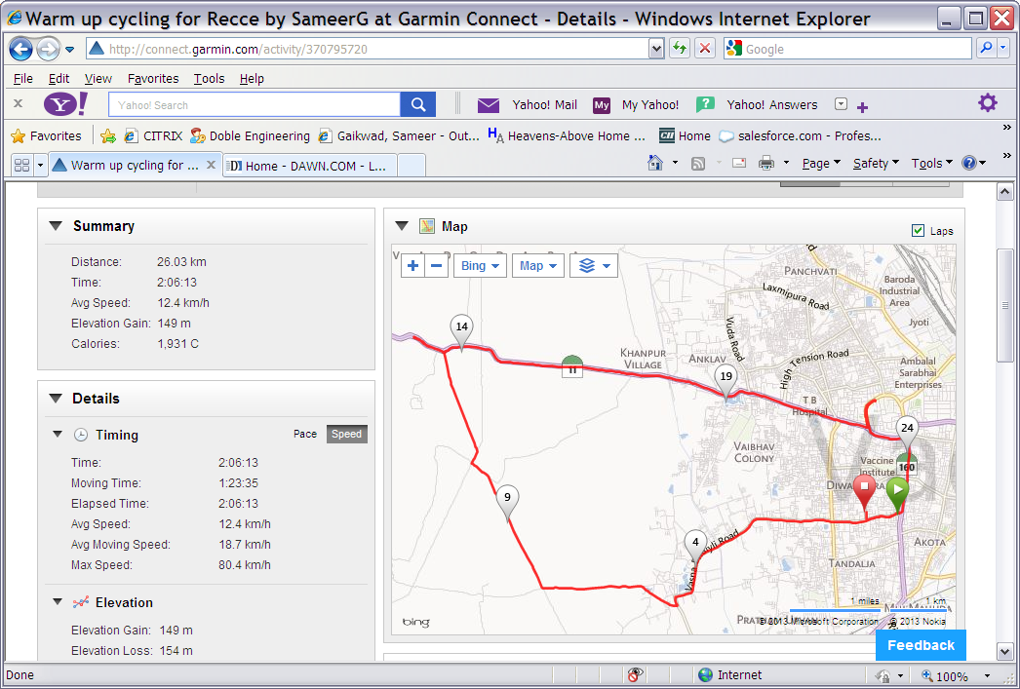

**TP – 21 km Ampad**

**TP - 5 km Shrishti Bnglws – No street light zone starts**

**TP - 10 km Inside Bhayli**

**TP - 15 km Sindhrot rd jn**

**MNC / Start - Finish**

**Notes:**

* **No dog menace noticed on Vasna Road (slight possibility opp Bina Nagar – 500 mtr from MNC)**
* **5 km TP (Shrishti Bunglows). 10/15/21/26 km runners to continue straight. Dark area starts. Head light / torch necessary.**
* **10 km TP is exactly on the T-junction of Bhayli-Padra road after entering the Bhayli village. 15/21/26 km runners turn right to move towards Sindhrot from here.**
* **15 km TP is exactly on the junction of Bhimpura-Sindhrot road. 21/26 km runners turn right to move towards Sindhrot from here.**
* **HM TP is immediately after the left curve on Sindhrot road - 500 mtr after Ampad village turning right.**
* **26 km TP is just before the Mini river bridge after the downhill gradient.**
* **If cardio at gradient not required for the long run then return from the Y junction @ Sindhrot road cross to clock 25 km.**