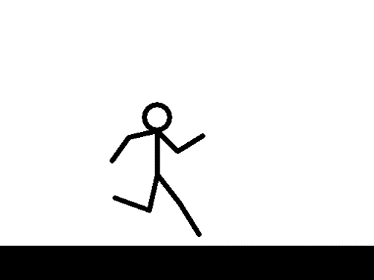
Attention all Running Friends! Olympic Trials Party time

The Olympic Trials in Atlanta is to be broadcast this weekend on NBC. Team Florida coach Enoch Nadler plus 2 of his elite – Kelly Griffin and Morgan Hull – are representing US! Although many of his group have gone to Atlanta, we’re planning on partying with the big screen TV!

When: This Saturday February 29th, 2020
12:00 - 3:00 p.m.
Where: Jenny Freeman’s house
Address: 3623 NW 46th Place
Number to call if you get lost: (352)378-0365
Details: Jenny’s making vegetarian chili and rice, John’s bringing cornbread, I’m bringing fresh fruit. Bring meat if you want! Bring anything else to snack on – or just come, we will have plenty! (Sounds like a tailgate party with a big screen…)

RSVP please by Friday afternoon: text to Jenny’s cell phone (352) 378-0365
Or email breezyeckenrode@gmail.com

