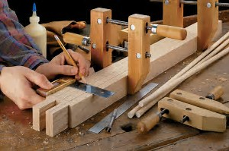

Woodworking Space Available

1 have an affordable woodworking space available to share with a couple of people. It is a 1500 square foot shop with all major tools available. 3hp unisaw table saw, 8 in jointer, 15 inch planer, drill press, band saw, panel saw, etc. We have room for 2 people. If you would like a place to run your business or hobby space, please call
303-902-8856

Heading 1
Want to insert a picture from your files or add a shape, text box, or table? You got it! On the Insert tab of the ribbon, just tap the option you need.

