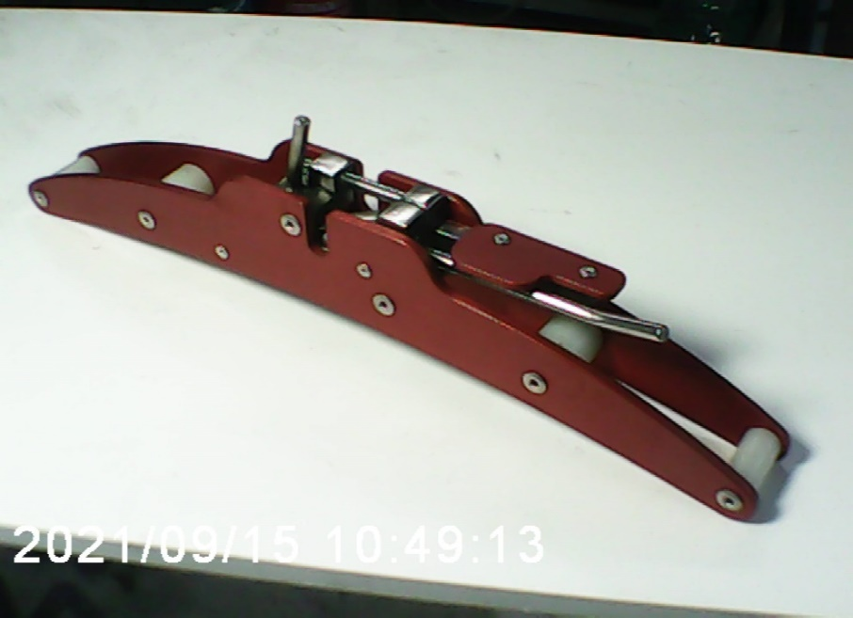
The Surface Tow Release STR-1
By Tides-Afab LLC.

This release was developed to fill the needs of a regional group, but for manufacturing feasibility, we are now making it available, on limited terms, to a larger audience.

The basic frame design is similar to ones produced for a while in Europe. However, our units are specifically created and tested to fulfill the performance criteria cited in the towing textbook, “Towing Aloft by Dennis Pagen”
The first requirement is that the frame can sustain loading to 600# without deformation.
Our larger frame prototype with 1/8” plates showed deformation at 330#. This prototype had over 50 trouble free flights. STR-1 is made with a smaller profile* but 3/16” plates which passes the 600# test and is ONLY 2 Grams more in weight than the P-type.
The latch mechanism is common to most others; however, the design has had the geometry optimized for tangential motion of the latch and radial motion of the pin. This allows the mechanism to easily fulfill all of the release force requirements of the “Towing Aloft” criteria” *
All of the materials, (stainless steel, anodized aluminum and nylon) are chosen for some rather brutal environmental tests; including 300 hrs. immersion in silted brine and then repeat the pull tests. The latches and springs are deliberately exposed for ease of inspection and cleaning. We recommend that the unit always be stored in the open position to minimize the reduction of spring preload. This is a sealed assembly and is not owner serviceable. Factory service is available if required.
(*) Refinements prompted by pilot input.
Base Pricing: per unit $218.00 + CTrst $13.85 = $231.85 (USD)
Add for Ground Shipping: + $12.00 US / +$15 Canada

SALES AGREEMENT

By execution of this purchase, the buyer agrees that: Because WE, (Tides-Afab LLC. Its assigns and heirs) have no control or input as to the final use of this product, WE assume NO LIABILITY or responsibility for any and all incidents directly or indirectly associated with its use. The buyer / pilot-in-command is fully and solely responsible for the effective use of this product.
BUYER- Sign___________________________________Date____/___/_______
Print______________________________________________________
USHPA#_____________________Rating________
ADDRESS_________________________________________________________
TOWN/CITY______________________________STATE______ZIP___________
Email_____________________________________________________________
Phone____________________________________________________________

STR-1 Serial #__________________ Date sold______/_______/____________

Purchase Procedure: (Because of production limits in a one-man shop:)
First Call Peter at 203-980-7147 to reserve a serial number.
Second: When I have your unit ready to ship, I will then ask for you to mail me your payment with the signed Sales Agreement.
Third: Your unit will be sent out immediately upon receipt of your payment.
Payments: Personal checks or Western Union money orders are preferred.
Made out to: Tides-Afab LLC.
Mail to: 635 Silver Sands Road, Area 54
East Haven, CT 06512

