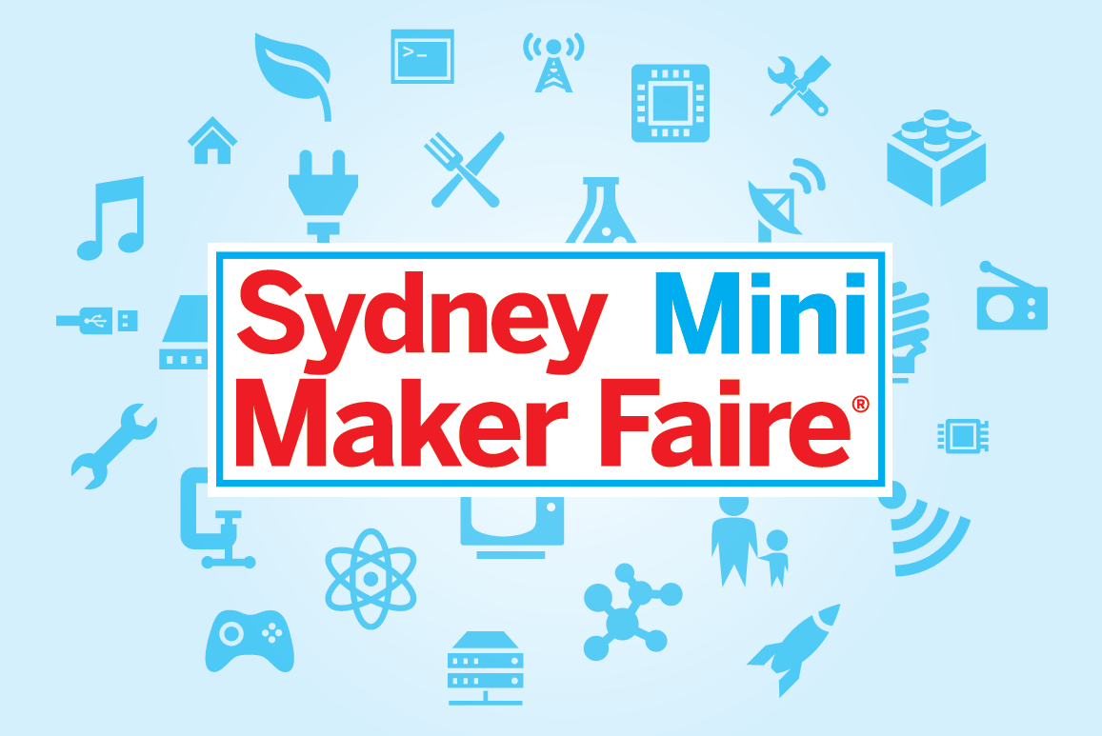

2015
Maker Manual

Sydney Mini Maker Faire is an event independently organised and operated by the Powerhouse Museum under license from Maker Media, Inc.

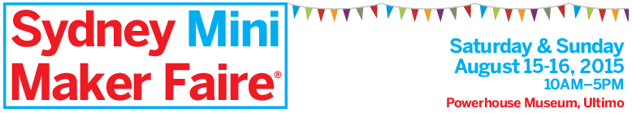

MAKER MANUAL

Maker Faire is the Greatest Show (and Tell) on Earth – a family-friendly showcase of invention, creativity and resourcefulness, and a celebration of the world-wide Maker movement. It’s a place where people show what they are making, and share what they are learning.

Sydney Mini Maker Faire is returning to the Powerhouse Museum for its third year as part of the Sydney Science Festival 2015. Over two days you will have the opportunity to showcase to the public the various ways you are championing the maker movement, whether through your ideas, products or new design applications and processes. We encourage you to spread the word and share the details with your networks.

Date Saturday 15 and Sunday 16 August 2015
Venue Powerhouse Museum, 500 Harris Street, Ultimo NSW
Hours 10.00am to 5.00pm each day

THE VENUE & SYDNEY SCIENCE FESTIVAL

The Powerhouse Museum boasts a unique and diverse collection which spans history, science, technology, design, industry, decorative arts, music, transport and space exploration. It is also home to the material heritage and stories of Australian culture, history and lifestyle, providing a comprehensive insight into this rich and diverse country.

The Sydney Science Festival has been developed to consolidate and amplify the promotion of National Science Week events across Sydney. Coordinated by Museum of Applied Arts and Sciences (MAAS), the Festival aims to encourage an interest in science among the general public and young people, and will provide an opportunity to highlight Sydney’s scientific credentials and foster partnerships between the community, research organisations and industry.

EVENT CONTACTS

If you have any questions in the lead up to the Sydney Mini Maker Faire, please contact:

Daniel Green Producer, Sydney Mini Maker Faire daniel.green@maas.museum
Janson Hews Manager, Partnerships and Festivals janson.hews@maas.museum
FOR YOUR INFORMATION

Thank you for your interest, and congratulations on your successful application to participate in the Sydney Mini Maker Faire 2015 (SMMF 2015).

Project participation in SMMF 2015 is subject to compliance with the ‘Terms & Conditions’ outlined during the application process. Your application to participate in the event constitutes your acceptance of these ‘Terms and Conditions’, and by accepting these conditions you are hereby entering into a ‘Stallholder Agreement’.

WHAT HAPPENS NEXT?

In addition to preparing your projects for the Faire, there are some formal requirements:

For all Commercial Maker Stallholders:
- Prepare for payment of your Commercial Maker Stallholder Fee ($200) to be made to the Powerhouse Museum on the Maker Registration Day (contact sydneyminimakerfaire@phm.gov.au if you are unable to attend the registration day for alternative payment arrangements). Payment can be made by cash or credit card.

In addition, for All Stallholders:
- Prepare your documentation:
  - Contact your insurer to arrange a current Certificate of Currency for Public Liability insurance, or contact sydneyminimakerfaire@phm.gov.au to arrange cover for a fee of $80.
  - Read the Contractor Induction Manual and sign Contractor Induction form
  - Complete and sign your Safe Work Method Statement (SWMS)

Completed forms and Certificate of Currency should be emailed to sydneyminimakerfaire@phm.gov.au by 7 August, or brought with you on the Maker Registration Day Saturday 8 August.

- Closer to the date you will be sent a Bump-In/Out schedule with your project’s allocated times and details. Make sure you review this schedule.

- We encourage participants to use social media to spread the word to your networks, get them excited about coming along to see your projects - Like, Tweet, Share, Follow etc! Check out: http://makerfairesydney.com/ Use: @MakerFaireSYD #MMFSYD

KEY DATES AND DETAILS

MAKER REGISTRATION DAY
A project representative must attend the Maker Registration Day scheduled one week before the event (contact sydneyminimakerfaire@phm.gov.au if there are any issues):

Date Saturday 8 August
Time 10am-1pm (including testing and tagging)
Venue PLC Rooms, Level 2, Powerhouse Museum 500 Harris Street, Ultimo

In addition to payment of the Commercial Maker Stallholder Fee and tagging and testing of electrical equipment, there are important documents which need to be submitted on the day:
- Valid Certificate of Currency for Public Liability Insurance up to $20 million (or payment of $80 to be made to the Powerhouse Museum on this day in lieu of individual Public Liability Insurance)
- Signed SWMS and Contractor Induction forms, if not already emailed to sydneyminimakerfaire@maas.museum

BUMP-IN Saturday 15 August
Bump-In for all Makers will be on Saturday 15 August between 7am – 9.30am.
Each Maker will be allocated an individual bump-in time. These times must be strictly adhered to. You will be notified by Sydney Mini Maker Faire staff about this process in the week leading up to the Faire.

Please bring your site map with you to assist in locating your allocated site. To prevent traffic jams and general congestion, we ask that you be prepared to simply unload/drop off your wares and then return to your site to unpack/set up after moving your car from the loading zone (please see parking in the glossary of key information for more information on parking near the museum). We suggest that you bring a friend to help you do this.

SITE ENTRY
You may enter the Powerhouse Museum to complete your set up from 7.00am. Upon arrival you will need to collect your identity lanyard from Powerhouse staff in the Level 1 Courtyard. Ideally please bring an assistant with you for the day to look after your stall if you need a break.

All Makers are expected to remain on site for the full opening hours from 10 am – 5pm.

Note that each stall will be provided with two (2) Mini Maker Faire lanyards, enabling museum entry. All those issued an identity lanyard must wear it visibly for the duration of the event and may be requested to show it to security upon re-entry to the building. If there are issues regarding the number of lanyards please contact us prior to the event. Friends and family visiting the Faire will be required to purchase a museum entry ticket.

BUMP-OUT Sunday 16 August
Bump out for all Makers will begin on Sunday 16 August at close of trading hours, from 5pm and must be completed by 7pm. These times must be strictly adhered to.

You are responsible for keeping your site clean & tidy. Please bring cloths, hand brooms, bags etc to leave the area clean as you will find it. This is when your friend will come in particularly handy!

WHAT WE PROVIDE YOU

- 1 x unclothed trestle table (Size is 1.8m (L) x 0.75m (W) x 0.94 (H).
The max load for the table is 100 Kgs.*
- 2 x chairs*
- Power source (if requested and confirmed in advance)
- 2 x Sydney Mini Maker Faire 2015 identity lanyards per stall to be worn on site at all times.
- Basic signage with your project name

- *If your stall has been allocated more tables and/or chairs in line with your application, this is what you will be provided with

THINGS FOR YOU TO BRING

- Everything you need for your project
- Table cloth or coverings for your allocated table
- Additional coverings if you wish to cover your stall/display overnight
- Extension cords, powerboards, adapters, cable ties etc
- Comfy shoes and clothing (you may be standing for most of the day)
- Your own additional signage and BluTac or 3M “Command” adhesive products if required
- Marketing materials, information brochures, business cards etc
- Pens, notebook, general stationery
- Email / Mailing list sign-up sheet

For those selling items on the day:
- Cash Float (Enough change for sales)
- A safe storage container or till for cash
- Calculator
- Price tags/bags/wrapping paper/boxes
- Price/inventory list
- Receipt book
- Wholesale catalogue/order forms
- EFTPOS machine (if applicable). Please note you will need to arrange for a mobile ETFPOS unit directly with your bank. Please be aware there is no ATM on site at the Powerhouse Museum.

ON THE DAY Maker Checklist

- Please bring your Mini Maker Faire site map and Welcome Pack with you

- Please pick up your Sydney Mini Maker Faire lanyards (2 in total) from a member of the Maker Faire crew upon arrival at the Museum, Courtyard Level 1

- Please bring a friend to assist you

- Bring your equipment already tested and tagged

- Bring your equipment charged (if needed) and chargers

- Bring additional signage if required, BluTac or 3M brand “Command” adhesive tapes, spare fixings and goods for clean up

- Bring your phone/camera/video/ipad or device to capture the moment

- Please bring a portable Wi-Fi internet connection if needed

HANDY STALLHOLDER TIPS

- Network with other stallholders, staff and visitors. Make friends with your neighbours – this can be particularly helpful for bathroom breaks!
- Consider how to arrange your space for maximum impact and access – The museum attracts a lot of visitors and you want to look your best.
- Have business cards, flyers etc on your table for people to take away with them and refer to later on.

- If you’re going to sell items, make sure prices are clearly marked, consider hiring an EFTPOS machine or taking orders. There is no ATM available onsite.
- Show how your product is used – this could be through the use of photographs, models, a demonstration or computer screen. Show their functionality. If your projects are wearable, make sure you have them on.
- Do some research and prepare yourself for the day – check out images from last year’s event, post messages to ask fellow practitioners for advice, contact Mini Maker Faire staff to ask questions.
- Have fun!

GLOSSARY OF KEY INFORMATION

AMENITIES
Disabled access toilets are located on level 2 & 4. Other toilets: level 3 behind the café, and in the level 1 Courtyard and North West corner. See Museum map for further detail.

Cancellation of Event
Final decisions regarding cancellation for safety reasons will be made by the event Project Managers and participants will be advised accordingly.

DISPLAYS WITH POWER
Makers with power requirements will be asked to set up at a specific time in the Bump-In schedule, when technical assistance will be available. There are important Testing and Tagging requirements which must be conducted prior to the Bump-In of the event, on the Registration Day (Saturday 8 August 2015), see below.

Note that all Makers are required to provide their own electrical equipment including extension cords, adapters and powerboards etc, there will be none available onsite. All electrical equipment must be tested and tagged prior to use at the Powerhouse.

ENVIRONMENTAL COMMITMENT
As an Environmental Commitment from you, we ask you to please respect the Museum building and grounds by taking all rubbish home with you for recycling or disposing of it in the bins provided. Your cooperation and support for waste minimisation is appreciated.

FIRST AID
Powerhouse Museum Gallery officers will be present onsite during the event and will be responsible for First Aid action if required. All incidents need to be reported as outlined in the Contractor Guidelines.

FOOD AND DRINK
In order to protect the collection and loan objects on display throughout the Museum, we must maintain strict environmental controls, and ask all visitors to the Museum to adhere to the policy of no food or drink within the Museum building. There is a large outdoor Courtyard and eating area on Level 1.

INSURANCE
$20 million Public Liability Insurance for conducting business outside of normal premises is compulsory for all stallholders. A valid certificate of currency, available from your insurance broker, must be presented with your paperwork on Registration Day (Saturday 8 August 2015). If you do not have your own Insurance the Museum can arrange cover for you from an approved Insurance Broker for an additional fee of $80 per stall, to be paid on the registration day. If you do not have Public Liability Insurance, please contact sydneyminimakerfaire@maas.museum for further information.

LOST & FOUND PROPERTY
Any lost property found should be handed over to Powerhouse Museum Gallery officers, or taken directly to Lost Property at the front counter on Level 3. To claim lost property, valid identification and description of the items must be provided.

PARKING
There is no on-site parking at the Powerhouse Museum. During the Bump-In/Out times, there will be a designated point for unloading and loading your exhibit/merchandise, within the Museum’s loading area, entered via Macarthur Street (off Harris St). You will then be required to move your vehicle for the rest of the day.

The Entertainment Centre car park, close to the Museum, offers a discounted fee upon presentation of a validated ticket. Don’t forget to validate your ticket before leaving the museum for the day, by presenting your Sydney Mini Maker Faire lanyard at the Museum Shop, to receive the discounted rate. For more details visit:
https://maas.museum/visit/powerhouse-museum/

SECURITY
Please do not bring computers, valuables and or other equipment until the day of the event or allocated Bump-In time. During the event, make sure your personal valuables are safely stored within your area and that you do not leave valuables unattended at any time. Large bags and coats can be stored in the cloakroom on Level 3.

Although there will be Security within the building, the Powerhouse Museum will not be held responsible for any damages or loss while on the premises.

SIGNAGE
The only approved methods of temporarily attaching any project signage to the museum walls are either BluTac or 3M brand “Command” adhesive products. Please bring these with you if you are planning on affixing temporary signage.

TESTING AND TAGGING
All electrical appliances, which will be used at Sydney Mini Maker Faire (including hired equipment) must have current tag and tested certification. Failure to do this will result in the inability to use the item. It is a Work Health and Safety requirement that all equipment is tested and tagged prior to the event opening to the public at 10am.

Two testing and tagging opportunities will be made available:
- at the Registration Day on Saturday 8 August, between 10am and 1pm
- on the opening morning of the Faire on Saturday 15 August from 7.00am, to be completed by 9.30am

VOLUNTEERS
Volunteers will be present during the course of the weekend to assist with the Sydney Mini Maker Faire with a focus on assisting the public. They will be identifiable by lanyards labelled Maker Faire Crew/Volunteer. Please be aware that Volunteers are not available to mind stalls.

WI-FI/INTERNET
There is free wireless internet is available throughout the Museum and its cafes, with varying signal strength in different parts of the building. After establishing Wi-Fi settings on your phone or device, select the PHM Visitor network and accept the terms of service. For more details visit: https://maas.museum/visit/powerhouse-museum/

The SMMF organisers are unable to guarantee WIFI access for all stalls. If it is essential that your exhibit requires Wi-Fi for certain operations, please advise us as soon as possible by emailing sydneyminimakerfaire@maas.museum

WORK HEALTH & SAFETY (WHS)
To ensure that we are adhering to WHS regulations, the WHS Act 2011 and WHS Regulations 2011, all stallholders entering any area of the Museum of Applied Arts and Sciences premises (Powerhouse Museum), will be required to provide the following documentation prior to or on Maker Registration Day:

- A current Certificate of Currency for Public Liability insurance as listed in the Insurance section.
- Contractor Induction Sign Off (see attached) is required to be completed and signed by all those unloading/packing up on the Museum site. In order to complete this form, contractors will be required to read the attached Contractor Manual (see attached).
- Safe Work Method Statement (SWMS) to be completed for the work to be undertaken, and signed by all participants (see separate SWMS attachment)
Please forward the above three (3) documents to sydneyminimakerfaire@maas.museum by 4pm on Friday 7 August or bring them along to Maker Registration Day Saturday 8 August.

