RCBus Specification

Pre-release
for review and feedback

Version 0.0.005
7-March-2023

Introduction 3
History 3
The Bus 3
Backplanes and Modules 5
Bus Connectors 6
Bus Pin Assignments 7
Bus Signals 9
Common Signals 9
RCBus-2014 10
RCBus-Z80 10
RCBus-68xx 10
RCBus-9995 11
RC2014 Compatibility 13
RCBus-Z80 13
Bus Profiles 13
Minimal 13
RCbus 40 13
RCbus Enhanced 14
RCBus 80pin 14
Appendix A - Background 15
Appendix B - RC2014TM USER Pin Usage 17
Appendix C - Bus Conventions For Mapping Motorola Busses 19
Introduction 19
Mapping The Bus 19
Mapping The Extended Bus 19
Additional Signals 20
Notes 20
Appendix D - Circuit Board Shapes and Sizes 21
Appendix E - Terminology 22
THE END 23
? 23
Notes, leftover bits and incomplete stuff followsUnresolved Issues & Notes 23
Guidance for Designers - contribution #1 25
Sub-specification specific signals 25
Address bus 25
Memory map 25
Introduction - contribution #1 26

Introduction
This document is the reference description for the Retro Computer Bus (RCBus) version 1.0. It is intended to guide the implementation of compatible devices on the bus. The goal of RCBus is to provide an environment for the development and exploration of digital electronics. This guide therefore should be considered as a reference not as law. Developers are positively encouraged to use the bus in innovative and bizarre ways.

History
The RCbus has its origins in Spencer Owen's RC2014 (retrochallenge 2014) entries and the simple passive Z80 bus interface it used to plug simple one or two function cards into a backplane. Spencer went on to launch a business (rc2014.co.uk) based upon this concept and the product range was trademarked
as RC2014TM.

Over time the bus evolved and has been modified, used (and abused) in a variety of ways by other parties, notably the 80 pin BP80 extensions to the original for Z180 systems.

RCbus is a specification based upon that generalization of that bus, and a branding for it that avoids confusion with the RC2014 product line, and also RetroChallenge 2014 (RC2014).

The Bus
This document describes the RCbus in terms of the passive backplane and plug in cards. Nothing precludes some of those cards being combined or the bus being an extension bus (possibly one of several extension busses) for a single board computer or other arrangement.

The underlying concept of the RCbus is a passive bus that carries mostly Z80 compatible signals using 5v signalling and with CMOS parts to keep the bus signalling low power and the fan out high. These design choices avoid the need for complex buffer circuits on the cards and make the bus much more accessible to newcomers.

The backplane consists of between 40 and 80 lines including power. The bus is not usually terminated nor is this necessary. There is no maximum number of card slots specified by the bus design but at 8MHz systems with over 15 cards appear to operate quite reliably.

A backplane may contain multiple variants of the slots. Several have a mix of 80 and 40 pin slots for example. A backplane may also contain combinations of RCbus and other bus interfaces providing compatibility is maintained.

Cards stand vertically in the backplane slots. If placed horizontally additional mechanical support for each card is likely to be required. The minimum spacing between cards should be [TBD]. It may be useful to allow additional space with some slots as certain cards are much deeper than normal. Suggested card profiles can be found in chapter XX. Cards should not dip down below their connector in order to gain space at the ends, as the backplane may itself have components alongside, but below the height of the sockets.

Power is supplied to the cards via the bus. Care should therefore be taken both of the grounding and the sizes of power traces. Nothing precludes a card with high power demands also having a direct power connector to the bus 5v/ground.

The backplane has signals that were historically referred to as "USER" signals. Some of these signals have other recommended uses in the RCbus standard but their usage remains optional and neither cards nor backplanes should assume a particular usage model for these lines.

RCbus is somewhat "legacy free". Most RCbus systems do not provide signals for dynamic RAM refresh and there are no 12v or -5v signal lines. Signals should be at CMOS levels and the use of 74HCT/AHCT CMOS parts for all bus connected signals, particularly input signals is strongly recommended. The use of other logic types isolated from the bus signal lines is a matter for the card designer.

There are three kinds of RCbus cards. The processor card is the source of many of the signals and there should be only one. (Extending the bus to support multiple bus masters is ongoing) The second type of cards are passive cards. These provide power or control signals but are not active participants in bus traffic. Examples include clock generators, power supplies and reset controllers. The final card type is device cards. These are the consumers of the signals from the processor and are active participants on the bus.

The naming reflects the historic separation of functions on the bus. Nothing prevents a card from providing functions in two or even all three categories at once.

Backplanes and Modules
Backplanes and modules can be any size and shape, but established norms are worth following.

Below is an example of an RCBus module which has a partial second row of bus pins.
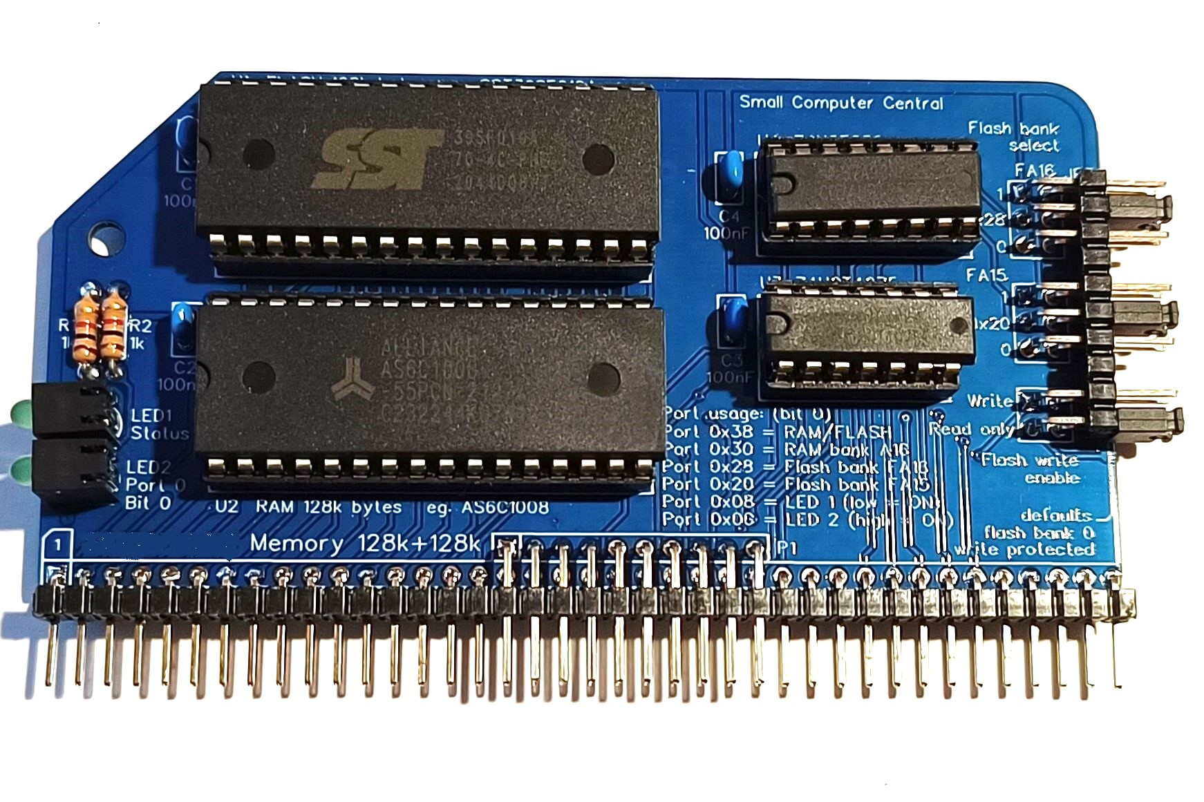
Below is an example of an RCBus backplane which has 80-pin module sockets.

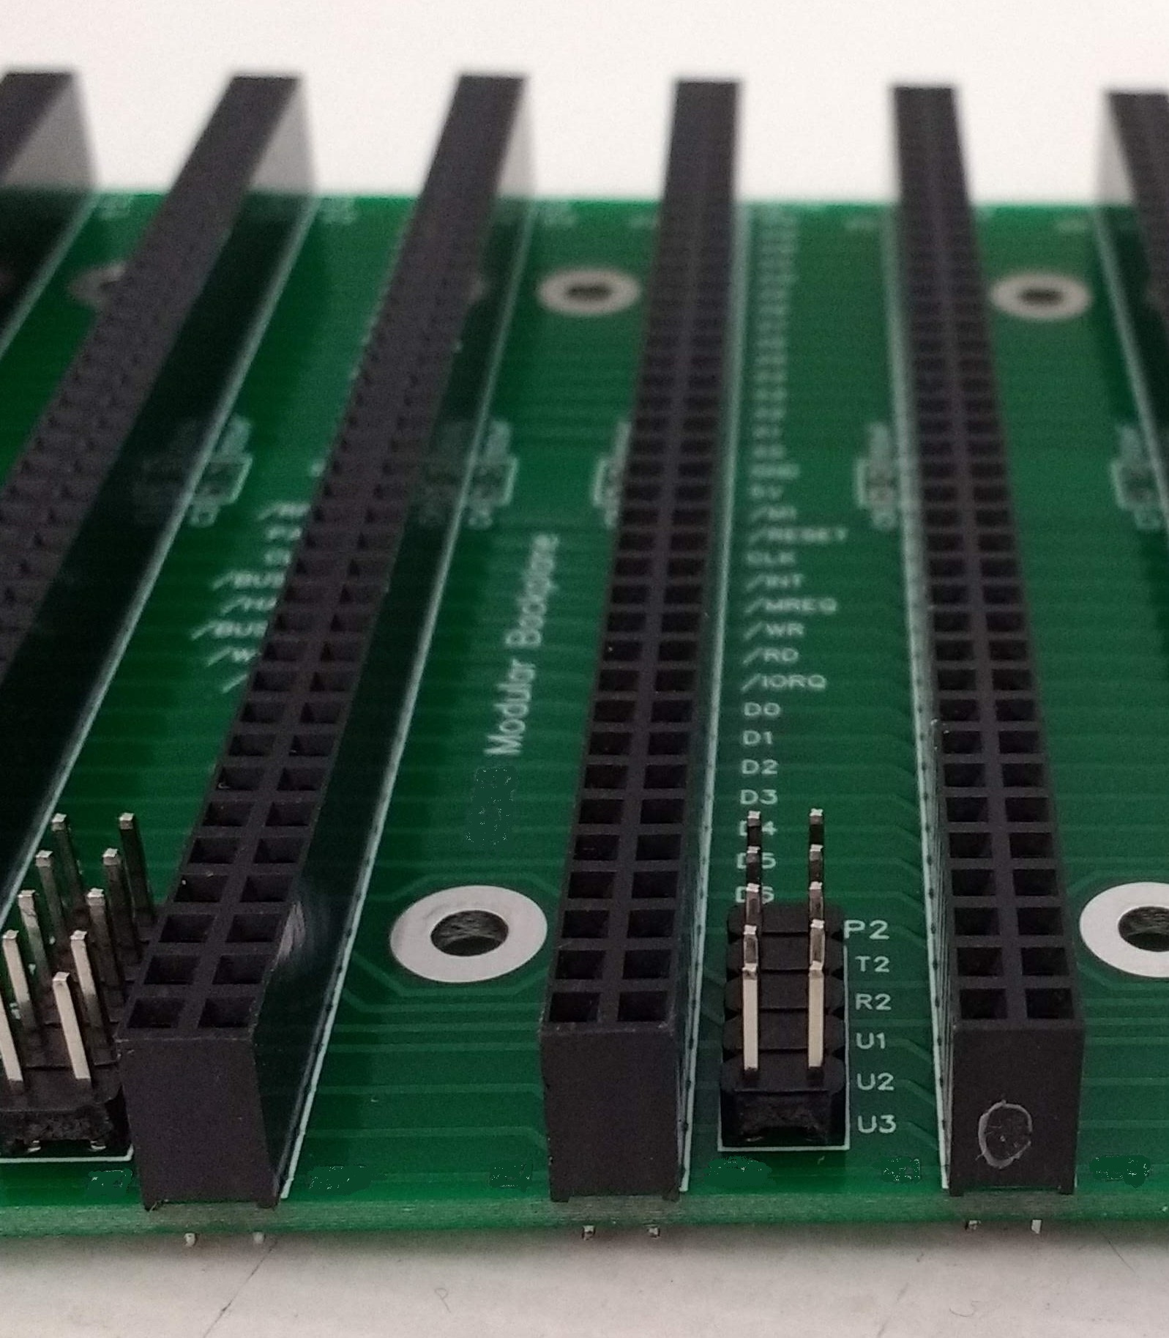

Bus Connectors
The bus connectors are low cost header pins and sockets, either single or double row with up to 40-pins in each row.

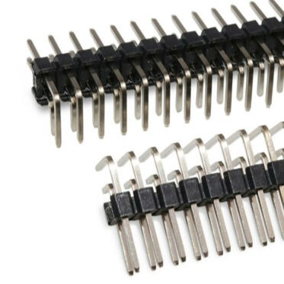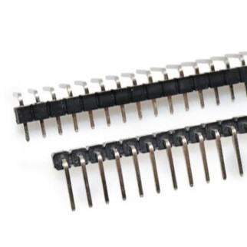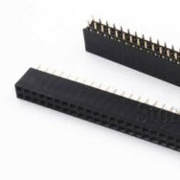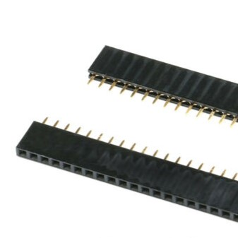

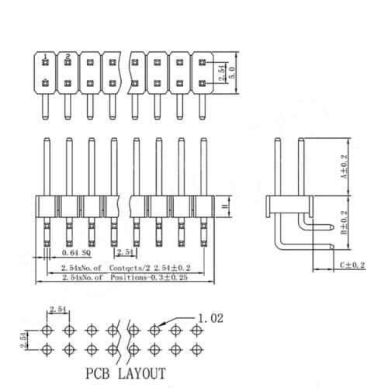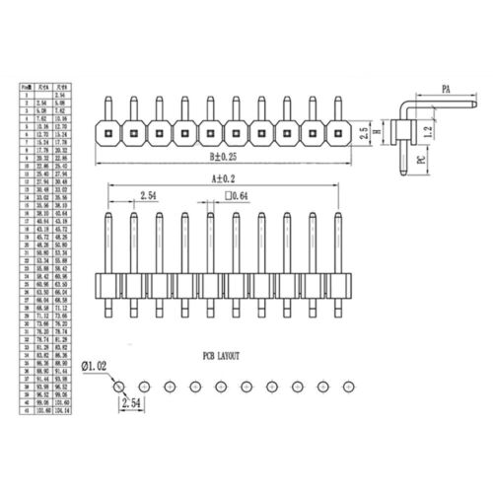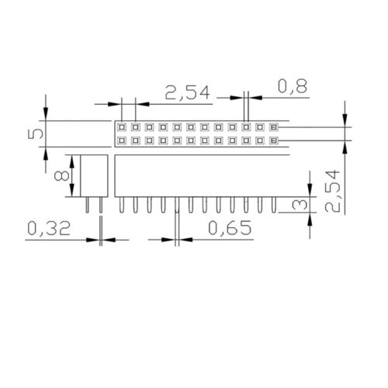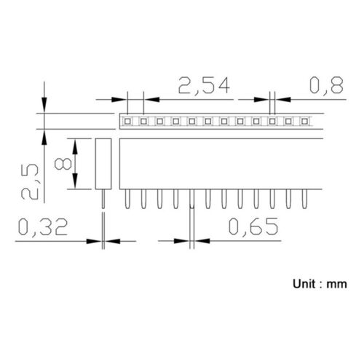
Pin length ~6mm, pitch 2.54mm

Note that the most commonly used male 1x40 angled connector has a different profile to the 2x40 connector.

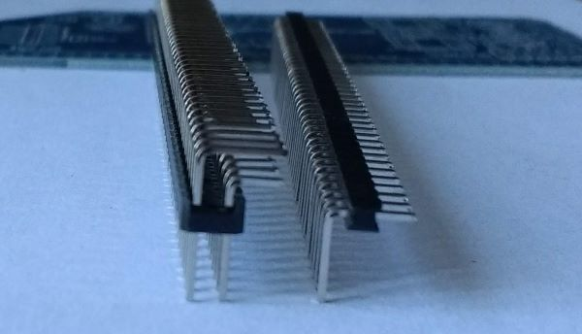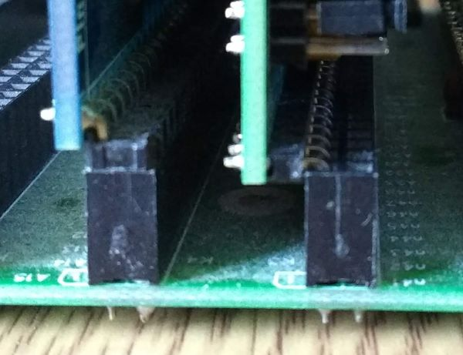

Single row bus socket viewed from above:

Pin 1
Pin 40

Front Back

Double row bus socket viewed from above:

Pin 1 Pin 40
Pin 41 Pin 80

Front Back

Bus Pin Assignments
Bus signals are either common to all bus specifications or specific to one or more specifications.

Pin  1st row | RC2014TM  standard | RCBus  backplane | RCBus  Z80 | RCBus  68xx | RCBus  9995 | Notional  16-bit CPU
1 | A15
2 | A14
3 | A13
4 | A12
5 | A11
6 | A10
7 | A9
8 | A8
9 | A7
10 | A6
11 | A5
12 | A4
13 | A3
14 | A2
15 | A1
16 | A0
17 | GND
18 | +5V
19 | nM1
20 | nRESET
21 | CLOCK
22 | nINT
23 | nMREQ
24 | nWR
25 | nRD
26 | nIORQ
27 | D0
28 | D1
29 | D2
30 | D3
31 | D4
32 | D5
33 | D6
34 | D7
35 | TX
36 | RX
 | 2014 | Backplane | Z80 | 68xx | 9995 | 16-bit
37 | USER1 | p37 | INT1 | FIRQ | MEMEN | p37
38 | USER2 | p38 1 | IEI | E | CRUIN | p38 1
39 | USER3 | p39 ¹ | IEO | RW | CRUCLK | p39 ¹
40 | USER4 | p40 | p40 | p40 | p40 | p40

¹ Backplane configurable for direct or cascade (daisy-chain) connections
Second row bus signals:

Pin  2nd row | RC2014TM  enhanced | RCBus  Backplane | RCBus  Z80 | RCBus  68xx | RCBus  9995 | Notional  16-bit CPU
41 | N/A | P41 ?  3v3
42 | N/A | p42 ¹ | BAI | p42 | p42 | p42
43 | N/A | p43 ¹ | BAO | p43 | p43 | p43
44 | N/A | p44 ?  USER# | p44 | p44 | p44 | p44
45 | N/A | p45 ?  HiLo byte | p45 | p45 | p45 | p45
46 | N/A | p46 | p46 | p46 | p46 | p46
47 | N/A | p47 | p47 | p47 | p47 | p47
48 | N/A | p48 | p48 | p48 | p48 | p48
49 | N/A | A23
50 | N/A | A22
51 | N/A | A21
52 | N/A | A20
53 | N/A | A19
54 | N/A | A18
55 | N/A | A17
56 | N/A | A16
57 | GND
58 | +5V
59 | nRFSH
60 | PAGE
61 | CLOCK2
62 | nBUSACK
63 | nHALT
64 | nBUSRQ
65 | nWAIT
66 | nNMI
67 | D8
68 | D9
69 | D10
70 | D11
71 | D12
72 | D13
73 | D14
74 | D15
75 | TX2
76 | RX2
 | 2014 | Backplane | Z80 | 68xx | 9995 | 16-bit
77 | USER5 | p77 | INT2 | p77 | p77 | p77
78 | USER6 | p78 | p78 | p78 | p78 | p78
79 | USER7 | p79 | p79 | p79 | p79 | p79
80 | USER8 | p80 | p80 | p80 | p80 | p80

¹ Backplane configurable for direct or cascade (daisy-chain) connections

Bus Signals
Signals are TTL level unless otherwise indicated.

Common Signals
This section describes each of the signals common to all processor types.

Signals are defined by their function with a Z80 CPU unless otherwise stated.

+5V Power supply +5 volts, recommended tolerance +/-0.25 volts.

+3V3 Power supply +3.3 volts. Optional.

A0 to A23 Address bus, output from CPU, active high, tristate. Typically, 8-bit processors will only use A0 to A15.

nBUSAK Bus acknowledge, output from CPU, active low. The CPU outputs a low on this line indicating the address bus, data bus, and control signals MREQ, IORQ, RD, and WR have entered their high-impedance states.

nBUSRQ Bus request, input to CPU, active low. This is pulled low by a device that wants to take control on the CPU’s address, data and control bus.

CLOCK Clock, input to CPU. System clock used for synchronisation so it should normally be the CPU clock signal.

CLOCK2 This is a second clock usually used as a clock source for a UART.

D0 to D15 Data bus, input/output, active high, tristate. 8-bit processors will only used D0 to D7. Unused data lines can be left floating.

GND Power supply ground.

nHALT Halt, output from CPU, active low. This indicates the CPU has executed a HALT instruction and is waiting for an interrupt before resuming operation.

nINT Interrupt request, input to CPU, active low. This signal should have a pull-up resistor can is pulled low by any device requesting an interrupt.

nIORQ Input/output request, output from CPU, active low, tristate. The Z80 has a separate address space for I/O devices but other processors will likely need to create a window in their memory map for I/O.

nM1 Machine cycle one, output from CPU, active low.
This signal is very specific to the Z80 and should be pulled up for other processors.

nMREQ Memory request, output from CPU, active low, tristate. Indicates that the address bus holds a valid address for a memory read or a memory write operation.

nNMI Non-maskable interrupt, input to CPU, active low. Negative edge triggered interrupt.

PAGE Page RAM/ROM, active high. Low to enable ROM and disable its shadow RAM. High to disable ROM and enable its shadow RAM. For a Z80 system the ROM is at the bottom of memory (starting at address 0x0000) following reset. This signal is set high to replace this ROM with RAM, allowing a full 64k of RAM. Perhaps a better name would be RAM_ENable. There are other memory management schemes in use that do not use this signal.

nRD Read, output from CPU, active low, tristate. Indicates that the CPU wants to read data from memory or an I/O device.

nRESET Reset, input to CPU, active low. System reset signal.

nRFSH Refresh, output from CPU, active low. Indicates a memory refresh cycle.

RX This signal is designed to allow a serial port to communicate with a device on another module. RX is an input to a serial port, such as a UART, and an output from a serial device, such as a terminal module.

RX2 A second serial communications ‘RX’ signal.

TX This signal is designed to allow a serial port to communicate with a device on another module. TX is an output from a serial port, such as a UART, and an input to a serial device, such as a terminal module.

TX2 A second serial communications ‘TX’ signal.

nWAIT Wait, input to CPU, active low. Communicates to the CPU that the addressed memory or I/O devices are not ready for a data transfer. The CPU continues to enter a WAIT state as long as this signal is active.

nWR Write, output from CPU, active low, tristate. Indicates that the CPU wants to write data to memory or an I/O device.

RCBus-2014
The following are signals specific to the basic RC2014TM bus specification.

USER# Signals USER1 to USER8 are free for the user to do as they please.

RCBus-Z80
The following are signals specific to systems using the Z80 family bus specification. Eg. Z80 and Z180.

nBAI Bus acknowledge in, input, active low. BAI and BAO form a direct memory access priority daisy-chain. BAI signals that the system buses have been released for DMA control.

nBAO Bus acknowledge out, output, active low. BAI and BAO form a direct memory access priority daisy-chain. BAO signals that the CPU has relinquished control of the bus.

IEI Interrupt enable in, input to an interrupt generating device, active high. IEI and IEO form an interrupt priority daisy-chain. A high on IEI indicates that no other device of higher priority is interrupting.

IEO Interrupt enable out, output from an interrupt generating device, active high. IEI and IEO form an interrupt priority daisy-chain. IEO is high only when IEI is high and this device is not requesting an interrupt.

nINT1 Interrupt, input to CPU, active low.

nINT2 Interrupt, input to CPU, active low.

p## Reserved

RCBus-68xx
The following are signals specific to systems using the 68xx, 63xx and 65xx family bus specification.

nFIRQ Fast interrupt request, input to CPU, active low.

E Data bus enable, input to CPU, active high.

RW Read/write, output from CPU. High for read operations, low for write operations.

p## Reserved

RCBus-9995
The following are signals specific to systems using the TMS9995 family bus specification.

nCRUCLK CRU clock, output from CPU, active low.

CRUIN CRU input data,input to CPU, active high.

nMEMEN Memory enable, output from CPU, active low.

p## Reserved

RC2014 Compatibility
For an RCbus device to be RC2014TM compatible it should use only those pins specified in the RC2014 specification and support Z80 timings. It should work with a 7.3728MHz signal on clock.

For an RCbus CPU card to be RC2014 compatible it should provide at least all the signals in the base RC2014 specification. The processor must be a CMOS Z80 and if providing the clock should provide the clock at 7.3728MHz.

A strictly RC2014 compatible device or processor is a strict subset of RCbus. There are, by intent, no conflicts between the two.

RCBus-Z80
The Z80 processor only operates correctly with Zilog peripherals if the processor and peripherals are running from the same clock. Therefore it is normally desirable that the bus CLOCK is the Z80 input clock and this means that any card generating the system clock should generate a signal suitable for the Z80 processor. In particular the signal levels should be close to 5v and to ground. An RC2014 compatible CPU card will run at 7.3728MHz, and some peripheral cards require this.

The Z80 interrupt chain allows the use of IM2 interrupt mode. This mode has advantages but also significant restrictions. If more than four cards are actively on the chain then the backplane must contain lookahead logic (as per Zilog documentation). In addition it is not possible to reliably mix IM2 using devices and classic interrupts. Developers therefore may want to consider the ability to route some slot interrupts to Z80CTC or PIO pins to use them as an interrupt controller.

Bus Profiles
These are suggested levels of functionality and combinations of signals to rely upon when creating boards or processor cards.

Minimal
The following signals are present
+5, GND, A7-A0, D7-D0, IORQ, INT, RD, WR, RESET

The following signals will be pulled high or valid
M1, MREQ

This subset is designed to allow the use of I/O devices on RCbus slots in a system which is otherwise self contained or uses other bus interfaces.

RCbus 40
The following signals are present
+5, GND, A15-A0, D7-D0, IORQ, MREQ, INT, RD, WR, RESET

The following signal will be pulled high or valid
M1

A clock signal may be present but the value is undefined.

This subset allows the use of memory and I/O cards and contains the functionality that can reasonably be relied upon regardless of the processor card that is in use.

RCbus Enhanced
This matches the enhanced RC2014TM bus pins.

As well as the RCbus 40 lines /WAIT and /NMI become available as well as the /RFSH, /BUSRQ and /BUSAK for Z80 processors. The RC2014 specification also includes D8-D15 and PAGE but these are nor relevant to RCbus in general.

A clock signal may be present on CLK and one may be present on CLK2 but their value is undefined.

RCBus 80pin
A23-A16 are added to the bus. Processor cards only drive the lines they support. This means that a memory card that is designed to support a larger number of address pins than the processor will need jumpers or to pull up those lines. Some processor cards do pull up address lines for other reasons (bus mastering) so if the line is pulled in a direction it should be up.

On the standard 80pin systems using the Z180 processor the CLK will be the Z180 clock (often 18.432MHz) M1 will be valid and lines A16-A19 will be in use.

Appendix A - Background
To understand what the RCBus is and why it exists, it is necessary to consider what has led us here.

In 2014 Spencer Owen created a modular version of Grant Searle’s Z80 computer design, which he called RC2014. He began selling it on Tindie and in 2016 he gave up his job and worked on RC2014 full time.

The RC2014 system attracted a community of enthusiasts, some of which made RC2014 compatible modules, as encouraged by Spencer’s website: “If your module may be of use to other RC2014 owners, please consider sharing your design or selling them yourself. I’m happy to help you with this and to spread the word. Note that “RC2014” is a registered trademark, so you are not allowed to call your module “RC2014 [thingy] Module” or use the RC2014 logo. However, feel free to mark your modules as “Designed for RC2014.”

Before long there was talk of extensions to the RC2014 bus.

In 2018 the topic “New backplane -wishes ?” led to Spencer posting the following on 17-June-2018:

“I've been musing over enhancements to the backplane for a little while now, and whilst nothing is set in stone, the pin layout would follow this;

Enhanced |  | Standard |  |  | Enhanced |  | Standard
A31 | 1 | 1 | A15 |  | Clock2 | 21 | 21 | Clock
A30 | 2 | 2 | A14 |  | BUSACK | 22 | 22 | INT
A29 | 3 | 3 | A13 |  | HALT | 23 | 23 | MREQ
A28 | 4 | 4 | A12 |  | BUSRQ | 24 | 24 | WR
A27 | 5 | 5 | A11 |  | WAIT | 25 | 25 | RD
A26 | 6 | 6 | A10 |  | NMI | 26 | 26 | IORQ
A25 | 7 | 7 | A9 |  | D8 | 27 | 27 | D0
A24 | 8 | 8 | A8 |  | D9 | 28 | 28 | D1
A23 | 9 | 9 | A7 |  | D10 | 29 | 29 | D2
A22 | 10 | 10 | A6 |  | D11 | 30 | 30 | D3
A21 | 11 | 11 | A5 |  | D12 | 31 | 31 | D4
A20 | 12 | 12 | A4 |  | D13 | 32 | 32 | D5
A19 | 13 | 13 | A3 |  | D14 | 33 | 33 | D6
A18 | 14 | 14 | A2 |  | D15 | 34 | 34 | D7
A17 | 15 | 15 | A1 |  | Tx2 | 35 | 35 | Tx
A16 | 16 | 16 | A0 |  | Rx2 | 36 | 36 | Rx
Gnd | 17 | 17 | Gnd |  | USR5 | 37 | 37 | USR1
5v | 18 | 18 | 5v |  | I2C SDA | 38 | 38 | IEI
RFSH | 19 | 19 | M1 |  | I2C SCL | 39 | 39 | IEO
Page | 20 | 20 | Reset |  | USR8 | 40 | 40 | USR4

However, on 16-June-2019 Spencer created the topic “Upcoming changes to the RC2014 bus and ecosystem“ in which he stated “RC2014 will not be changing” and further clarified this by stating “The RC2014 bus does not support IEI/IEO modules. Through-hole components are used. And the physical bus will not be changing.”

This came as a bit of a blow to those who were looking to build on the RC2014 system and led to a discussion about how to move forward. This discussion didn’t produce any solid answers.

On 31-Jan-2023 Spencer created the topic “What has an RC2014 and a Hoover got in common?” in which he stated the following:
”RC2014 is a trademark under British law, belonging to RFC2795 Ltd (ie my company).”
“All of these kits carry the RC2014 name and RC2014 logo, and are labelled as being RFC2795 Compliant.”
“Any other kit is NOT an RC2014.”
“All sellers seem to do a very good job of making the distinction in their listings. But I don't think it is doing anybody any favours by calling a non-RC2014 machine an RC2014, least of all to the creators of compatible machines.“

This led to another discussion about the future in which it was suggested that a new name be found for products that have a degree of compatibility with RC2014 products but are not made by RFC2795 and are thus not RC2014 products. To this suggestion, Spencer wrote: “RCBus or RC80 Bus sound good to me. It takes the essence of what the bus is without limiting it by what the RC2014 natively supports.”

Spencer’s official description of an RC2014 remains:
“RC2014 is a simple 8 bit Z80 based modular computer. It is inspired by the home built computers of the late 70s and computer revolution of the early 80s. It is not a clone of anything specific, but there are suggestions of the ZX81, UK101, S100, Superboard II and Apple I in here. It nominally has 8K ROM, 32K RAM, runs at 7.3728MHz and communicates over serial at 115,200 baud.”

Much of what some in the retro computer community wish to do with their RC2014 based systems does not match this description.

And thus the RCBus project was created.

Appendix B - RC2014TM USER Pin Usage
The RC2014TM bus has a number of spare pins, usually called USER pins. These have been used by designers to add functions not provided by the defined bus pins. The RCBus specification attempts to maintain compatibility with the most common uses. The following is a list of some of those uses.

Product | Pin 37 | Pin 38 | Pin 39 | Pin 40 | Pin 77 | Pin 78 | Pin 79 | Pin 80
RC2014 | USER1 | USER2 | USER3 | USER4 | USER5 | USER6 | USER7 | USER8
BP80 | USER1 | USER2 | USER3 | IEO | USER5 | USER6 | USER7 | IEI
SC102  Z80 CTC | BCT3* | IEI* | IEO* |  | BCT0* | BCT1* | BCT2*
SC103  Z80 PIO |  | IEI* | IEO*
SC104 Z80 SIO/2 |  | IEI* | IEO*
SC110  SIO+CTC | CTC3* | IEI* | IEO* |  | CTC0*
SC111  Z180 CPU | INT1*
SC112  Backplane |  |  |  | IEO |  |  |  | IEI
SC113  Backplane |  |  |  | IEO |  |  |  | IEI
SC116  Backplane |  |  |  | IEO |  |  |  | IEI
SC126  Z180 SBC |  |  |  | IEO |  | SCL*  (I2C) | SDA*  (I2C) | IEI
SC132  Z80 SIO/0 |  | IEI* | IEO*
SC149  Z80 CPU | BUSAK* | WAIT* | BUSAK* | NMI*  BUSAK*
Z80 CPU + CTC module (TP) | CTC3* | IEI* | IEO* |  | CTC0*
Z180 MPU (TP) | INT1* |  |  |  | INT2*
Z280 MPU (TP) | INTA* |  |  |  | INTC*
Universal SIO (TP) |  | IEI* | IEO*
DUART (TP) |  | IEI* | IEO*
16450/550 (TP) | IRQ* |  |  |  | IRQ*
Network Controller (TP) | IRQ*
Basic & Modular Backplane 4 (TP) | USER1* | IEI*/USER2*  direct or cascade | IEO*/USER3*  direct or cascade | USER4 | USER5 | USER6 | USER7 | USER8
6809E/6309EP (TP) | FIRQ* | E* | RW*
65C02  65C816  6803/6303  6808  6809/6309  68HC11  65C22  6840  65C21  (Alan Cox) | FIRQ*  (some) | E* | RW*
TMS9995  (Alan Cox) | MEMEN  * ? | CRUIN  * ? | CRUCLK  * ?
* = jumpered so the end user can select if the bus pin is connected or not

Product | Pin 37 | Pin 38 | Pin 39 | Pin 40 | Pin 77 | Pin 78 | Pin 79 | Pin 80
PPI  (Dino) | LED* | SLT_A* | CASS* | SLT_B* | OUT*
Easy-Z80  (Sergey Kiselev) |  | IEI | IEO
Z80Ctrl/CPU/IOX  (JBLangston) | SCL | MISO | MOSI |  | IOXCS | AUXCS1 | AUXCS2
* = jumpered so the end user can select if the bus pin is connected or not

Appendix C - Bus Conventions For Mapping Motorola Busses

Introduction
The Motorola style 8-bit bus differs considerably from the bus expected by the conventional RCBus. It is possible to map from one to the other but it can be useful when integrating Motorola bus devices to make the Motorola bus signals available.

This appendix documents the existing conventions that are used for mapping a Motorola style bus to the RCBus. It is intended to be descriptive not prescriptive.

Mapping The Bus
The following signals are mapped directly onto the RCBus from the Motorola style bus

A15-A0: Address bus
D0-D7: Data bus
INT: IRQ (open collector)
RESET: RESET (see notes section)
CLOCK: (see notes section)

The Motorola bus has two different signals. E is a square wave clocking the bus. During one half of the E cycle the signals change, during the other half of the E cycle the signals are valid. There is no provision
for an "idle" cycle, instead an additional read cycle is generated. This is usually targetted at a dummy location such as FFFF but some processors will generate dummy read cycles to other addresses and this can require care and is usually handled in software.

The second signal is RW. This indicates if the cycle is a read or a write using a single line unlike the 8080/Z80 bus where \RD and \RW may both be high to indicate no activity.

The Z80 style \RD and \WR signals are generated by combining the E clock with RW so that \RD or \WR goes low only when the bus state is valid.

As the Motorola bus has no notion of a separate I/O space an I/O window is normally used. By convention this is at 0xFEXX because this address window is suitable for existing operating systems for these platforms and mirrors many historic machines. There is no requirement to use 0xFEXX as the I/O
card will generally only decode the low 8-bits of the address bus anyway.

The two signals for controlling the cycle type on the Z80 bus are \MREQ for a memory request and \IORQ for an I/O request. These can be generated by decoding the upper bits of the address generated by the processor when the bus is valid.

The final 40-pin RCBUS signal is /M1. This has no equivalent on Motorola bus processors as it is used as part of the Z80 interrupt decode not just as an indication of instruction start. The current cards pull this high so that the peripheral cards do not decode bus activity as a Z80 interrupt cycle.

Mapping The Extended Bus
The extended bus provides A23-A16, which are directly equivalent to A23-A16 on the 65C816 card.

The extended bus provides several signals that have no easy mapping. These are /BUSRQ /BUSACK and /HALT. None of these signals are used by most peripheral cards except specialist cards such as the Z80 DMA interface.

The other two signals mostly map. The \NMI signal is equivalent to the \NMI signal on Motorola bus systems (called XIRQ on some processors). The /WAIT signal is near enough the same semantics as the Z80 one that it can be provided except on the 6309E/6809E which do not support clock stretching
this way as they are intended to run synchronously with a SAM or similar device on the other half of the E cycle.

Additional Signals
Some Motorola bus peripherals are complicated (or near impossible) to operate without the Motorola bus signals. At other times it is just useful to reduce chip count to have access.

Existing Motorola bus processor cards can provide the E RW and \FIRQ signals on bus pins. Jumpers should be used as the lines are intended to be available to the user for other purposes if desired.

37 | \FIRQ | Open collector, pull up on CPU card
38 | E | E clock
39 | RW | RW signal from processor

Using these signals on a peripheral device makes the peripheral card incompatible with the basic RCbus. There is a trade-off between the convenience and simplicity of interfacing and the compatibility.

Notes

Reset
The reset signal on many classic RCbus boards is very poor. The original RC2014TM systems in particular lack a proper reset controller. The Motorola bus devices that need a clean reset (such as the 68HC11) should include their own reset controller to clean up the reset during power on.

Clock
The conventional RCbus clock was 7.372MHz. This is also conveniently a clock that generates good serial signals and a bit under 2MHz E clock for 63xx/68xx processors. There is no requirement to use this clock, but it does improve compatibility. For slower parts half this clock is similarly convenient.

The 6502 processor clock input and E clock are the same barring skew. This effectively means a 2MHz 6502 has the same timing requirements as the 7.37MHz Z80. Whilst the RCbus can be run with a high speed 65C02 or 65C816 part it will be necessary to use 74AHCT parts in general, and even then some of the standard boards such as the 512K/512K memory card will be too slow to go above about 8MHz.

Bus Hold
68xx and 63xx series devices have a bus hold time (the time that signals remain valid on the data and address bus after \WR rises) that is broadly compatible with the Z80 timings used on the bus. The "classic" 6502 and 65C02 parts likewise do. Modern 65C02 and 65C816 parts have almost no bus
hold. On a backplane it becomes necessary for the processor card to cut the \WR signal early in order to produce a bus hold, otherwise many RCbus cards will not work.

Signal Bounce and Buffering
Some of the NMOS parts generate significant ground bounce when the address bus changes if they are driving a load with significant capacitance - such as an RCbus backplane. In these cases it may be wise to buffer the signals. Buffering signals from NMOS parts also improves compatibility with standard RCbus cards. This is not normally a problem when driving 74HCT series parts, but can be for driving other things directly (such as the CF adapter).

Memory Layout
The 63/68xx and 65xx parts require ROM is present at the top rather than bottom of memory at boot. The classic 512/512K card provides this, whilst the standard 'flat' 512/512K cards have a jumper to switch the RAM/ROM over.

Appendix D - Circuit Board Shapes and Sizes
RCBus modules and backplanes can be any shape and size you wish as long as they include RCBus compatible connectors. Below are some suggested shapes and sizes.

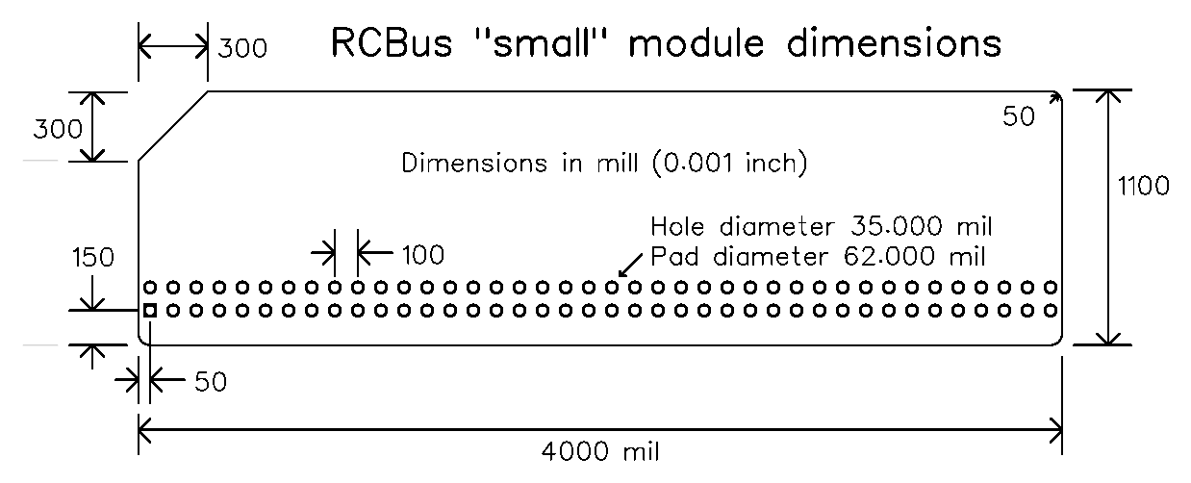
The second (top) row of bus pins is optional

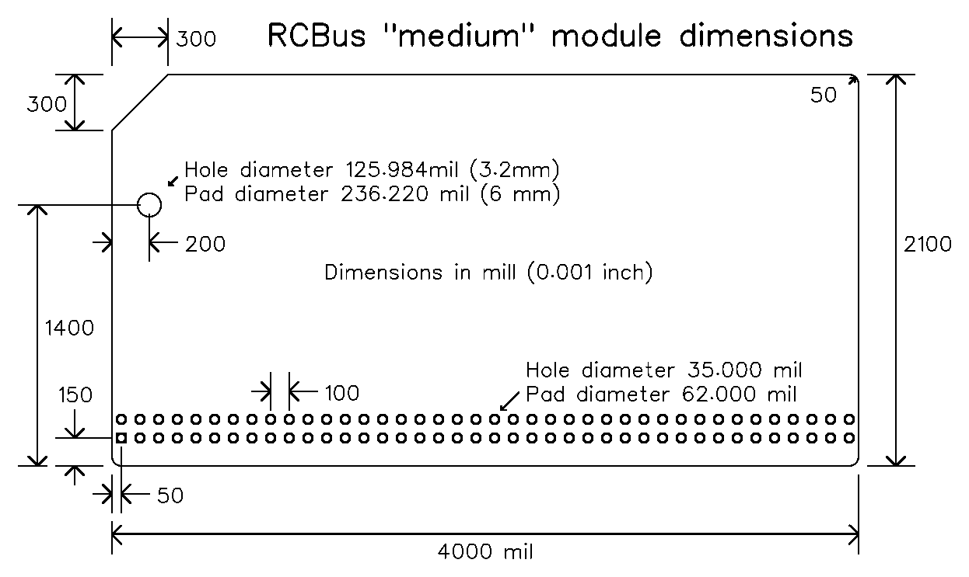
It is recommended that the mounting hole has a 6 mm diameter pad or a 6 mm unobstructed clearance for fixings

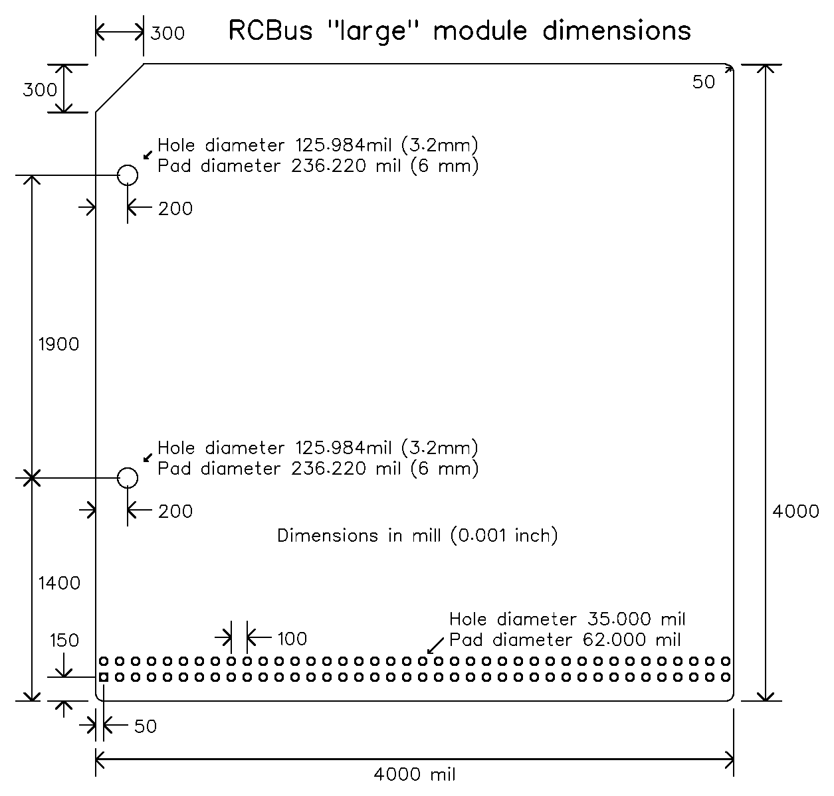

The common RCBus-2014 module dimensions can be found at www.rc2014.co.uk

Appendix E - Terminology
RCBus A generic term to cover all uses and designs based on the RCBus specification.

RCBus Minimal
This set of signals is designed to support input/output devices only.
Signals: +5V, GND, A0 to A7, D0 to D7, nIORQ, nINT, nRD, nWR, nRESET, nM1, nMREQ
Optional: CLOCK, TX, RX

RCBus 40 This set of signals is designed to support memory and input/output devices.
Signals: +5V, GND, A0 to A15, D0 to D7, nIORQ, nINT, nRD, nWR, nRESET, nM1, nMREQ
Optional: CLOCK, TX, RX

RCBus Enhanced
This matches the enhanced RC2014TM bus pins.
Signals: +5V, GND, A0 to A15, D0 to D7, nIORQ, nINT, nRD, nWR, nRESET, nM1, nMREQ
nWAIT, nNMI, nRFSH, nBUSRQ, nBUSAK, D8 to D15, PAGE, CLOCK, CLOCK2
TX, RX, TX2, RX2
Some of these signals are optional.

RCBus 80pin Additional signals and pin numbers are:
Signals: +5V, GND, A0 to A23, D0 to D7, nIORQ, nINT, nRD, nWR, nRESET, nM1, nMREQ
nWAIT, nNMI, nRFSH, nBUSRQ, nBUSAK, D8 to D15, PAGE, CLOCK, CLOCK2
TX, RX, TX2, RX2
Some of these signals are optional.

RCBus Extended
This refers to the pins that have multiple possible functions depending on the processor or system in which they are used. These pins are p37 to p40 (pins 37 to 40), p77 to p80 (pins 77 to 80), and p41 to p48 (pins 41 to 48).

RCBus-2014 The subset of this specification that applies specifically to compatibility with the RC2014TM bus.

RCBus-68xx The subset of this specification that applies specifically to compatibility with the 6800 and compatible processor bus signalling.

RCBus-9995 The subset of this specification that applies specifically to compatibility with the TMS9995 and compatible processor bus signalling.

RCBus-Z80 The subset of this specification that applies specifically to compatibility with the Z80 and compatible processor bus signalling.

THE END

?

Notes, leftover bits and incomplete stuff follows

Unresolved Issues & Notes
Possible additional signals needed: (Alan Cox)
No low/high enables to make D15-D8 actually usable
Multiple interrupt lines
DMA - BUSRQ etc
3v3 power

Are TX2 and RX2 required? (Tadeusz Pycio)

Do we need DREQ and TEND for Z180

Possibly 3v3 supply (but as Tadeusz has pointed out existing backplanes only have thin tracks on the available signal lines)

- bit data hi/lo byte enable (1 pin or 2)

Some new pins as genuine USER functions‼

Do we want a MEM_EN signal? (Tadeusz Pycio)

Better name for PAGE = RAM_EN ? (Tadeusz Pycio)

We still do not have assigned pins for the DMA service request signals. My suggestion was to use pins 78 (DREQ1) and 79 (DREQ2), but if others see the need to add DACK/EOP in addition to these signals it is worth considering another location (pins 45-48 ?) (Tadeusz Pycio)

Guidance for Designers - contribution #1
The basic idea is that all processor types generate the common bus signals, essentially Z80 compatible signals, where ever possible. Any additional processor or sub-specification specific signals are optional. This approach is designed to give the greatest compatibility across all uses of the RCBus.

It is recommended that CMOS ICs be used wherever possible and that 74HCT series ICs are used rather than other 74 series families.

For further guidance on processor specific issues and sub-specification specific issues, see the appropriate appendix.

Sub-specification specific signals
It is recommended that jumper options be provided on modules for connections to the sub-specification specific signals. Namely, pins 37 to 40, 77 to 80, and 42 to 48.
??? should this only be the traditional USER pins? (ie. 37 to 40, and 77 to 80)

Address bus
Unused address lines should ideally be pulled down with weak pulled down resistors to enable CPU and memory modules to be used together even if there is a mismatch in the number of address lines used.

Memory map
Some processors require boot ROMs to be at the top of memory and others at the bottom of memory. It is recommended that memory modules provide an option for this.

Some processors have separate address spaces for I/O devices and some require them to be mapped as memory. Memory modules designed to work with different processors will need to allow for this.

Processors that do not have separate I/O address spaces should generate the RCBus IOREQ signal when I/O addresses are decoded and also ensure the MREQ signal is not active at these times.

Introduction - contribution #1
The documentation describes the Retro Computer Bus (RCBus).

The RCBus is an extended version of the RC2014TM bus.

The RCBus has been created for the following reasons:
- To help distinguish RC2014TM products from products that are not RC2014TM but that claim a degree of compatibility with RC2014TM
- To reduce the chances of trademark infringement
- To help members of the retro computer community share designs and sell products based on the RC2014TM bus
- To specify a common approach to supporting features not provided by the RC2014TM bus
- To specify a common approach to supporting processors other than the Z80

Appendix A provides some background information which should help explain the above list of reasons for creating the RCBus.

The RCBus has a common backplane but some of the signals are not required for some use cases and some signals have different functions depending on the processor and other factors. Modules connected to the backplane can either work with all other RCBus modules or, more likely, a sub-set of RCBus modules.

To indicate which modules are compatible with each other, a number of sub-specifications are documented, such as:
- RCBus-2014 This is the RC2014TM specification (see www.rc2014.co.uk)
  - RCBus-2014-s RC2014TM standard (40-pin) bus
  - RCBus-2014-e RC2014TM enhanced (>40-pin) bus
- RCBus-Z80 Includes extensions to support advanced Z80 and Z180 family features
- RCBus-68xx Includes extensions to support the Motorola bus style processors

A module that only requires the RC2014TM standard 40-pin bus might be compatible with RC2014-2014-s, RCBus-2014-e, and RCBus-Z80. Of course, such a compatibility claim does not mean you can put any two “compatible” modules together and expect them to work. For example, two RC2014TM serial modules will not work due to address conflicts. What “compatible” means is the physical and electrical bus signals are compatible.

The term RCBus can be used for any design that works with the full RCBus backplane or a sub-set of the RCBus backplane.

RC2014 is a trademark under British law, belonging to RFC2795 Ltd (Spencer Owen’s company)

