Please see the below screenshot for manual stop and start.

When we try to stop the services it is still running.

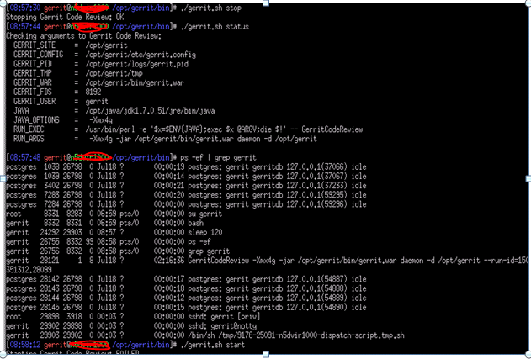

When we do manual stop and start, there is one file(gerrit_index.config) under path /opt/gerrit/index and updating with below values.

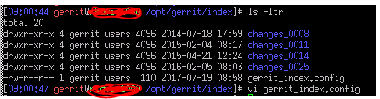

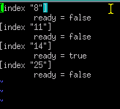

**Error_log**

[2017-07-19 06:00:35,310] WARN  com.google.gerrit.server.cache.h2.H2CacheImpl : Cannot build BloomFilter for jdbc:h2:file:/opt/gerrit/cache/conflicts: Database may be already in use: "Locked by another process". Possible solutions: close all other connection(s); use the server mode [90020-174]

[2017-07-19 06:00:36,301] ERROR com.google.gerrit.pgm.Daemon : Unable to start daemon

com.google.inject.ProvisionException: Unable to provision, see the following errors:

1) Error injecting constructor, org.apache.lucene.store.LockObtainFailedException: Lock obtain timed out: [NativeFSLock@/opt/gerrit/index/changes_0014/open/write.lock](mailto:NativeFSLock@/opt/gerrit/index/changes_0014/open/write.lock)

  at com.google.gerrit.lucene.LuceneChangeIndex.<init>(LuceneChangeIndex.java:241)

  while locating com.google.gerrit.lucene.LuceneChangeIndex annotated with @com.google.inject.internal.UniqueAnnotations$Internal(value=9)

1 error

        at com.google.inject.internal.InjectorImpl$2.get(InjectorImpl.java:1025)

        at com.google.inject.assistedinject.FactoryProvider2.invoke(FactoryProvider2.java:770)

        at com.google.gerrit.lucene.$Proxy104.create(Unknown Source)

        at com.google.gerrit.lucene.LuceneVersionManager.start(LuceneVersionManager.java:150)

        at com.google.gerrit.lifecycle.LifecycleManager.start(LifecycleManager.java:74)

        at com.google.gerrit.pgm.Daemon.start(Daemon.java:293)

        at com.google.gerrit.pgm.Daemon.run(Daemon.java:205)

        at com.google.gerrit.pgm.util.AbstractProgram.main(AbstractProgram.java:64)

        at sun.reflect.NativeMethodAccessorImpl.invoke0(Native Method)

        at sun.reflect.NativeMethodAccessorImpl.invoke(NativeMethodAccessorImpl.java:57)

        at sun.reflect.DelegatingMethodAccessorImpl.invoke(DelegatingMethodAccessorImpl.java:43)

        at java.lang.reflect.Method.invoke(Method.java:606)

        at com.google.gerrit.launcher.GerritLauncher.invokeProgram(GerritLauncher.java:166)

        at com.google.gerrit.launcher.GerritLauncher.mainImpl(GerritLauncher.java:93)

        at com.google.gerrit.launcher.GerritLauncher.main(GerritLauncher.java:50)

        at Main.main(Main.java:25)

Caused by: org.apache.lucene.store.LockObtainFailedException: Lock obtain timed out: [NativeFSLock@/opt/gerrit/index/changes_0014/open/write.lock](mailto:NativeFSLock@/opt/gerrit/index/changes_0014/open/write.lock)

        at org.apache.lucene.store.Lock.obtain(Lock.java:89)

        at org.apache.lucene.index.IndexWriter.<init>(IndexWriter.java:753)

        at com.google.gerrit.lucene.AutoCommitWriter.<init>(AutoCommitWriter.java:34)

        at com.google.gerrit.lucene.SubIndex.<init>(SubIndex.java:75)

        at com.google.gerrit.lucene.SubIndex.<init>(SubIndex.java:60)

        at com.google.gerrit.lucene.LuceneChangeIndex.<init>(LuceneChangeIndex.java:274)

        at sun.reflect.NativeConstructorAccessorImpl.newInstance0(Native Method)

        at sun.reflect.NativeConstructorAccessorImpl.newInstance(NativeConstructorAccessorImpl.java:57)

        at sun.reflect.DelegatingConstructorAccessorImpl.newInstance(DelegatingConstructorAccessorImpl.java:45)

        at java.lang.reflect.Constructor.newInstance(Constructor.java:526)

        at com.google.inject.internal.DefaultConstructionProxyFactory$2.newInstance(DefaultConstructionProxyFactory.java:86)

        at com.google.inject.internal.ConstructorInjector.provision(ConstructorInjector.java:105)

        at com.google.inject.internal.ConstructorInjector.construct(ConstructorInjector.java:85)

        at com.google.inject.internal.ConstructorBindingImpl$Factory.get(ConstructorBindingImpl.java:267)

        at com.google.inject.internal.InjectorImpl$2$1.call(InjectorImpl.java:1016)

        at com.google.inject.internal.InjectorImpl.callInContext(InjectorImpl.java:1092)

        at com.google.inject.internal.InjectorImpl$2.get(InjectorImpl.java:1012)